**­Jupiter - Term 2 Creative Curriculum:** **why are jungles so wet and deserts so dry? 2024/2025**

**Computing:**

Creating media: Audio production

- Identify that sound can be recorded

- To recognise the different parts of recording a podcast

- To apply audio editing skills

- To evaluate the effective use of audio

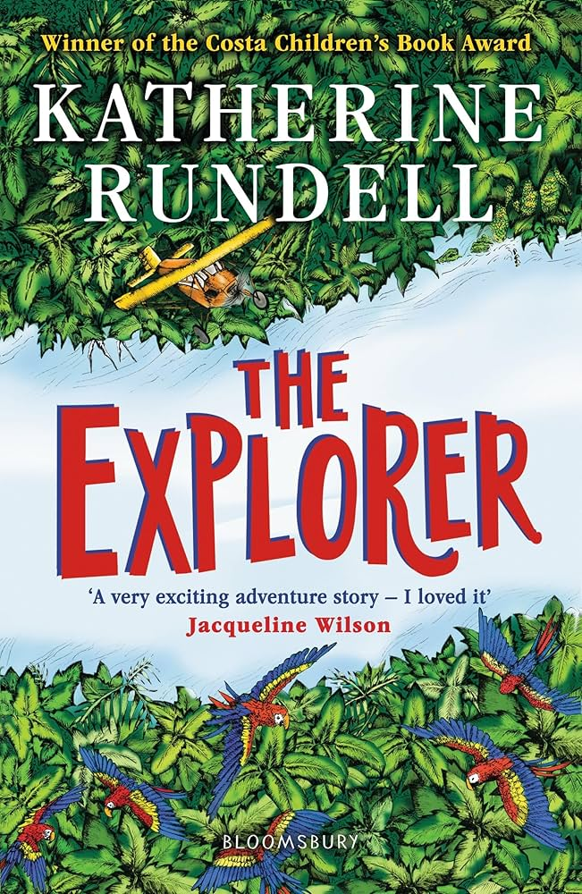

**R.E:** -

Why is Jesus inspiring to some people?

**Topic: Geography enquiry – Why are jungles so wet and deserts so dry?**

Learn about, and reflect upon, how climate has such an important influence upon landscapes, plants, animals and human activity on Earth – investigate this relationship at a number of scales.

Application of skills & processes:

Recognise Identify Describe Empathise Synthesise Explain Apply

Observe Select Categorise Evaluate Reach informed conclusions Hypothesise

Classify Sequence Compare & contrast Make reasoned judgements. Justify

Recall Summarise Reason/speculate Demonstrate understanding Critique

**Art/DT:**

* Textiles: Christmas stockings
* Design
* Make
* Evaluate our designs

**SPaG –**

* Expanded noun phrases
* Fronted adverbials
* Word classes
* Apostrophes

|  |  |  |  |  |  |
| --- | --- | --- | --- | --- | --- |
| **colouredNCbackground.png**  **Numeracy**  **Measurement - Area**  **-** What is area?  - Counting squares  - Making shapes  - Compare areas  **Multiplication and Division**  **-** Multiples of 3  - 6 times-table and division facts  - 9 times-table and division facts  - The 3, 6 and 9 times-table  - Multiply and divide by 7  - 7 times-table and division facts | **Literacy:** Class Reading Book: *The Explorer by Kathrine Rundell*  **Fiction – Horrid henry**   * Read a selection of outrageous Horrid Henry stories. Explore setting, character and plot. Study expanded noun phrases and fronted adverbials. Write a new story.   **Non fiction – Save the Rainforests**   * Cherish rainforests, persuading others to do so too, with *Where the Forest Meets the Sea* and *The Vanishing Rainforest.* Expand noun phrases and revise possessive apostrophes. | | Numeracy - Reasoning  Reasoning is the catalyst for the teaching of maths. A key skill in becoming fully numerate (and to becoming an independent thinker) is the ability to make your own decisions and learn from them.  This key skill is central to the children’s math’s learning and a chance to allow learners to choose their own methods and ways of recording, then present their findings in whichever way they decide. Learners are encouraged to explain their reasoning, thus extending the understanding and their ability to communicate.  Horrid Henry: Book 1 : Simon, Francesca, Ross, Tony: Amazon.co.uk: Books | **Science-**  States of matter   * Compare and group materials together, * Observe that some materials change state when they are heated or cooled, * Identify the part played by evaporation and condensation in the water cycle * Investigate the effect of temperature on the rate of evaporation.   **Languages: Spanish**  **Language nut**  Animals, colours & sizes   * More about pets * Farm animals * Zoo animals * Animals in nature * Colours * Sizes | **Music**  Move to the Beat: Exploring Rhythm and Pulse   * Exploring pulse through rhythm and movement * Controlling pulse using voices and instruments * Exploring the difference between pulse and rhything   **Physical Education**  **Invasion Games: Netball**  Developing knowledge of different invasion games**.**  Accurate passing  Finding space  Defending players and the ball  **Gymnastics -**   * Developing balances and jumps * Creating a sequence of gymnastic skills. |
|  |  |
|  |  |
|  | |  | |
|  |  |