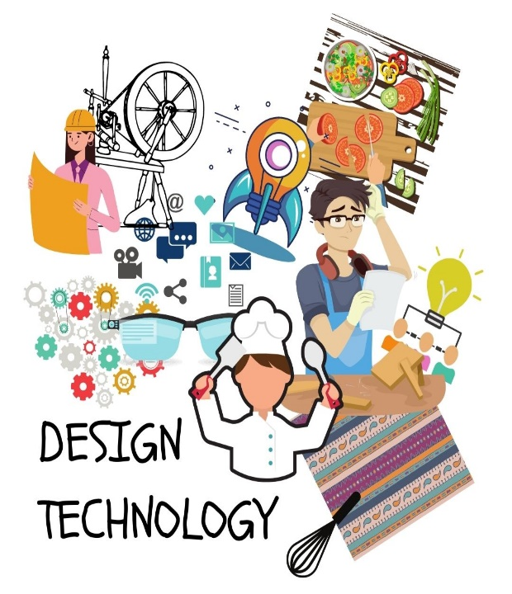

D & T Policy

Character Qualities:

Independence to select materials and make decisions using own ideas.

Curiosity to use different materials and techniques.

Self-control to use concentration and work collaboratively.

May 2025

**DT POLICY**

## Purpose of Study

Art, craft and design embody some of the highest forms of human creativity. A high-quality art and design education should engage, inspire and challenge pupils, equipping them with the knowledge and skills to experiment and create their own work. As pupils progress, they should be able to think critically and develop a more rigorous understanding of art and design. They should also know how art and design both reflect and shape our history, and contribute to the culture, creativity and wealth of our nation. Art education should foster an enjoyment and appreciation of the visual arts, and a knowledge of great artists.

## Aims and Intent

Aims

D.T. prepares children to take part in the development of tomorrow’s rapidly changing world. Creative thinking encourages children to make positive changes to their quality of life. The subject encourages children to become autonomous and creative problem-solvers, both as individuals and as part of a team. It enables them to identify needs and opportunities and to respond by developing ideas and eventually making products and systems. Through the study of design and technology they combine practical skills with an understanding of aesthetic, social and environmental issues, as well as functions and industrial practices. This allows them to reflect on and evaluate present and past design and technology, its uses and its impacts. D.T. helps all children to become critiques and informed consumers and potential innovators.

**National Curriculum Aims**

The National Curriculum for Design and Technology (D&T) aims to equip pupils with the knowledge, skills, and understanding to design and make high-quality prototypes and products for a wide range of users. It also focuses on developing their ability to critique, evaluate, and test their own work and the work of others, as well as understanding and applying the principles of nutrition and cooking.

Objectives

The objectives of DT are:

* to develop imaginative thinking in children and to enable them to talk about what they like and dislike when designing and making;
* to enable children to talk about how things work, and to draw and model their ideas;
* to encourage children to select appropriate tools and techniques for making a product, whilst following safe procedures;
* to explore attitudes towards the made world and how we live and work within it;
* to develop an understanding of technological processes, products, and their manufacture, and their contribution to our society;
* to foster enjoyment, satisfaction and purpose in designing and making.

## Implementation: Teaching and Learning

**The Curriculum**

We teach D.T. as part of our broad and balanced curriculum. We enable the skills and knowledge of the D.T. curriculum to be delivered in an innovative and imaginative way using the teaching procedures and styles outlined below. We believe that linking the skills and knowledge of D.T. across the curriculum enables deeper, more connected learning between subjects. We teach D.T. through carefully planned topics ensuring that over the year each area of the D.T. curriculum, the programmes of study and statements of attainment, are met. We do realise that some aspects of the D.T. curriculum may still need to be taught discretely. Although as a school we follow the same topic, the activities and learning opportunities are fully differentiated and appropriate to the age and ability of the child.

**Teaching and learning styles**

The school uses a variety of teaching and learning styles in D.T. lessons. Our principal aim is to develop the children’s knowledge, skills and understanding in D.T. Teachers ensure that the children apply their knowledge and understanding when developing ideas, planning and making products and then evaluating them. We do this through a mixture of whole-class teaching and individual/group activities. Within lessons, we give children the opportunity both to work on their own and to collaborate with others, listening to other children’s ideas and treating these with respect. Children critically evaluate existing products, their own work and that of others.

**D.T. curriculum planning**

We currently use ‘Kapow’ to base our long term DT objectives on. This allows us to plan for single and mixed year groups and ensure progression through a two year rolling cycle. Kapow provides a planned progression with activities that develop D.T. knowledge.

**Differentiation**

We aim to encourage all children to reach their full potential through the provision of varied opportunities. We recognise that our curriculum planning must allow pupils to gain a progressively deeper understanding and competency as they move throughout the school.

Careful thought will be given to the provision of appropriately structured work for children with SEN. The school uses the strategies of ‘The Dyslexia Friendly School’ that enable all children increased access to the curriculum through a broad – base, multi sensory, visual auditory and kinaesthetically planned curriculum.

Planning attempts to ensure that the level of challenge is appropriate to their specific needs.

**Foundation stage**

In the Foundation Stage, the arts are linked throughout all of the planning, so that opportunities arise each day, to be creative. They form part of the Expressive Arts and Design area of learning (see Early Years policy).

**Key stage 1 pupils will learn to:**

Through a variety of creative and practical activities, pupils should be taught the knowledge, understanding and skills needed to engage in an iterative process of designing and making. They should work in a range of relevant contexts [for example, the home and school, gardens and playgrounds, the local community, industry and the wider environment]. When designing and making, pupils should be taught to:

* **Design** - purposeful, functional, appealing products for themselves and other users based on design criteria.
* generate, develop, model and communicate their ideas through talking, drawing, templates, mock-ups and, where appropriate, information and communication technology.
* **Make** - select from and use a range of tools and equipment to perform practical tasks [for example, cutting, shaping, joining and finishing]
* select from and use a wide range of materials and components, including construction materials, textiles and ingredients, according to their characteristics
* **Evaluate** - explore and evaluate a range of existing products
* evaluate their ideas and products against design criteria
* **Technical knowledge** - build structures, exploring how they can be made stronger, stiffer and more stable
* Explore and use mechanisms [for example, levers, sliders, wheels and axles], in their products.

**Key stage 2 pupils will learn to:**

Through a variety of creative and practical activities, pupils should be taught the knowledge, understanding and skills needed to engage in an iterative process of designing and making. They should work in a range of relevant contexts [for example, the home, school, leisure, culture, enterprise, industry and the wider environment]. When designing and making, pupils should be taught to:

* **Design** - use research and develop design criteria to inform the design of innovative, functional, appealing products that are fit for purpose, aimed at particular individuals or groups.
* Generate, develop, model and communicate their ideas through discussion, annotated sketches, cross-sectional and exploded diagrams, prototypes, pattern pieces and computer-aided design
* **Make** - select from and use a wider range of tools and equipment to perform practical tasks [for example, cutting, shaping, joining and finishing], accurately select from and use a wider range of materials and components, including construction materials, textiles and ingredients, according to their functional properties and aesthetic qualities.
* **Evaluate -** investigate and analyse a range of existing products
* evaluate their ideas and products against their own design criteria and consider the views of others to improve their work.
* understand how key events and individuals in design and technology have helped shape the world
* **Technical knowledge -** apply their understanding of how to strengthen, stiffen and reinforce more complex structures
* understand and use mechanical systems in their products [for example, gears, pulleys, cams, levers and linkages]
* understand and use electrical systems in their products [for example, series circuits incorporating switches, bulbs, buzzers and motors]
* apply their understanding of computing to program, monitor and control their products.

**Cooking and nutrition**

As part of their work with food, pupils should be taught how to cook and apply the principles of nutrition and healthy eating. Instilling a love of cooking in pupils will also open a door to one of the great expressions of human creativity. Learning how to cook is a crucial life skill that enables pupils to feed themselves and others affordably and well, now and in later life.

Pupils should be taught to:

Key stage 1

* use the basic principles of a healthy and varied diet to prepare dishes
* understand where food comes from.

Key stage 2

* understand and apply the principles of a healthy and varied diet
* prepare and cook a variety of predominantly savoury dishes using a range of cooking techniques
* understand seasonality and know where and how a variety of ingredients are grown, reared, caught and processed.

## Impact: Assessment and Monitoring

**Assessment:**

Teachers assess children’s work in D.T. by making assessments as they observe them working during lessons. They record the progress made by children against the learning objectives for their lessons. An overall assessment will be made at the end of a topic through a planned ‘End of Unit’ assessment task. They record this information and use it to plan the future work of each child.

The teacher will pass on relevant information to other teachers. Staff hold meetings with parents and written annual reports are forwarded to parents in the summer term.

**The Role of the subject lead**

* Write and review the policy.
* Monitor teaching and learning.
* Support teachers with resources.
* Attend relevant courses and feedback to staff.
* Seek opportunities to link the school with experienced and emerging artists in the community.

**Monitoring and Review:**

The subject leader is responsible for coordinating the art curriculum, supporting colleagues with resources and direction and ensuring a broad and balanced range of skills are taught.

**Personal, Social, Health Education (PSHE) and Citizenship,**

**Spiritual, Moral and Cultural Development (SMSC)**

D.T. contributes to the teaching of elements of PSHE and Citizenship. The children have the opportunity to discuss how they feel about their own work and the methods and approaches used by others.

The teaching of D.T. offers opportunities to support the social development of our children through the way we expect them to work with each other in lessons. Groupings allow children to work together and give them the chance to discuss their feelings about their own work and the work of others. Their work in general helps them to develop a respect for the abilities of other children and encourages them to collaborate and co-operate across a range of activities and experiences. The children learn to respect and work with each other and with adults, thus developing a better understanding of themselves.

They also develop a respect for the environment, for their own health and safety and for that of others. They develop their cultural awareness and understanding, and they learn to appreciate the value of differences and similarities. A variety of experiences teaches them to appreciate that all peoples are equally important, and that the needs of individuals are not the same as the needs of groups.

**Health and Safety**:

General requirements for Health and Safety apply in this subject and care needs to be taken when using tools, and materials. Tools should be checked before use, be age appropriate and children should be trained to use them safely. Children are taught to follow proper procedures. Teaching staff are responsible for the supervision of activities.

**Resources**

We have a wide range of resources to support the teaching of D.T. across the school. The equipment is kept in both our own classrooms and in the resources room. Resources are updated continually as appropriate including computing resources.

**Accessible for all**

All children regardless of gender, race, culture, background and ability have an entitlement to arts education at an appropriate and challenging level. To ensure that children experience high standards of success, creative development will be taught to take regard of children’s abilities to ensure progress.

Through the arts the children may be encouraged to:

* Be self-motivated and self-critical.
* Value their peers.
* Develop their thinking and reasoning skills.
* Observe, present, evaluate and record experiences.
* Become organised.
* Learn how to use a range of resources to meet their needs.
* Experience diverse and creative teaching and learning styles and make cross curricular links.
* Develop an appreciation and enjoyment of design.

## Character vision

“We are preparing children for the challenges of the 21st century – learning and working in a knowledge making world, rather than a knowledge applying world. Through our creative spirit as teachers, children will heighten their sensitivity, emotional intelligence and resilience and embrace enterprise and risk taking”

David Pyle

Headteacher

Reviewed Summer 2025

To be reviewed Summer 2026