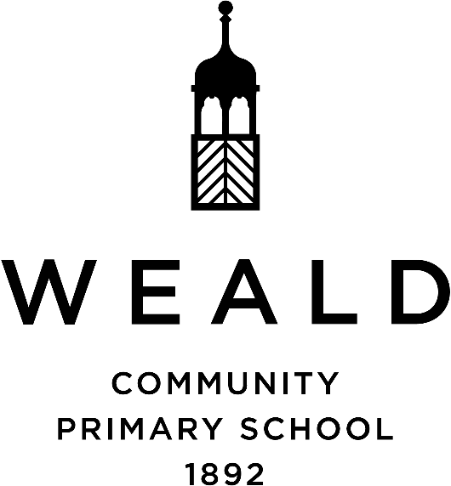

|  |
| --- |
| **ASSESSMENT FRAMEWORK POLICY**  **2024-2025** |

|  |  |
| --- | --- |
| **Senior Leadership Team** | |
| **Headteacher**  **Deputy Headteacher**  **Leader of learning Success** | **David Pyle**  **Chris Taylor**  **Lisa Drogomirecki** |
| **Date Reviewed** | **September 2024** |
| **Next Review** | **September 2025** |
| **Governor Review** | **L & D March 2025** |

Aims

The aim of this document is to provide an assessment framework for Weald Community Primary School which:

* embeds formative assessment in quality first teaching, impacting positively on pupils’ learning outcomes and supporting teachers and leaders to secure at least one year’s progress for every year of teaching, for every pupil, in every year of primary school.
* provides a reliable mechanism for school leaders and teachers to evaluate progress and moderate standards and expectations in core and foundation subjects.
* supports the collection of simple, clear summative data and pertinent analysis relating to pupil attainment in Maths and English which supports continued progress in pupil learning, as well as the schools self-evaluation and school improvement

**Assumptions**

* The expectations set by the National Curriculum (2014) are high. If a pupil is a ‘secure learner’ in one year-group, and remains a secure learner a year later, it is assumed that he/she has made one year of progress for one year of teaching. This represents good progress.
* Excellent progress would be represented by achieving a deeper level of understanding, making lateral connections across contextual and subject boundaries, using knowledge mastered for extended reasoning and problem solving etc. Good or better progress would not involve moving on to the programme of study for the year group above.
* If a pupil has fallen behind and requires additional support to work securely within the programme of study for their year group, or is working below their year group expectations, it is assumed that their progress needs to accelerate; they need to ‘catch-up’. Action is required to accelerate progress – e.g. further additional support or effective intervention informed by research evidence.

**Expectations**

At Weald we are all working together to establish research-informed, quality first teaching, for all pupils, including formative assessment strategies such as:

* clear learning objectives
* co-constructed success criteria
* effective questioning
* retrieval practice activities
* effective feedback
* the use of a repertoire of low stakes continuous assessment activities e.g. tasks, tests, quizzes, exit tickets etc to support teachers’ evaluation of pupil learning, inform their planning for next steps, addressing misconceptions and pupils’ individual learning needs.
* A mastery approach to pedagogy

**Formative Assessment**

School leaders at all levels and class teachers engage in Pupil Progress Meetings (PPMs) at the end of each half term. These meetings are structured conversations which consider the range of evidence relating to pupil achievement (attainment and progress) during the previous several weeks. They provide a regular opportunity to:

* moderate expectations and standards in each class and year group through triangulation of evidence which includes pupils’ work, outcomes of their assessment activities, tests and quizzes etc.
* evaluate pupils’ progress from their key stage starting points and, where concerns emerge, consider what needs to be done at class or school level to ensure pupils’ do not continue to fall behind.
* evaluate the quality of education, standards and achievement in the foundation subjects.
* moderate teachers’ assessments of pupil achievement in the foundation subjects.
* provide responsive professional development for teachers relating to quality first teaching, assessment literacy and practice, effective learning interventions; effective differentiation for mastery (provision of additional support, rapid intervention, pre-teaching, scaffolding, time etc) and the provision of opportunities for deeper learning.

PPMs consider all pupils at some point during the year, but individual meetings may consider a sample of pupils rather than the whole class, including a representative sample of groups within the cohort e.g. more-able, disadvantaged, SEND, looked-after, boys and girls.

**Summative assessment**

Assessment data at Weald is tracked using the Arbor assessment tool.

Taking account of all the evidence accumulated since the last summative assessment point, including the results of standardised tests or any other tests or other assessment activities, teachers arrive at a summative assessment of pupil achievement in reading, writing, SPaG and mathematics.

* Pupils who are working securely within the programme of study for their age are considered ‘secure learners’ and are coded ‘light green’ on Arbor.
* Pupils who are achieving a deeper level of understanding of objectives from the programme of study for their year group, are coded ‘dark green’.
* Those who are working within the programme of study for their age, but progress may have slowed during that year, are coded ‘grey.
* For those pupils working below the expected progress for that year, are coded ‘yellow’.
* This summative data is updated in Arbor three times per year. Any changes are discussed at PPMs.
* Where there is a school improvement imperative, it may be necessary to assess judgements half termly.

**Special educational needs**

For those children with special educational needs, we assess using all of the above. For those children working below their year group, assessments are tailored to best fit and show the progress and accomplishments of each individual child.

For children working significantly below their academic year group (and being assessed using the old P-scales and new standards), we use the PIVATS assessment tool. This allows us to track small, individual steps of progress whilst running alongside any tailored or bespoke learning which children are completing.

**Statutory Assessment**

National tests and statutory assessments in core subjects are conducted in the year groups and at the points dictated by the DfE.

**Standardised Tests**

Whiterose Maths, PIRA, FRED’s Fluency in reading and GaPS are conducted three times a year as well as an internal or external moderation of writing against the Kent descriptors –preceding a summative assessment point. The results of these tests inform:

* an evaluation of the pupil’s progress throughout the year and year-on-year;
* moderation and benchmarking of standards and expectations across year groups
* triangulation of the evidence to inform teachers’ summative assessment judgements.
* Formative assessment of whole class and cohort gaps in learning and misconceptions to inform teachers’ planning for future teaching and learning and school leaders’ planning for professional learning and school improvement.
* Scores from standardised tests are recorded in the subject folders.

**Arbor Tracking**

The Senior leadership team at Weald have worked with Arbor to create a tracking and assessment analysis system which reflects this assessment model. Teachers enter their summative judgements into the software as outlined above, highlighting whether the child is working below, emerging, expected or exceeding the year objectives at that stage in the year. Reports can then be generated which support comprehensive analysis of pupil attainment, including selected groups. Further evaluation of pupils’ progress is supported by analysis of pupils’ standardised test outcomes.

**Assessment in Foundation Subjects**

At Weald school foundation subjects are assessed using progression documents for each subject. The Curriculum and Pedagogy Framework supports the provision of precise and detailed programmes of study for each of the foundation subjects. Teachers use low stakes assessment tasks, tests and quizzes to assess the extent to which pupils have learned and remembered age-appropriate curriculum content and develop domain specific skills. These assessments form the basis of teachers’ summative judgements made at the end of the year, indicate children’s attainment.

**Pupils and Parents**

Pupils are encouraged to be part of the assessment process by reflecting on their progress towards success criteria in lessons, self-evaluation of personal learning and collaborative evaluation with the teacher using assessment grids as laid out in their books. Teachers are expected to make opportunities for pupils to engage in personal and peer marking, feedback and evaluation.

We value and recognise the role of parents in their children’s education so our school shares information with parents to enable them to support their child.

Formal consultations are available to parents three times a year and informal consultations are arranged as necessary. Parents of the most vulnerable pupils in our school receive additional consultations with the ‘Leader of Learning Success’ to discuss progress and interventions and maximise parental relationships. Through all of this information, we aim to enable all families to engage with their child’s personal development.

**The effectiveness of this assessment policy is monitored regularly through book looks and monitoring led by subject teams and is reported to the governing body.**