Saturn **– Term 5 Creative Curriculum:** **How does the weather affect our lives? 2024/ 2025**

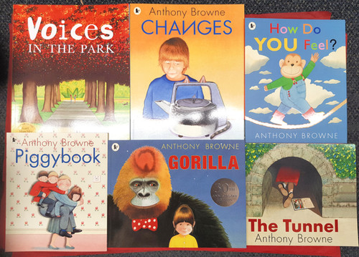

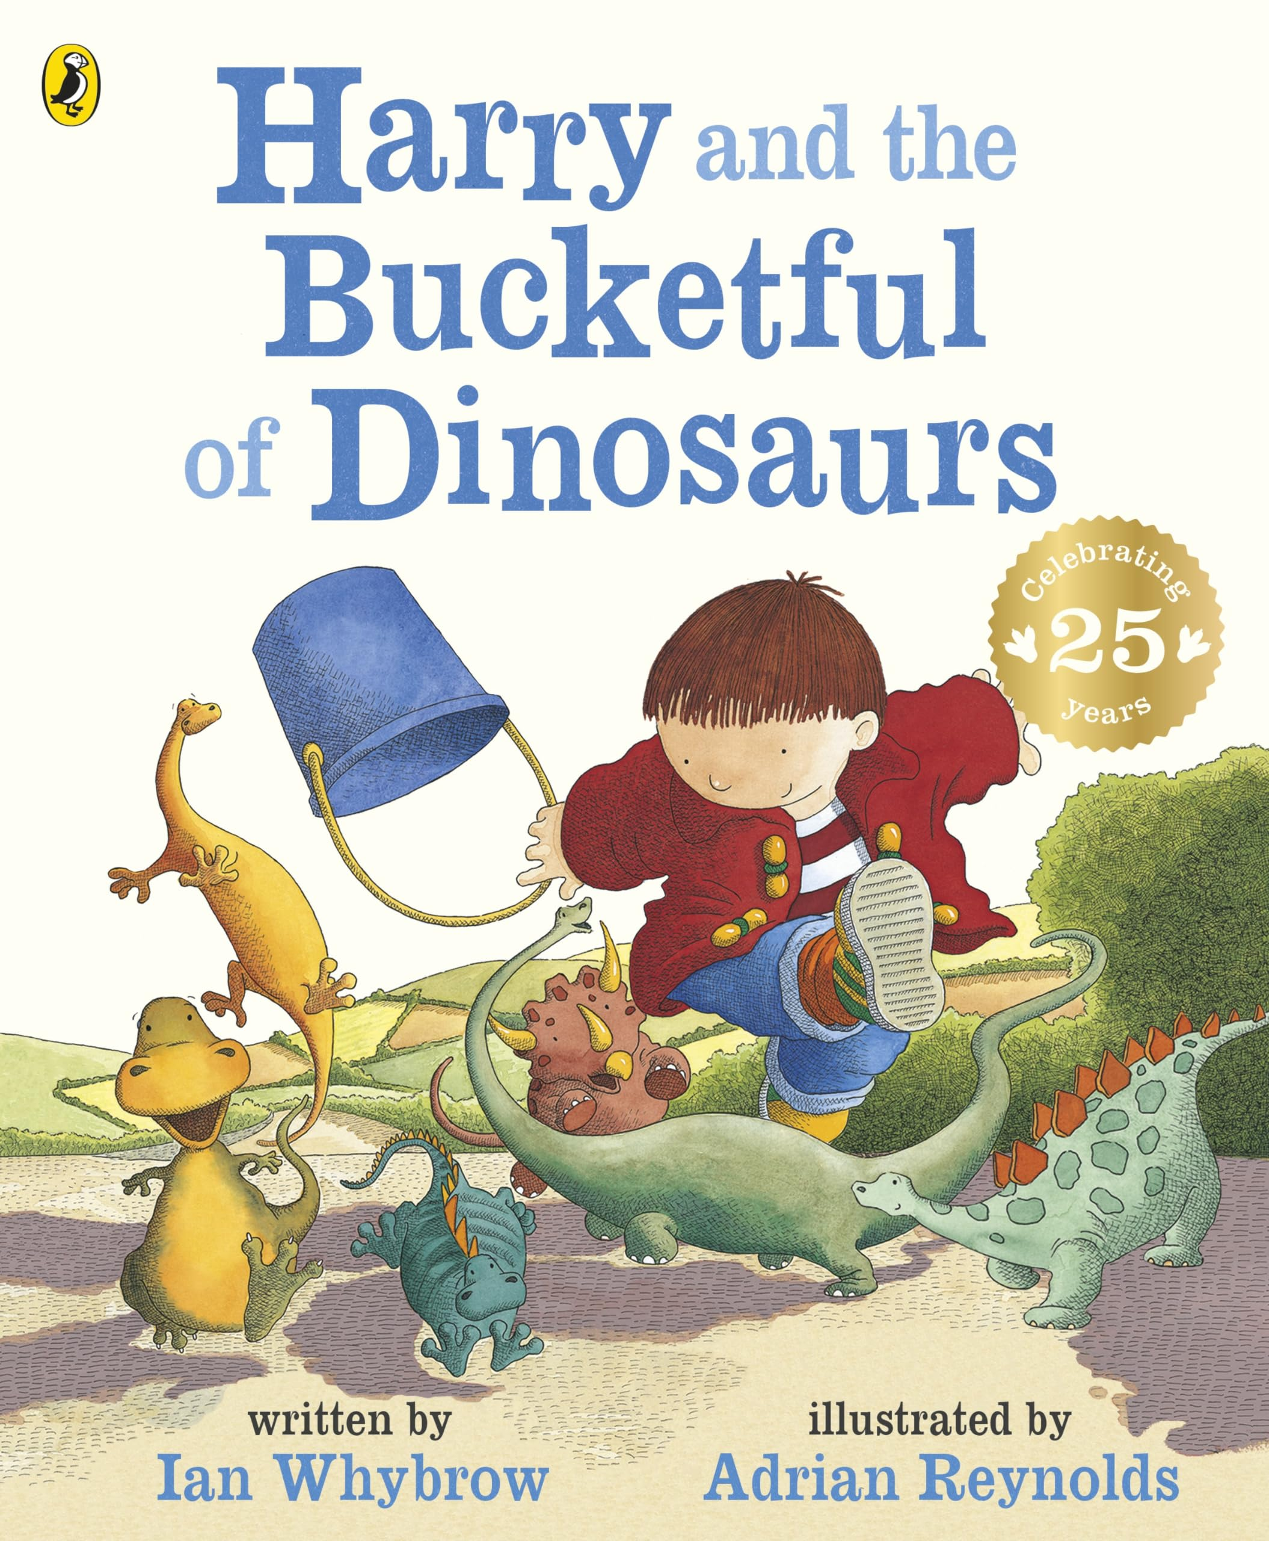

**Computing:**

**Making digital music:**

How music makes us feel.

Rhythms and patterns

How music can be used

Notes and tempo

Creating digital music

Reviewing and editing music

**Science**

**Everyday Materials – Squash, bend, twist and stretch.**

* Understand how everyday materials can be used for more than one thing.
* Understand how different everyday materials can be used for the same thing.
* Understand why the properties of materials make them suitable or unsuitable for particular purposes.
* Recognise squashing, bending, twisting and stretching can change the shape of solid objects.

Literacy:

Fiction:

Text: Anthony Browne books

Activity: comparing same author, story in the state of author

Skill: adjectives, noun phrases, conjunctions.

Non -Fiction

Texts: Dinosaurs

Differences between fiction and non-fiction. Research and create fact files using noun phrases. Study sentence types.

Poetry:

Peace at last by Jill Murphy.

**Topic: Geography enquiry – How does the weather affect our lives?**

**This aim enables children to learn about the Geography surrounding the weather. Year 2 will understand the concept of weather and form a solid foundation for studying climate.**

**To begin to understand how weather affects them as individuals on a daily and seasonal basis.**

**As well as comparing to people in other locations around the world.**

**An important concept of seasonality in weather and how the elements of weather changes during a typical year. This topic will build on Geographical skills and fieldwork.**

**We will build on these ideas within Art and Music, using weather to influence creatively.**

**R.E:** -

Continue – How and why do we celebrate special and sacred times.

Start – how should we care for others and the world why does it matter?

**Art/DT:**

Create a print with different simple lines and shapes inspired from aspects of the weather.

Using inspiration from different weather inspired artists to create our own weather inspired painting.

**SPaG -**

Adverbs

Word classes

Coordination

Apostrophes for possession

Past and present tense

Reviews

|  |  |  |  |  |  |
| --- | --- | --- | --- | --- | --- |
| **colouredNCbackground.png**  **Maths**  **Number – Fractions**   * Review Multiplication and Division * Equal and unequal parts * Recognise and find a half, quarter, third and three quarters. * Begin to count in fractions up to a whole.   **Measurement – Time**   * Introduce o’clock and half-past * Quarter past and quarter to * Tell the time up to and past the hour. * Tell the time to 5 minutes. * Minutes in an hour and hours in a day |  | | Maths - Reasoning  Reasoning deepens mathematical learning; it creates a mastery approach to learning. This term we will start to build up reasoning and problem-solving during learning. Using this approach in APE tasks (Answer, Prove and Explain).  Developing pictorial, concrete and abstract learning. Starting to visualise their mathematical problems to find a solution quickly and accurately.  Drawing on prior knowledge towards new math problems. | **Languages: Spanish -** **Languagenut**  Review: How I look  New: Animals, colours and sizes. | Singing/rhythm games  Element of music appreciation / general knowledge  Larger focus on composition and performance of a piece of music inspired by the weather.  Review of year  **Physical Education:**  **Music**  Exploring rhythmic patterns  Multi skills Athletics running/jumping and throwing. Jump 2 feet (1-2 feet and 2 -2 feet) Throw for distance.  Racket skills – acquire skills to use a racket correctly including, balancing, sending and at a target |
|  |  |
|  |  |
|  | |  | |
|  |  |