Saturn **- Term 5 Creative Curriculum: Once Upon a Time. 2024/ 2025**

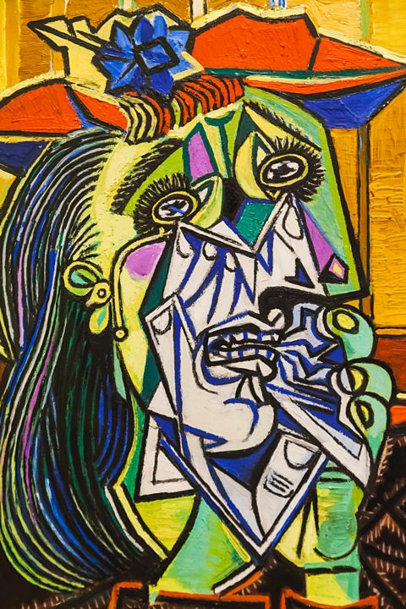

**Art/DT:**

**Drawing and painting**

Artist- Picasso

Focus style: Cubism

What do we know about him as an artist?

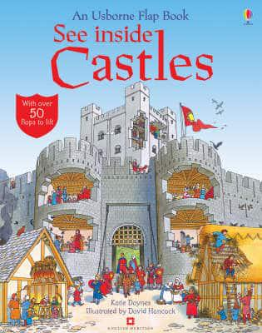

**Computing:**

**Creating media – Digital writing**

* Exploring the keyboard
* Adding and removing text
* Exploring the toolbar
* Making changes to text
* Explaining my choices
* Pencil or keyboard?

Literacy:

Non-Fiction/ Fiction

**Writing Outcomes**

* Comparison
* Writing in role
* Re-writing a fairy tale
* Role Play- Performing a fairy-tale
* Script writing
* Making predictions
* Expanded noun phrases to describe and specify
* Writing direct and reported speech.
* Editing
* Letter writing

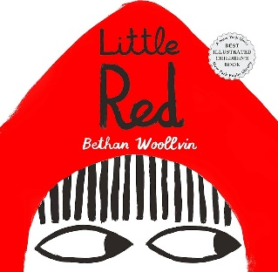

**Topic: Once Upon a Time-**

Key Questions:

* What was the purpose of a castle?
* Why do castles have a moat?
* Are fairy tales fiction or non-fiction stories?
* What are some common features of

fairy tales?

**R.E:** -

* **What makes some places sacred?**
* Exploring special places, discovering churches, exploring mosques, visiting a sacred place and reflecting on sacred places.

**SPaG -**

* Prefixes
* Onomatopoeia
* Pronouns (I, she, her, they, them, he him)

|  |  |  |  |  |  |
| --- | --- | --- | --- | --- | --- |
| **colouredNCbackground.png**  **History: Castles**  Hi1/1.3 :significant historical […] places in their own locality.   * The concept of a castle as a place of defence and home for important people like lords and kings. * Explore different types of castles like motte and bailey, stone keeps, and concentric castles, using visuals. * Identify key castle features like walls, towers, gates, and moats, potentially using a model or diagram. * What life was like inside a castle, including the Great Hall, kitchen, and other rooms, using books and videos. * Create a timeline showing the development of castles over time, emphasizing that they were built for defence and power. |  | | Fractions  In this unit, children explore finding halves and quarters of shapes, objects, and quantities through practical activities.  Position and Direction  In this unit, children explore describing position, direction, and movement, including whole, half, quarter, and three-quarter turns, using practical activities and directional language.​  **Numeracy**  Multiplication and division  In this unit, children explore counting in 2s, 5s, and 10s, making equal groups through sharing and grouping, and solving problems using repeated addition, doubling, and arrays.  Numeracy:  Reasoning  Reasoning deepens mathematical learning; it creates a mastery approach to learning. This term we will start to discuss reasoning and problem-solving during learning.  Developing pictorial, concrete and abstract learning. Starting to visualize their mathematical problems to find a solution quickly and accurately.  Drawing on prior knowledge towards new math problems. | **Science**-    **Plant Parts-Growing**   * The children will learn about how seeds and bulbs grow and grow sunflowers, keeping sunflower growing diary where we will keep track of our flowers height. * Conducting an experiment and recording the results on a bar graph. * Exploring the life-cycle of a sunflower. | * **Use voices expressively and creatively** by singing songs and speaking chants/rhymes * **Play tuned and untuned instruments** musically * **Listen with concentration and understanding** to a range of high-quality live and recorded music * **Experiment with, create, select and combine sounds** using the inter-related dimensions of music (pitch, dynamics, tempo, rhythm).   **Physical Education**  Games: Striking and fielding   * I can show some different ways of hitting, throwing and striking a ball * I can hit a ball or bean bag and move quickly to score a range of points (further distance scores more points). * I can play as a fielder and get the ball back to a STOP ZONE * I can begin to follow some simple rules (carrying the bat, not over taking someone.   **Music**  **Fairytale Picnic** |
|  |  |
|  |  |
|  | |  | |
|  |  |