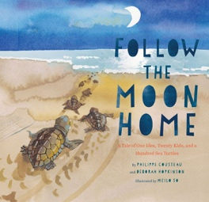Saturn **– Term 3 Creative Curriculum:** **What does it take to be a great explorer? 2024/ 2025**

**Topic: History enquiry – What does it take to be a great explorer?**

**This aim enables children to learn about the exploits of a range of famous explorers and to develop their knowledge of peoples lives at various points in the past. Children will reflect on the achievements of the explorers studied and in particular the personal qualities they exhibited in order to achieve what they did during the times at which they were alive.**

**Engaging in historical vocabulary and supported to recognise where the people and events they are studying fit with chronological framework can be time-lined.**

**We will link this across other subjects such as Art, creating a piece of artwork linking to the different explorers, using artistic and historical techniques.**

**Science**

**Plants – ready steady grow.**

To design and set up a test to find what plants need to stay healthy.

To look closely at the parts of a seed that will grow and explain germination.

Describe life cycle of a plant.

Describe what happens to a plant if they don’t get what they need. And how plants are suited to their habitat.

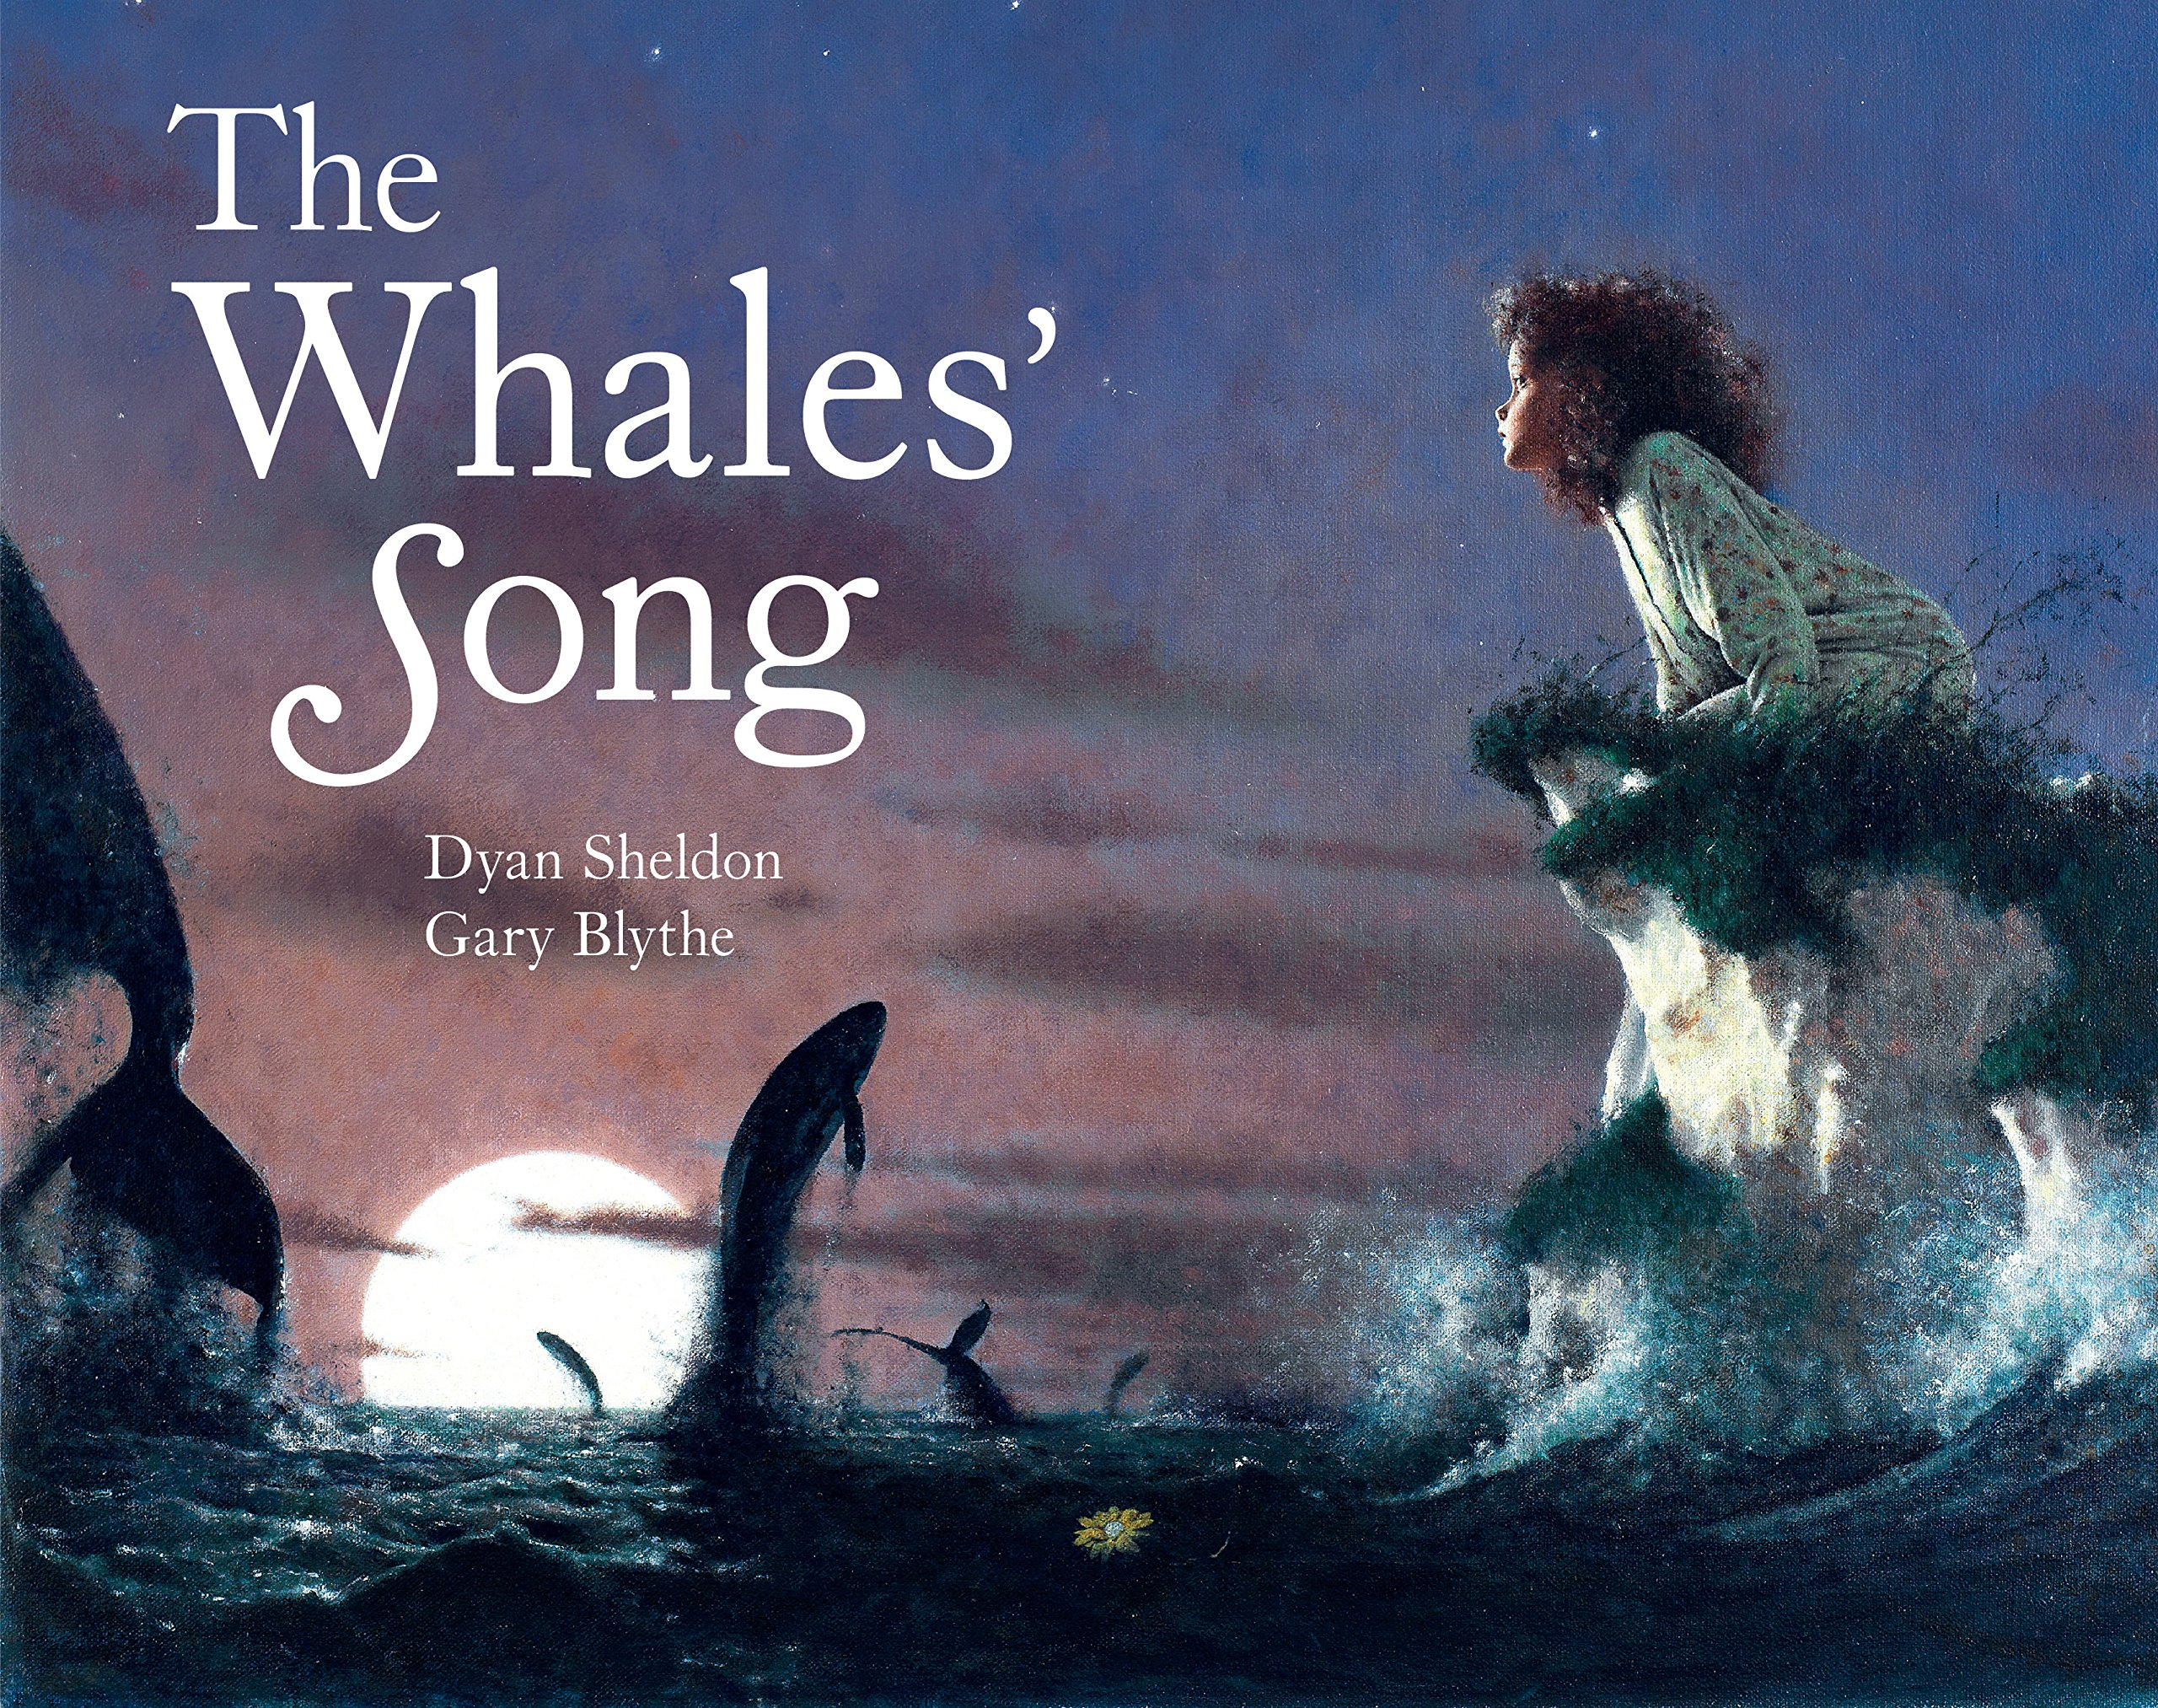

Literacy:

Fiction:

Text: The Fox, The Whale’s Song The owl who is afraid of the dark

Activity: story planning & writing.

Skill: noun phrases, conjunctions, alliteration, onomatopoeia, suffixes.

Non -Fiction

Text: Follow the moon home and a book of sea creatures

Activity: Biographies: fiction and Non- Fiction differences. Description

and Biographies, Apostrophies, conjunctions.

Poetry:

Monster poems

**R.E:** -

Who is a Jew and what do they believe in?

**Computing:**

Programming A – Robot Algorithms

To describe a series of instructions as a sequence

To explain what happens when we change the order of instructions.

To use logical reasoning to predict outcome

of a program.

-To explain that programming projects can have code and artwork.

- To design and algorithm.

**Art/DT:**

Using different artistic techniques to create a piece of artwork to represent a different explorer.

Neil Armstrong

Ranulph Fiennes

Amy Johnson

Christopher Columbus

**SPaG -**

Noun phrases

Homophones

Adjectives: ‘-full’ and ‘-less’

Questions and commands

Sentence writing

Reviews

|  |  |  |  |  |  |
| --- | --- | --- | --- | --- | --- |
| **colouredNCbackground.png**  **Maths**  **Number – Multiplication and Division**  Recognise, make and add equal groups  Introduce the multiplication symbol  2 times table, 10 times table and 5 times table.  Divide by 2, 5 and 10.  **Measurement – Money, length, height and Mass**  Count, calculate and compare money.  Find the correct change.  Measure m,cm, g and kg. |  | | Maths - Reasoning  Reasoning deepens mathematical learning; it creates a mastery approach to learning. This term we will start to build up reasoning and problem-solving during learning. Using this approach in APE tasks (Answer, Prove and Explain).  Developing pictorial, concrete and abstract learning. Starting to visualise their mathematical problems to find a solution quickly and accurately.  Drawing on prior knowledge towards new math problems. | **Languages: Spanish -** **Languagenut**  Review: Hobbies and Pets  Where I live | **Physical Education:**  **Music**  Exploring rhythmic patterns  **Target Skills –**  Ball and target acquiring skills to send a to a target with control and accuracy  **Dance -**  Copy some dance elements and copy short sequences  Element of music appreciation / general knowledge  Learning quavers and semibreves (and their rests)  Musical terms: tempo  Various percussion instruments |
|  |  |
|  |  |
|  | |  | |
|  |  |