**Model Framework:** The table shows key criteria, arranged hierarchically, where significant new learning is introduced. The criteria are cumulative.

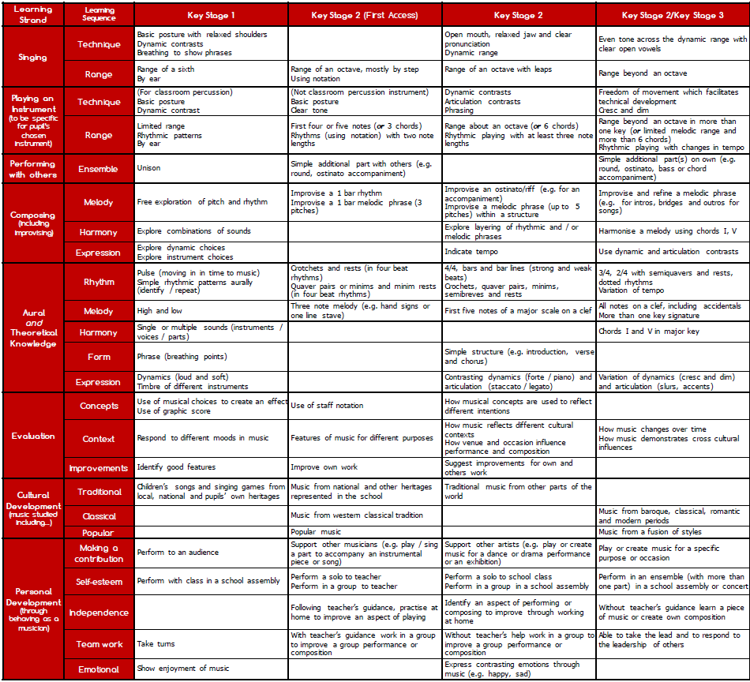Previous criteria will continue to be refined according to the context of the musical learning.