**Weald CPS: Assessment in Geography**

**Overview**

* What can we do to **embed** and **measure** Geography where pupils ‘know more, remember more and can do more?’ (Ofsted 2021)
* How do we plan and implement **a curriculum that connects substantive knowledge** to create a composite schema for each child?
* How can **assessment practices raise attainment?**

**Start with the end in mind**

* Know what you want the pupils to know at the end of a unit of work.
* Know how to assess that they know it.

**Top three reasons for Assessment**

* Inform future lessons: identify gaps in learning; starter task focussed on correcting previous mistakes or misconceptions.
* Measure knowledge and understanding: meaningful assessment leading to summative judgements.
* Share with and include pupils: verbal & subject-specific feedback

**Assessment in Primary Geography**

The government does **not** require any data from schools regarding children’s attainment within the subject. To this end, without a national standard, teachers need to have an array of tools at their disposal to monitor appropriate curriculum coverage, carry out reliable formative assessment, track progress and ensure progression year on year. The GA progression framework 2020 considers assessment at three temporal levels.

**Three levels of Assessment**

* **Day to day:** focus: short term, formative assessment; Afl; immediate feedback & next steps; directly supports progress and limits ‘cumulative dysfluency’ which might prevent acquisition.
* **Periodic:** focus: medium-term, formative/summative; broader view of progress and improvement; making interim judgements by applying expectations in the classroom. More in depth feedback.
* **Transitional:** focus: long-term, summative; formal recognition of achievement; a major piece of work; end of KS enquiry; perhaps synoptic; drawing learning together; reported to parents/carers/next school.

**Formative Assessment techniques/tools:** promote practice, retrieval, recall and rehearsal.

* deep questions
* talk partners
* post-it notes
* two truths and a lie
* KWL grids
* Mind/concept maps
* Quizzes - low stakes.
* working walls
* Geog. Your memory: how does an image link to previous learning?
* Retrieval practice challenge

**Marking Policy**

* There is a standardised approach across all year groups which is as follows:
* Work stamped across applicable subjects with a 3 sided stampers denoting independent, supported or verbal feedback.
* Work stamped across applicable subjects with a smiley face stamper for self-assessment (green, amber, red).
* Staff can provide written feedback if necessary, using a green pen for praise or a pink pen for further comments.
* Children respond to marking or peer edit using purple pens.
* Staff will highlight sections of written material in a highlighter pen to show areas of a child’s work where the learning objective has been achieved.

**Benefits**

* Pupils’ active involvement in the learning process
* Improved awareness of pupil performance at all stages of a SoW
* Increased reflection and a chance to correct previous inaccuracies.
* Pupils more likely to seek assistance.
* Better prepared for high stakes tasks

**Assessment via pupil voice**

* What have you been studying in Geography?
* Do you enjoy Geography lesson (1-10. Why/why not?)
* What is your favourite aspect of Geography?
* How often do you do Geography?

These act as good softeners but ultimately you need to learn whether pupils are learning and remembering Geography.

* What does it mean to think, work and act like a Geographer?
* You are learning about biomes at the moment; can you tell me about a type of biome? Last term you learned about lines of latitude; how do the two link?
* I saw you learning about rivers in the lesson. Tell me/explain to me how this connects with settlements that you studied last year?
* How would you find out more about a place; New York, for example?
* What if you could visit any country in the world; where would you go and why?
* What kind of settlement do you live in, how do you know?

**Character Education**

* Weald CPS’ characterqualities which will engender high quality Geography enquiry are:

**Curiosity; Respect; Enthusiasm; Social Intelligence; Teamwork; Resourcefulness; Empathy and Responsibility.**

**Weald CPS Assessment Methodology statement**

We seek **short responses,** to check pupils’ **component knowledge,** and **longer** **tasks** that allow them to **apply** what they have learned to **answer geographical** **questions.**

This might include **short tests** of specific knowledge, more **developed enquiries** to assess conceptual understanding and skills, and perhaps occasional synoptic assessment, such as problem-solving or decision-making exercises. These can focus on the extent to which pupils can apply skills, link ideas together and move from the particular to the general, so demonstrating their progress as **geographical** **thinkers.**

**The GA considers that there are 3 aspects of achievement in Geography and, within these, 5 dimensions of progress.**

**Contextual world knowledge**

* Demonstrating greater fluency with world knowledge by drawing on increasing breadth and depth of content and contexts.

**Understanding**

* Extending from the familiar and concrete to the unfamiliar and abstract. (scale)
* Making greater sense of the world by organising and connecting information and ideas about people, places, processes and environments.
* Working with more complex information about the world, including the relevance of people’s attitudes, values and beliefs.

**Geographical enquiry and skills**

* Increasing the range and accuracy of pupils’ investigative skills and advancing their ability to select and apply these with increasing independence to geographical enquiry.

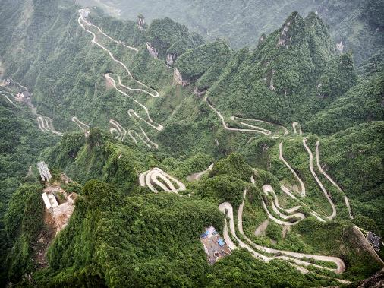**The Curriculum is the Progression Model**

The curriculum is a route planned across a subject’s landscape towards a given destination. The destination- the knowledge to succeed- can be the same, but the routes can be varied.