Mars-Term 3 Creative Curriculum: How did a pile of dragon bones help to solve an Ancient Chinese mystery? 2024/2025
Topic: History enquiry - How did a pile of dragon bones help to solve an Ancient Chinese mystery?
Describe and explain the historical significance of the bones bought by Wang Yirong in Peking in 1899
Explain the significance of oracle bones to Shang rulers and how they might have been used, justifying their decision
Identify, describe and compare and contrast the lives of people in different sections of Shang society and explain why our understanding is very limited one
Recognise, describe and justify the qualities they feel are required in a great ruler and compare and contrast these with those exhibited during the reigns of King Cheng Tang and Di Xin of the Shang Dynasty
Make a reasoned judgment from the evidence of tomb artefacts about the identity of the occupant of a Shang burial chamber
Application of skills & processes:

Recognise Identify Describe Empathise Synthesis Explain
Observe Select Categorise Evaluate Reach informed conclusions Hypothesise
Classify Apply Sequence Compare & contrast Make reasoned judgements
Recall Justify Summarise Reason/speculate Demonstrate understanding Critique

Literacy:

L.O: To revise word classes. To explore the rhyme structure of a poem.

Text: The Most Dangerous Animal in the World by Valarie Bloom

Class write of first 6 plot points in The Nowhere Emporium by Ross McKenzie

Text: The Nowhere Emporium by Ross McKenzie

Art/DT:

William Morris
looking at the artist William Morris and creating a motif or decorative design inspired by nature. investigate Morris’s artwork, practising the patterns of natural things forms around us. Designing a motif in the style of Morris which can then be printed
SPaG -
identify adverbials both within and at the front of sentences!
Discuss adverbials in own and others’ writing.
Find all the determiners in a given sentence!
identify preposition phrases in sentences, including prepositions of place and time.
Identify statements when reading cross curricular texts
Identify the verb forms of a challenging extract which may mix forms.
Computing - taught: Webpage creation and design

To review an existing website and consider its structure
To plan the features of a web page
To consider the ownership and use of images
(copyright)
Recognise the need to preview pages
To outline the need for a navigation path

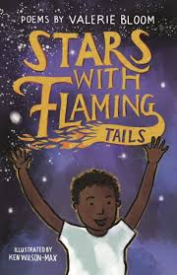
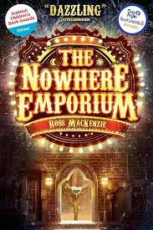
R.E: - If God is everywhere, why go to
a place of worship?
Make connections between how believers feel about places of worship in different traditions.
Select and describe the most important functions of a place of worship for the community.
Give examples of how places of worship support believers in difficult times, explaining why this matters to believers
Present ideas about the importance of people in a place of worship rather than the place itself.

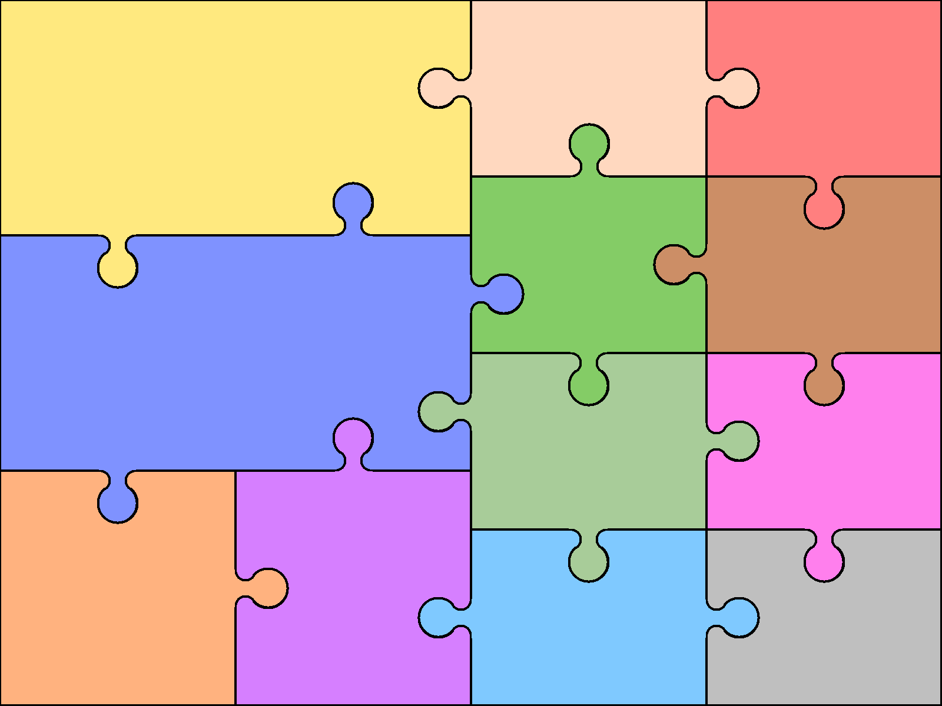  Numeracy  Fractions  Compare and order fractions.  Add and subtract fractions.  Add to a mixed number.  Add two mixed numbers.  Subtract fractions.  Subtract from a mixed number.  Multiply a unit and non unity fraction by an integer  Multiply a mixed number by an integer  Calculate a fraction of a quantity  Fraction of an amount  Use fractions as operators  Multiplication and Division  Multiply up to a 4-digit number by a 1-digit number.  Multiply a 2-digit number by a 2-digit number (area model)  Multiply up to 4-digit number by a 2-digit number.  Short division  Divide a 4-digit by a 1-digit number inc. remainders.  Efficient division  Solve problems with multiplication and division. | Numeracy - Reasoning  Reasoning is the catalyst for the teaching of maths. A key skill in becoming fully numerate (and to becoming an independent thinker) is the ability to make your own decisions and learn from them.  This key skill is central to the children’s math’s learning and a chance to allow learners to choose their own methods and ways of recording, then present their findings in whichever way they decide. Learners are encouraged to explain their reasoning, thus extending the understanding and their ability to communicate, numerically. |  |  | Science- Forces  Forces:  * Explain gravity  * Identify the effects of air resistance  * Identify the effects of water resistance  * Identify the effects of friction  * Recognise that some mechanisms allow a smaller force to have a greater effect  Languages: Spanish Languagenut  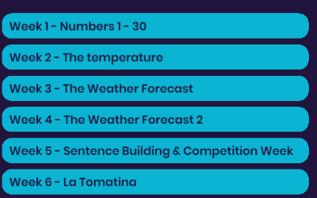 | Physical Education  Gymnastics  Investigate the language of gymnastics. Work in groups to create paired and group balances looking at counter tension and counter- balance. Create routines by putting balances and movements together.  Swimming at Sevenoaks Leisure Centre – to be able to swim 25metres of a recognised stroke for one whole length  Music - percussion  - Identify/recognise pitch, rhythm, dynamics  • Imitate / Explore / Experiment  • Describe sounds using: language, movement symbols (pictures, drawings, notation)  • Investigate hoe the sound is made  • Investigate musical concepts (loud, long, quiet etc)  • Discover world music  • compose pieces

