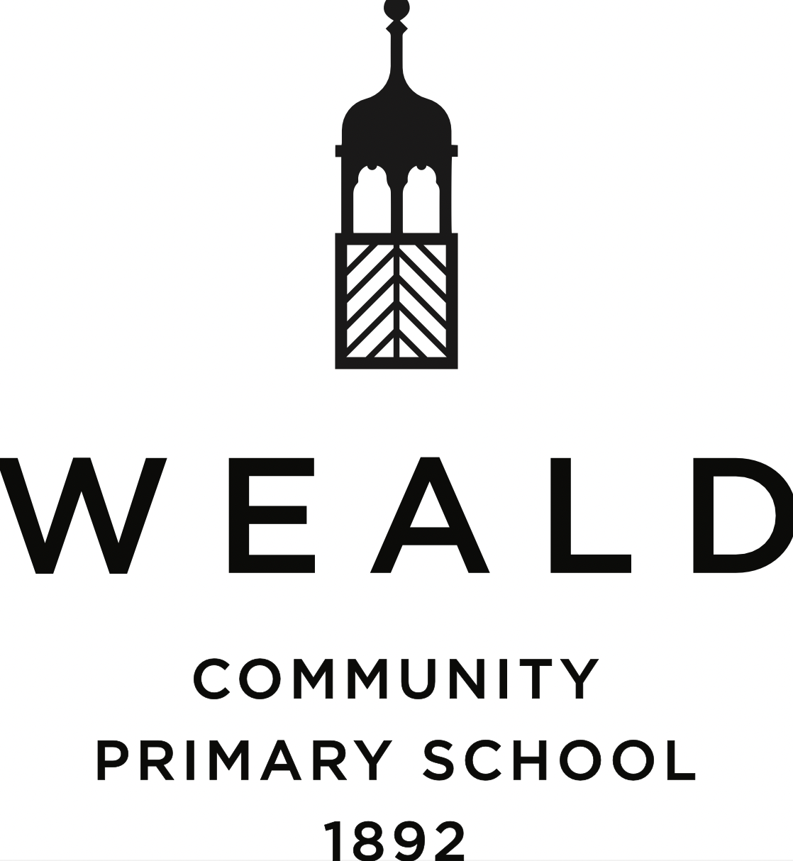

EYFS Policy
(including EYFS Behaviour)

Date written: July 2024
Date ratified by L and D team: November 2024

Date of next review: Autumn 2025

Contents
1. Aims 2
2. Legislation 2
3. Structure of the EYFS 2
4. Curriculum 2
5. Assessment 3
6. Working with parents 3
7. Safeguarding and welfare procedures 3
8. Monitoring arrangements 3
Appendix 1. List of statutory policies and procedures for the EYFS 4
Appendix 2. EYFS Behaviour Policy 4

1. Aims
This policy aims to ensure:
- That children access a broad and balanced curriculum that gives them the broad range of knowledge and skills needed for good progress through school and life
- Quality and consistency in teaching and learning so that every child makes good progress unique to their own starting points
- A close working partnership between staff and parents and/or carers
- Every child is included and supported through equality of opportunity and anti-discriminatory practice

2. Legislation
This policy is based on requirements set out in the 2021 statutory framework for the Early Years Foundation Stage (EYFS).

3. Structure of the EYFS
EYFS includes children from the September term after they turn 4.

4. Curriculum
Our early years setting follows the curriculum as outlined in the 2021 EYFS statutory framework.
The EYFS framework includes 7 areas of learning and development that are equally important and inter-connected. However, 3 areas known as the prime areas are seen as particularly important for igniting curiosity and enthusiasm for learning, and for building children’s capacity to learn, form relationships and thrive.
The prime areas are:
- Communication and language
- Physical development
- Personal, social and emotional development
The prime areas are strengthened and applied through 4 specific areas:
- Literacy
- Mathematics
- Understanding the world
- Expressive arts and design

We promote high engagement through high quality planning based on our observation of children’s needs, interests, and stages of development across the seven areas of learning. We recognise play as being an essential part of our curriculum and ensure we have a good balance of teacher-led and child-led learning. The needs of the children and learning styles are encouraged by using both the indoor and outdoor classroom equally. All resources are displayed on open shelving units so they are accessible at all times so the children can choose where to go, what to use and how. All early years’ staff will have a good understanding of how young children learn and develop and will recognise that learning can take place at all times of the day. These opportunities will be encouraged and extended by using high-quality questioning and modelling. We highly value parents as children’s first educators and recognise the importance of parents being involved with children’s learning. This is done through a bi-weekly newsletter and our learning journal ‘Tapestry’.

5. Assessment
At Weald CPS, ongoing assessment is an integral part of the learning and development processes. Staff observe pupils to identify their level of achievement, interests and learning styles. These observations are used to shape future planning. Staff also take into account observations shared by parents and/or carers.
Within the first 6 weeks that a child starts reception, staff will administer the Reception Baseline Assessment (RBA).
At the end of the EYFS, staff complete the EYFS profile for each child. Pupils are assessed against the 17 early learning goals, indicating whether they are:
- Meeting expected levels of development
- Not yet reaching expected levels (‘emerging’)
The profile reflects ongoing observations, and discussions with parents and/or carers. The results of the profile are shared with parents and/or carers for their child at the end of the academic year.
The profile is moderated internally (referring to the Development Matters guidance) and in partnership with other local schools, to ensure consistent assessment judgements. EYFS profile data is submitted to the local authority.

6. Working with parents
We recognise that children learn and develop well when there is a strong partnership between staff and parents and/or carers.
Parents and/or carers are kept up to date with their child’s progress and development. Parent consultations, held twice a year, as well as ongoing feedback helps to provide parents and/or carers with a well-rounded picture of their child’s knowledge, understanding and abilities.

7. Safeguarding procedures
Our safeguarding procedures are outlined in our Child Protection Policy. Please see the school website.

8. Monitoring arrangements
This policy will be reviewed and approved by Mrs Shortall, the head of Early Years.
At every review, the policy will be shared with the governing body.

Appendix 1. List of statutory policies and procedures for the EYFS
Statutory policy or procedure for the EYFS | Where can it be found?
Safeguarding policy and procedures | See Child Protection Policy
Procedure for responding to illness | See Health and Safety Policy
Administering medicines policy | See Supporting Pupils with Medical Conditions Policy
Emergency evacuation procedure | See Health and Safety Policy
Procedure for checking the identity of visitors | See Child Protection Policy
Procedures for a parent failing to collect a child and for missing children | See Child Protection Policy
Procedure for dealing with concerns and complaints | See Complaints policy

Appendix 2. EYFS behaviour policy

At Weald CPS we believe that children flourish best when their personal, social and emotional needs are met and where there are clear, developmentally appropriate expectations for their behaviour. It is our belief that children should be free to play and learn without fear of being hurt or unfairly restricted by anyone else.
Aims:
- To maintain a behaviour policy which is supported and followed by all members of the school community: children, staff and parents/carers
- To create, through positive role-models and attitudes, a caring, family atmosphere in which teaching and learning can take place in a safe and happy environment
- To teach, through the Early Years Foundation Stage, values and attitudes as well as knowledge and skills. We aim to teach children to behave in socially acceptable ways and to understand the needs and rights of others.
- To promote and encourage good behaviour by providing a range of rewards for the children
- To make clear to children the range of sanctions that will follow misbehaviour
- To encourage consistent, collaborative and co-operative behaviour management between and across year groups
- To work in partnership with parents
We will meet these aims through the following procedures:
- We have a named person with responsibility for behaviour management and the delivery of the curriculum for Personal, Social and Emotional development in the Early Years Foundation Stage.
This is Mrs Kate Shortall
- We require all staff to provide a positive model of behaviour by treating children, parents/carers and each other with friendliness, care and courtesy.
- We recognise that codes for interacting with other people vary between cultures and require staff to be aware of and respect those used by members of the school family.
- We familiarise new staff with our Positive Behaviour Policy.
- We work in partnership with parents/carers, who are informed regularly about their child’s behaviour by their class teacher.
- We work with parents/carers to address recurring negative behaviour and decide jointly upon strategies to be implemented both at school and at home.
- Supporting children in developing self-esteem, confidence and feelings of competence and success.
- Supporting children in feeling a sense of belonging, so that they know they are valued and welcome within their class and school.
- Praising and promoting considerate behaviour such as kindness, willingness to share, and care for anyone who is hurt or upset.
- Helping the children to set guidelines for good behaviour.
- Providing activities and games that encourage co-operation and teamwork.
Rewards and sanctions:
The EYFS follows the same rewards (for positive behaviour) and sanctions (for negative behaviour) as stated in the school’s Positive Behaviour Policy.
Please refer to this for further information.
Class rules:
The EYFS follows different class rules from the rest of the school. This is to reflect the children’s development they will be going through during this part of their school journey.
The class rules are: Kind hands, kind feet, kind words.
These are displayed in the classroom and are regularly enforced to the children through carpet time and learning opportunities.

