Term | Autumn 1 | Autumn 2 | Spring 1 | Spring 2 | Summer 1 | Summer 2
 | All about me! | How did we get here? | Minibeasts | People who help us | Once upon a time | Hot and Cold
 | Where do I live? What do I look like? Who is in my family? Looking at our local community. | Space and transport | Animals and habitats | Our LOCAL COMMUNITY AND THEIR JOBS | Fairy tales and castles | Exploring hot and cold places
Main Theme Book | 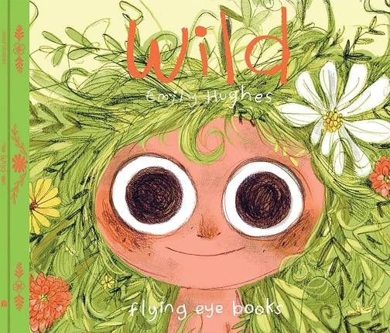 | 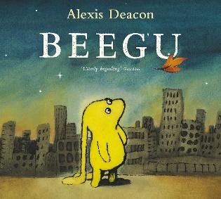  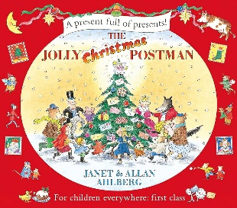 | 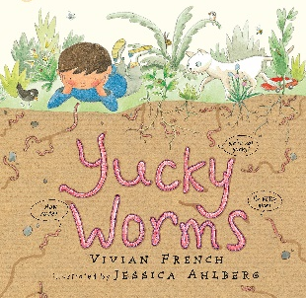  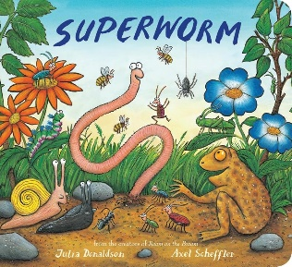 | 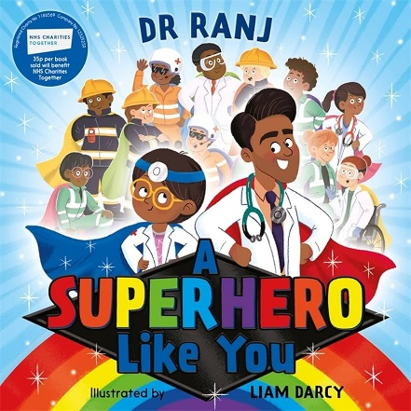 | 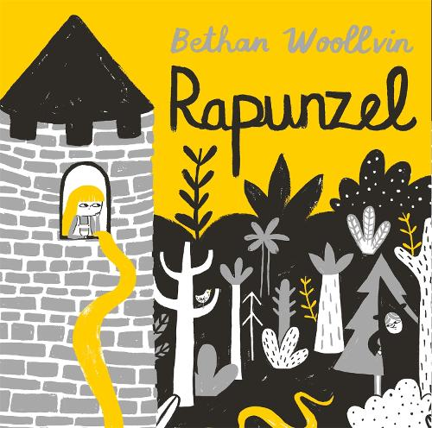  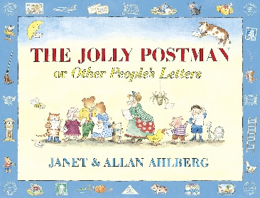 | 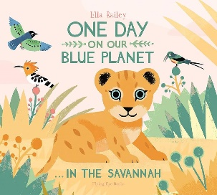  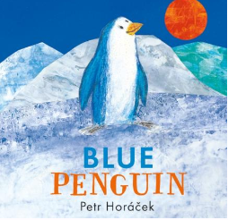
Season | September 22nd Autumn |  | December 21st winter | March 20th Spring |  | June 21st Summer begins
Literacy | Wild  Writing Outcomes  - Descriptive writing (use of adjectives)  - Generating opinions  - Responding to illustration and debate and argument  - Responding to the text  - Shared and group reading and writing  SPaG- Simple sentence structure, adjectives, full stops, capital letters and conjunctions. | Beegu  Writing Outcomes  - Responding to illustrations  - Interpreting the text  - Poetry  - Debating  - Writing for a purpose- how to write a letter  - Writing a description about the main characters  - conscience ally  SPaG- Plural noun suffixes, | Yucky Worms  Writing Outcomes  - Empathising with a character  - Poetry  - Emotive language  - Response to illustration  - Role Play  - Freeze Frame and Thought tracking  - Writing in role  SPaG- Expanded noun phrases, question marks, similes. | A Superhero Like You  Writing Outcomes  - Predicting  - Listen and respond to a story  - Adjectives  - Role play  - Persuasive writing  - Writing in first person  - Speech bubbles  SPaG Exclamation marks, speech marks, onomatopoeia, similes continued | Rapunzel/The Jolly Postman  Writing Outcomes  - Comparison  - Writing in role  - Re-writing a fairy tale  - Role Play  - Performing a fairy-tale  - Script writing  - Making predictions  - Expanded noun phrases to describe and specify  - Writing direct and reported speech.  - Editing  - Letter writing  SPaG- Prefixes | One day on our blue planet… In the Savannah  Writing Outcomes  - Empathising with a character  - Creating an informative poster  - Identifying features of non-fiction texts  - Writing a non-chronological report  - The use of verbs  - Editing work  - Exploring different types of sentence structures and when to use them  SPaG- Suffixes
Maths | Place Value: Number (Within 10); Number: Addition (within 10) | Addition and Subtraction (within 10) ; Shape | Number: Place Value (within 20); Number: Place Value (within 50); | Number; Place Value (multiples of 2,5 and 10); Measurement: Length and Height; Measurement: Weight and Volume | Number: Multiplication and Division (Reinforce Multiples of 2, 5 and 10 to be included); Fractions; Position and Direction; | Number: Place Value (within 100); Measurement: Money; Measurement: Time
Science | Human Senses  The children will revisit the five senses and will name body parts including recognising common structures between humans and other animals. | Space (solar system, the moon, gravity- design and create a rocket)/ Everyday materials (designing a space rocket)/ | Seasonal Changes (Autumn) (characteristics of materials)  Seasonal changes The children will learn about the four seasons and their associated weather, lean new vocabulary such as ever green and deciduous and learn about the science of day and night./Animals including humans (minibeasts) | Everyday materials  The children learn about materials their sources and their properties, including natural and human made. | Plant Parts  The children will learn about how seeds and bulbs grow and grow sunflowers. | Animals including humans-  Animal Parts The children will be revisiting their learning on the human senses and learn the names of the six animal groups (mammals, fish, amphibians, reptiles, birds and invertebrates).  Explore Mammals -Lions Case Study, food chains
Geography | Our Local Area-Human and Physical Geography and Place Knowledge  village, town, forest  Differences between Weald and London (village and a city) |  |  |  |  | Geographical Skills and Fieldwork and Human and Physical Geography  Use of a compass,
History |  | Apollo 11 and Neil Armstrong  Exploration into Apollo 11. What was it? When did it happen? Who is Neil Armstrong? What did he do?  Hi1/1.3 the lives of significant individuals in the past who have contributed to national and international achievements.  Hi1/1.2 events beyond living memory that are significant nationally or globally
RE | What does it mean to belong to a faith community? | Who is a Christian? How and why do we celebrate sacred times? | Who is a Muslim and what do they believe? | Who is Jewish and what do they believe? | What makes some places sacred? | How should be care for others and the world?
Art |  | Designing your own planet – papier mâché and mod roc. | Jackson Pollock, leaf rubbings, line and form |  |  | Creating a watercolour of the rainforest, printing
DT |  |  |  |  |  | Design and create a boat/create a new home for the orangutan/ create a model of the rainforest using junk modelling (shoeboxes will be required)
Music |  | Explore beat, pulse, heartbeat of the music, learning and performing songs.  Everyday songs for transitions and using our voices expressively. | Nursery rhymes: use their voices expressively and creatively by singing songs and speaking chants and rhymes |  |  | Ocarina: playing together: play tuned and untuned instruments musically
PE | BEAM | BEAM | Dance | Games- sending and receiving | Gymnastics  Skills:  - travelling,  - turning,  - holding position,  - balancing,  - floor and apparatus,  - push and pull actions,  - rocking on differing body parts,  - rolling,  - jumping patterns and on apparatus,  - combine travelling, balance and jumping on floor and apparatus. | Athletics: sports day practice  Skills:  - health and fitness,  - running (vary pace and speed, basic technique spring and jog in a straight line and change direction),  - jumping (different types of jumping, jump as high as possible and as far as possible),  - throwing (underarm, overarm with accuracy at a target),  - perform learnt skills with control, watch and describe classmates and suggest improvements.
Computing | Technology in our Classroom | Using Computer Technology | Developing Mouse Skills | Using a computing keyboard | Developing keyboard skills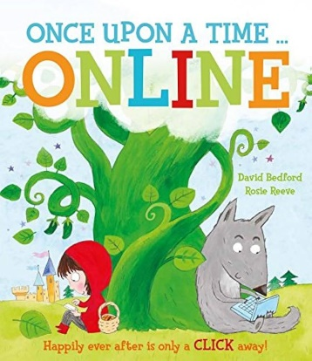 | Using a computer responsibly
Forest School |  |  | Leaf rubbing, making wormeries

https://thenational.academy/teachers/programmes/english-primary-ks1/units/a-superhero-like-you-reading-and-writing/lessons

spring 2 literacy: https://www.thenational.academy/teachers/programmes/english-primary-ks1/units/a-superhero-like-you-reading-and-writing/lessons/exploring-the-idea-of-a-superhero-and-predicting#slide-deck

