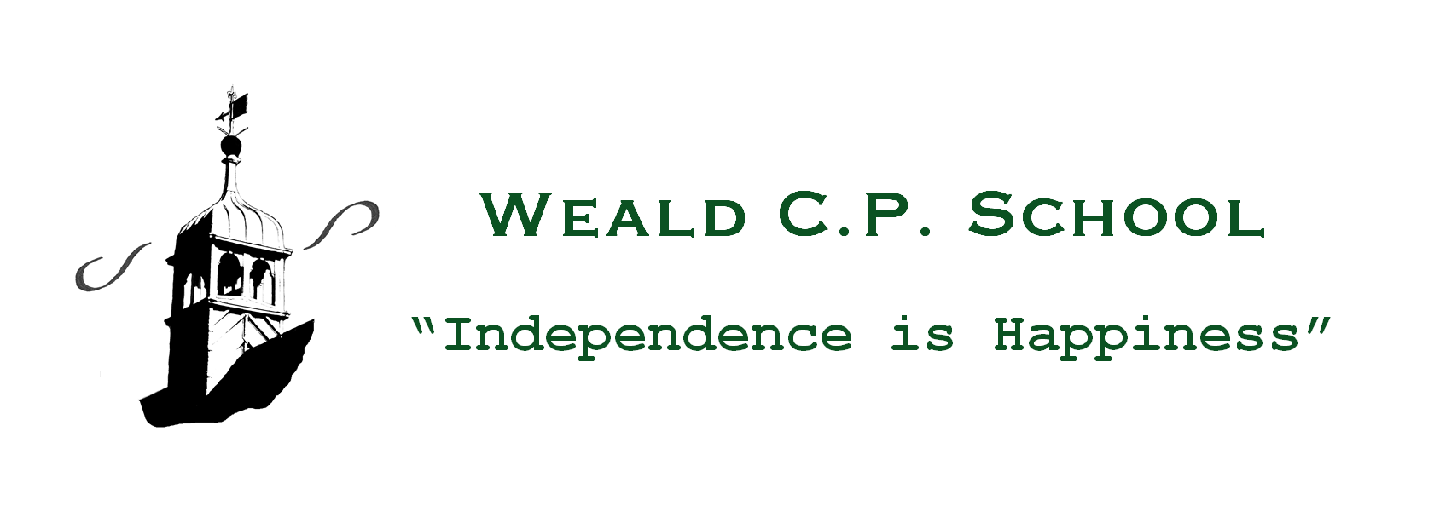
Sex & Relationships Education Policy

Context/Introduction
“All schools must have an up to date SRE policy which is made available for inspection and to parents. The policy must:

- Define sex and relationship education;
- Describe how sex and relationship education is provided and who is responsible for providing it;
- Say how sex and relationship education is monitored and evaluated;
- Include information about parents’ right to withdrawal; and
- Be reviewed regularly”

Sex and Relationship Education Guidance (DfEE 0116/2000)

Sex and relationship education is lifelong learning about physical, moral and emotional development. It is about the understanding of the importance of loving and caring relationships. It is about the teaching of sex, sexuality and sexual health.
Research demonstrates that good, comprehensive sex and relationship education does not make young people more likely to become sexually active at a younger age.

Weald CPS
- Geography: located in a suburbanised village on the outskirts of Sevenoaks, Kent
- Age range: 5-11; co-educational, 157 on roll
- Religious, cultural, ethnic mix of pupils: predominantly, white, middle to high income families; Christian.
- Special educational needs, disabilities: no statemented children and generally low %s of SEN
- Health and social needs = minimal and number of Pupil Premium children = low.

Moral and Values Framework

Sex and relationship education will reflect the values of the PSHE and Citizenship programme. SRE will be taught in the context of relationships.
In addition SRE will promote self esteem and emotional health and well-being and help children form and maintain worthwhile and satisfying relationships, based on respect for themselves and for others, at home, school, work and in the community.

Process for Policy development
The policy has been developed in consultation with pupils, parents/carers, teaching-non teaching staff, governors, school health staff and other relevant agencies.
Methods of consultation included, auditing existing provision in order to develop, implement, monitor and evaluate the curriculum.
A parents’ meeting is held annually to provide an opportunity to share the policy with parents.

Aims and Objectives for Sex and Relationship Education
The aim of SRE is to provide children with age appropriate information, explore attitudes and values and develop skills in order to empower them to make positive decisions about their health related behaviour.
This should take place with consideration of the qualities of relationships within families.

The objectives of Sex and Relationship Education are;

- To provide the knowledge and information to which all pupils are entitled
- To clarify/reinforce existing knowledge
- To raise pupils’ self esteem and confidence, especially in their relationships with others;
- To help pupils understand their sexual feelings and behaviour, so they can lead fulfilling and enjoyable lives;
- To help pupils’ develop skills (language, decision making, choice, assertiveness) and make the most of their abilities.
- To provide the confidence to be participating members of society and to value themselves and others;
- To help gain access to information and support
- To develop skills for a healthier safer lifestyle
- To develop and use communication skills and assertiveness skills to cope with the influences of their peers and the media
- To respect and care for their bodies
- To be prepared for puberty and adulthood

The teaching programme for Sex and Relationship Education

Legal requirements
All schools must teach the following as part of the National Curriculum Science Orders. Parents do not have the right to withdraw their child/children.

National Curriculum Science

Key Stage 1
- that animals including humans, move, feed, grow, and use their senses and reproduce.
- a) to recognise and compare the main external parts of the bodies.
b) that humans and animals can reproduce offspring and these grow into adults.
- to recognise similarities and differences between themselves and others
- treat others with sensitivity.

Key Stage 2
- that the life processes common to humans and other animals include nutrition,
growth and reproduction.
- about the main stages of the human life cycle.

Every child is entitled to receive SRE regardless of ethnicity, gender, religion, age, culture, disability, sexuality, language specials needs, disadvantaged and looked after children.

It is our intention all children have the opportunity to experience a programme of SRE at a level which is appropriate for their age and physical development with differentiated provision if required.

Such a programme can successfully follow the outline given below;

Foundation
Children learn about the concept of male and female and about young animals. In ongoing PSHE work, they develop skills to form friendships and think about relationships with others.

Key Stage 1
Through work in Science, children learn about life cycles of some animals, understand the idea of growing from young to old and learn that all living things reproduce. They learn about the importance of personal hygiene to maintain good health. In RE and Citizenship children reflect on family relationships, different family groups and friendship. They learn about rituals and traditions associated with birth, marriage and death and talk about the emotions involved.
They begin to co-operate with others in work and play and begin to recognise the range of human emotions and ways to deal with them.
They also learn about personal safety.

Key Stage 2
In Science children build on their knowledge of life cycles and learn about the basic biology of human reproduction including birth of a baby in years 5 & 6.
Children are taught about the physical, emotional and social changes at puberty, which include personal hygiene. In RE and Citizenship, they continue to develop an understanding of relationships within a family, between friends and the community and that there are different patterns of friendship. They will develop skills needed to form relationships and to respect other people’s emotions and feelings. They will consider how to make simple choices and exercise some basic techniques for resisting pressures.
Sex and relationship education should focus on the development of skills and attitudes not just the acquisition of knowledge.

This content has been agreed in consultation with governors, parents and teaching staff.

The organisation of Sex and Relationship Education

Mrs Cutbush is the designated teacher with responsibility for coordinating sex and relationship education.

Sex and relationship education is delivered through Science, RE, PSHE, Citizenship, literacy activities and Circle Time. Sex and relationship education is taught by classroom teachers, teaching assistants and if appropriate, outside visitors such as the school nurse.

A range of teaching methods are used to teach sex and relationship education. These include use of video, discussion, looking at case studies, drama and role-play.

Sex and relationship education is usually delivered in mixed gender groups; however, there may be occasions where single gender groups are more appropriate and relevant.

Resources to teach sex and relationship education include fiction, reference books, leaflets and extracts from videos.
Channel 4 Living and Growing video Unit 1, 2 & 3 plus work books.
Unit 1 5-7yrs Differences / How did I get Here? / Growing up
Unit 2 7-9 yrs Changes / How babies are made / How babies are born
Unit 3 9-11yrs Girl talk / Boy talk / Let’s talk about sex
Available from 4 Learning, PO Box 400 Wetherby LS23 7LG Tel 08701 246444

Sex and relationship education is monitored and evaluated by the leadership team as part of the school’s development plan. As a result of this process, changes will be made to the sex and relationship education programmes as appropriate.

Specific Issues

- Parental consultation
The school includes information on sex and relationship education in the school prospectus and full details are available on request.
The school informs parents when aspects of the sex and relationship programme are taught and provides opportunities for parents to view the videos and resources being used.
Parents have the right to withdraw their children from those aspects of sex and relationship education, not included in the National Curriculum Science Orders. Alternative work should be set.
However, this rarely happens; by working in partnership with parents, they recognise the importance of this aspect of their child’s education.

- Child protection / confidentiality
Teachers need to be aware that effective sex and relationship education, which brings an understanding of what is and is not acceptable in a relationship, may lead to disclosure of a child protection issue.
The staff member will inform the Head Teacher /Designated Child Protection person in line with the LA procedures for child protection.
A member of staff cannot promise confidentiality if concerns exist.

- Links with other policies
This policy is linked with the following policies:
PSHE & Citizenship
Equal Opportunities
Child Protection
Behaviour
Anti Bullying

- Dealing with difficult questions
Ground rules are essential to provide an agreed structure to answering sensitive or difficult questions. The use of an anonymous question box, as a distancing technique, may be useful for pupils who do not wish to be identified.

Teachers will endeavour to answer questions as honestly as possible but if faced with a question they do not feel comfortable answering within the classroom, provision would be made to meet the individual child’s needs.

- Use of visitors
“Visitors should complement but never substitute or replace planned provision. It is the PSHE co-ordinator’s and teacher’s responsibility to plan the curriculum and lessons.” Sex and Relationship Guidance DfEE 0116/2000 P 29 6.11

When appropriate, visitors such as the school nurse may be involved in the
delivery of sex and relationship education, particularly in Key Stage 2.

- Children with special needs
Teaching and resources will be differentiated as appropriate to address the needs of these children in order for them to have full access to the content of sex and relationship education.

Monitoring and Evaluation

Monitoring is the responsibility of the Headteacher and teacher with responsibility for sex and relationship education.

The school will assess the effectiveness of the aims, content, and methods in promoting students’ learning by lesson observation, sampling teachers planning, questionnaires to teachers and children and feedback from parents.

The effectiveness of the SRE programme will be evaluated by assessing children’s learning and implementing change if required.

SRE issues will be included in the induction programme for all new members of staff.

Reviewed: March 2023

To be reviewed: March 2025

