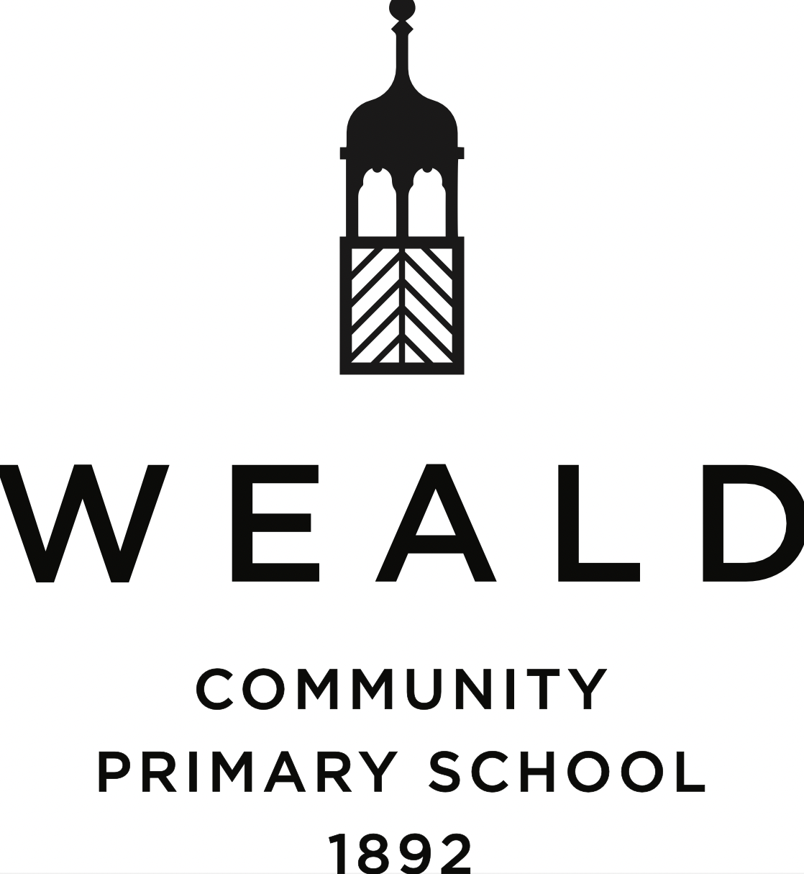

Curriculum Statement

Date written: September 2023

Date of next review: September 2024

It is our belief that every pupil who enters our school community should be valued and nurtured, challenged and inspired. Underpinning the development of the curriculum are the philosophical approaches and practices of Character Education: see ‘Character through Schools’ and Global Learning based upon the school’s ‘Connecting Schools’ Expert Centre status.

We aim to develop individuals, through good teaching and encouragement, to reach their full potential academically, socially and emotionally against the background of a broad, balanced and differentiated curriculum. In all school activities, we aim to promote independence, respect for learning, consideration for others, and self-esteem.
We recognise that every child has a different knowledge base and skill set, as well as varying aptitudes and aspirations; and that, as a result, there is a determination for every child’s needs to be assessed and their talents developed through diverse teaching strategies. Therefore, we seek to develop the full potential of every pupil outside the classroom in physical, creative, and cultural pursuits, including new technology.

The curriculum offered at Weald CP School is broad, balanced and
challenging. It is designed to give a good grounding from the Early Years, not only in reading, writing and mathematics but also in science, design technology, ICT, social sciences/humanities and the creative arts. We consider PE, sport, drama, music & dance as critical components of creativity, teamwork and the building of character qualities such as fortitude, communication and sense of fair play.

Curricular content is based upon the National Curriculum, particularly with respect to literacy, numeracy and science. Grouping in maths and English further differentiates the curriculum. This begins in Reception and allows children to progress at a pace which is conducive to their optimal learning.

Curriculum aims

Through personalisation of the educational offer, we strive to match learning tasks to appropriate levels of ability and attainment so that all children can gain a sense of achievement and pleasure from their learning.

To this end, we aim to help our children:

- Use language and numbers effectively and with understanding;
- Develop a critical understanding and respect for the environment and world in which they live and an awareness of the interdependence of individuals, groups and nations;
- Develop lively, enquiring minds, the ability to ask questions, solve problems, argue rationally and apply themselves to tasks;
- Develop self-awareness, a sense of self-respect, and a willingness to be self-motivated and contribute to the school community and the wider society;
- Develop a respect for other people, acknowledging that the differences in their abilities, background, and beliefs bring richness into our own lives;
- Gain pleasure from joining with others in games and outdoor activities and develop the social skills needed to live and work co-operatively.

Implementation of curriculum aims

The class teachers will be responsible for the broad spread of teaching at Key Stage One and Two; however, from Year Three upwards, the school operates a specialist teaching model which seeks to enrich learning and reduce teacher workload through the utilisation of teachers’ areas of interest, knowledge, experience and skill.

Within this framework, our aims are fulfilled in the following ways:
• All children embrace the challenge of writing in different genres and continue to build their confidence in speaking and listening activities.
• Maths provides all children with the opportunity for developing their numerical skills and investigative work.
• From the acquisition of key skills, we encourage our children to develop as active learners with lively and enquiring minds, the ability to ask questions, solve problems, argue rationally and apply themselves to tasks.
• Increasingly, ICT is employed in our teaching and learning across the school.
• In the wider world, the environment, human achievements and aspirations, self-awareness and self-motivation and awareness of others feature significantly through the teaching of Geography, Science, History, PSHE and RE.
• The teaching of Modern Foreign Languages is an integral part of our curriculum.
• A passion for the Arts is also developed through our teaching of Music, Dance and Art.
• There is a strong emphasis on PE & sport, enabling all children to enjoy participation in a wide range of individual and team sports. A full programme of sporting competition is available to children.

Curriculum planning

To be effective, teaching and learning must be planned.
Planning incorporates EYFS, the National Curriculum and Character Education.
Children take the National Curriculum SATs tests at the end of Key Stage One and Key Stage Two. Tests are marked internally at Key Stage One and externally at Key Stage Two.

Reception follows the DfE Curriculum Guidance for the Early Years Foundation Stage.
• Communication & language;
• Physical development;
• Personal, social & emotional development;
• Literacy;
• Mathematics;
• Understanding the world;
- Expressive arts & design.

From Year One to Year Six, the curriculum consists of the National Curriculum; each subject has a policy and action plan which outlines the intent, implementation and impact of the programmes of study. These are amplified through each year group’s medium-term plans (published six times per year).

From Foundation Stage through to Year 6, opportunities will be taken to extend the curriculum beyond the statutory requirements through:
• visitors, including artists, authors, actors, musicians; scientists etc
• the use of the school grounds, the locality and the wider environment (outdoor learning
• educational visits including residential trips from Year 3 upwards.;
• support of parents.

Many of these activities will embrace the cultural diversity of the society in which we live and enhance the aesthetic environment of the school.

Coverage & time allocation

Currently, each lesson is approximately one hour in length and the expected provision is as follows:

Maths X 5 including Mental Maths
English/ Writing X 4
SPAG X 1
Reading X 1
Science X 2
PSHE/RE/ Character X 1
Modern Foreign Languages X 1
Humanities – History/ Geography X 1
PE/Sport X 2
Music X 1
Art/DT X 1
ICT X 1
Outdoor Learning X 1

22 lessons

The curriculum coverage and allocation of time for the delivery of the various subjects is an on-going developmental process and the overall balance will be reviewed each year and adjusted according to children’s needs.

Reviewed: September 2023

To be reviewed: September 2024

