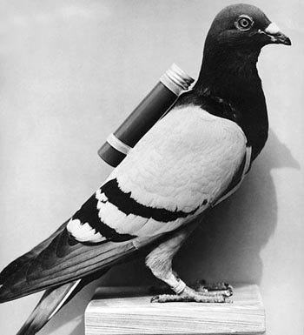
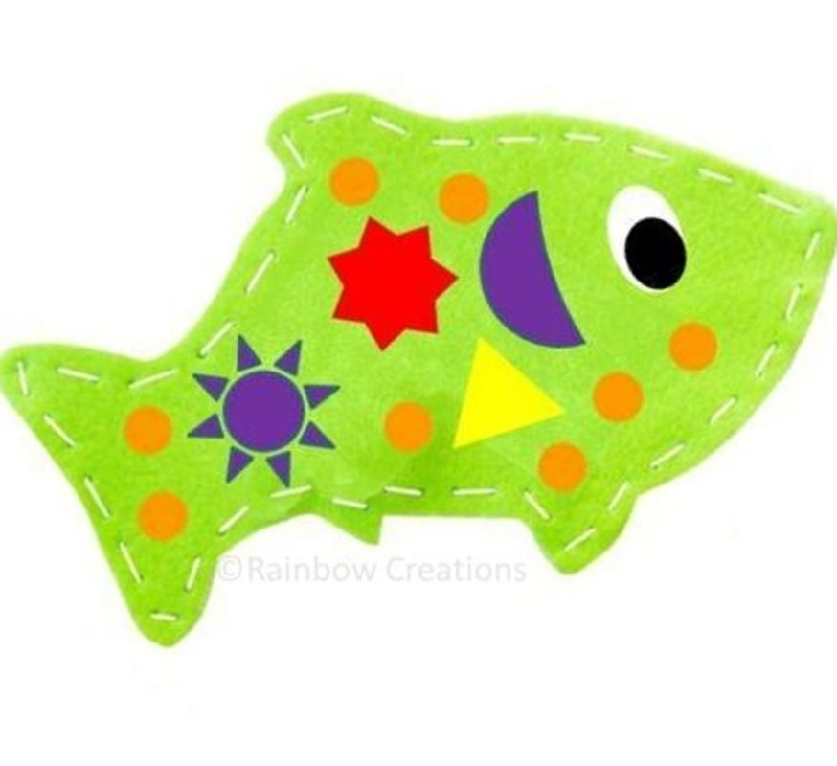
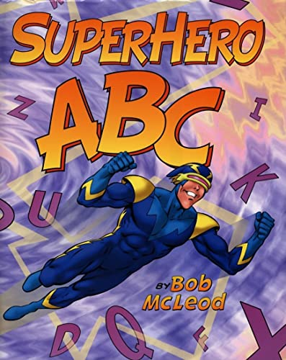
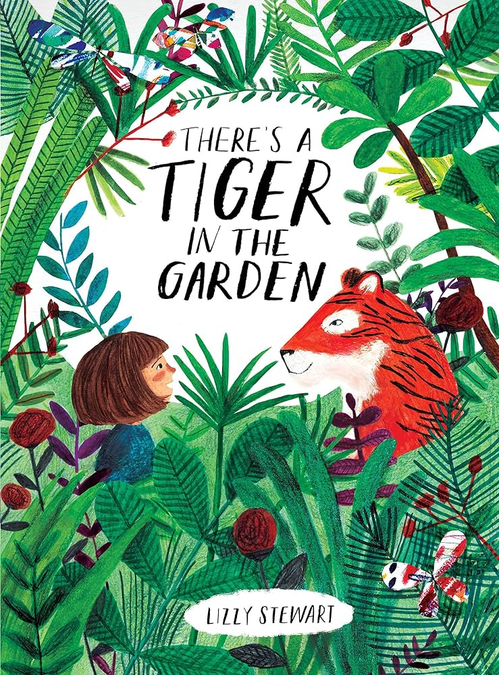
Creative Curriculum: World War One Mercury-Term 5 2023/2024
History:
Why was Charles sent to prison?
Why were messenger pigeons so important during WW1?
Why were messages sent by pigeon always in code?
How did children know a war was happening in 1916?
Why were horses very important during WW1?
Application of skills & processes:
Recognise Identify Describe Empathise
Observe Select Categorise Reach informed conclusions
Classify Sequence Compare & contrast Make reasoned judgements
Recall Summarise Reason/speculate Critique
Synthesise Explain Hypothesise Demonstrate understanding
Justify Apply Evaluate

Literacy:
Superhero Stories
Superheroes ABC by Bob McLeod
Draw & write captions, reading comprehension, create a superhero & describe it, identify opposites, write comparative sentences, complete a superhero ID form, act out dialogue, write speech bubbles for dialogue, create a comic book strip
Information Texts: Comparing Non-Fiction & Fiction
There’s a Tiger in the Garden by Lizzy Stewart
Use imagination to add ideas to a story, identify ideas that are actual & those that are imaginary, write facts, use question headings to sort facts, look at similarities & differences between animals, alliterative descriptions, make predictions, factual or fictional sentences, write questions, create an information poster, write factual labels & captions
Art/DT:

SPAG:
Punctuation sentences (. ! ?)
Noun suffixes -es
Exclamation marks
Capital letters for names of people & places
Writing question sentences
ICT:
Creating Media: Digital Writing
Exploring the keyboard
Adding & removing text
Exploring the toolbar
Making changes to text

R.E:
Who is Jewish & what do they believe?
Weaving & sewing

  Numeracy:  Number  Multiplication & Division  Count in 2s, 5s & 10s Recognise & add equal groups Make arrays & doubles Make equal groups-grouping & sharing  Fractions  Recognise & find half of an object, shape or quantity Recognise & find quarter of an object, shape or quantity | Phonics:  Review Set 2 Sounds  In particular: ar, or, air, ir, ou, oy Build speed of reading words containing ay, ee, igh, ow, oo, oo  Common exception words  were, was, come, do, to, his, has, there, go, my, me  Set 3 Sounds  ea, oi, a-e, i-e, o-u, u-e, e-e  Read all set 2 sounds speedily. Read nonsense words containing set 2 sounds. |  |  | Science:  Plants: Different plants & their parts  What’s growing outside?  Labelling parts of a plant  Growing potatoes  What is inside a flower & tree?  What lives in the garden?  Application of skills:  Plan enquires  Take measurements  Record data  Make predictions  Report & present findings  Identify scientific evidence | P.E:  Racket Skills  Send & retrieve, fielding, batting  Dance  Movement, rhythm, shape
 |  |  |  | Languages:  Spanish:  Family members  Key vocabulary:  Madre: Mother Padre: Father Abuela: grandmother  Abuelo: Grandfather Hermana: Sister  Hermano: Brother Tia: Aunt Tio: Uncle | Music:  Exploring pitch  Recognising changes in pitch & copying simple pitch patterns  Performing simple melodic patterns using voices & pitched instruments

