Outdoor Education: Policy & Practice
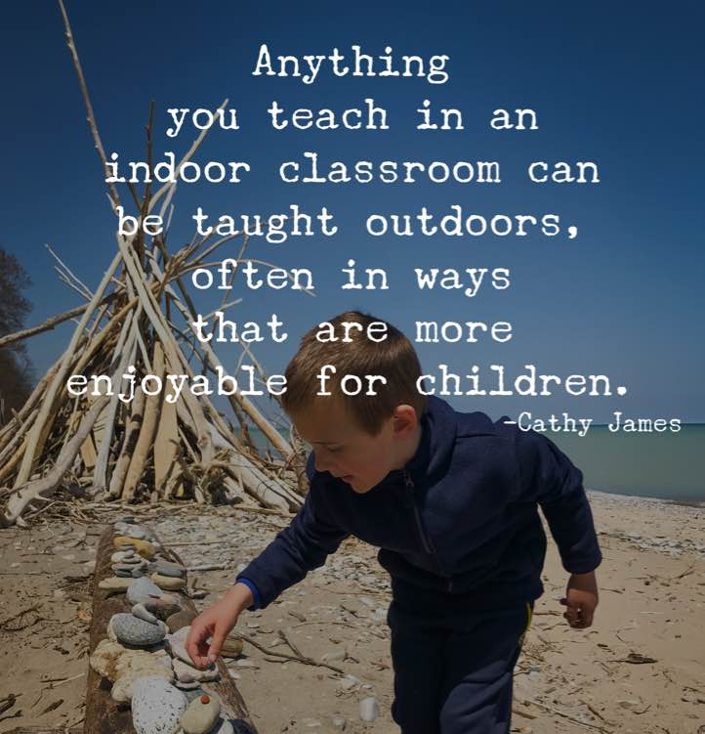

Introduction

Outdoor learning is a broad term that includes outdoor play in the Early Years, school grounds projects, environmental education, adventurous activities, personal and social education, team building, education for sustainability and much more. Outdoor learning does not have a clearly defined boundary, but it does have a common core, using the outdoor environment to enrich the teaching and learning of others.

At Weald, we are predominantly interested in the actions of a Forest School education and how we can integrate this with the everyday curriculum. For example, outdoor learning can spark greater creativity for pupils in English. Students’ imaginations can be fired and first-hand experiences can be provided as a basis for writing. Stories based in the woodland, using artefacts and natural objects are all hooks to engage children and get them enthused about their learning experiences.

Equally, in Maths, being outdoors is useful for making abstract concepts real. The experiential and hands-on nature of outdoor learning experiences makes the curriculum come alive for pupils.

Character Education
Impacts on learning outcomes such as social skills, engagement, confidence and self-esteem is linked with outdoor education. Outdoor learning is reported as supporting features of Character Education. The value of confidence in successful learning has been highlighted for years. Being outside leads children to have greater confidence in their own abilities, sometimes through taking more risks, so they are willing to try different challenges within and outside the classroom.
Outdoor learning has also been seen to encourage and develop social skills, communication, teamwork, new friendships, kindness and leadership. It consistently enthuses and motivates children, resulting in greater engagement with learning. If engagement is achieved, attainment will be increased as children will be interested and focussed on what is presented to them.
The opportunity to develop key character skills as well as taking ownership in their learning in contexts outside the classroom also contributes to improved behaviour. Studies have shown enjoyment of fresh air, new experiences and a practical context are all important to children and their conduct around school.

The character qualities which will engender high quality learning are:
Curiosity; Enthusiasm; Social Intelligence; Teamwork; Resourcefulness; Respect; Empathy and Responsibility.

Accountability

This policy outlines the learning, teaching, organisation and management of Outdoor learning at Weald CPS. The implementation of this policy is the responsibility of all teaching staff.

The role of the Outdoor Education Team is to:

- Support colleagues in teaching the subject content and developing their skills in planning, teaching and assessing
- Update and oversee the audit of resources needed to deliver the curriculum.
- Monitor progression and evaluate the impact of the learning and teaching
- Review regularly the curriculum content and pedagogy
- Keep up to date with developments in the teaching and assessment

Aims and Intent
Here at Weald, we truly believe that learning outdoors can be the educational context which encourages children and young people to make connections experientially, leading to deeper understanding within and between curriculum areas and meeting learner needs.
Outdoor learning, used in a range of ways, will enrich the curriculum and make learning fun, meaningful and relevant for children and young people. Outdoor learning can deliver sustainable development education through initiatives such as working to improve biodiversity in the school grounds and engaging with the local community.
As part of our school vision (independence is happiness), we have decided to expand and enhance the breadth of our curriculum by incorporating a designated outdoor learning and Forest School curriculum that will become part of our weekly routine. It is our aim that this new LOtC (Learning Outside the Classroom) will uphold the high standards and expectations that our school sets for its pupils and serve as a cornerstone to increasing their life skills and experiences throughout their primary school education.
The primary aims of this curriculum will be:
- To build self-esteem and confidence in children.
- To build resilient, determined and independent learners
- To develop children’s personal, social and emotional development.
- To develop children’s and encourage creativity
- To encourage collaboration.
- To develop and build the ideas of risk management and risk benefit
- To improve children’s life skills and experiences
- To enable children to gain a respect for the natural environment and wildlife.
- To transfer negative behaviours into positive ones.
- To let children be children

These aims will be covered with a variety of Forest Schools and outdoor learning teachings and strategies that not only seek to aid the children in their learning but also be provided in a positive, enjoyable, creative and inspiring manner that will allow them to transfer the skills and knowledge from the LOtC lessons into the classroom and life outside of school.
Implementation
To ensure that this LOtC curriculum reaches the high standards of teaching and learning that we pride ourselves on at Weald, weekly timetable lessons will be incorporated into the curriculum for teaches to take the children outside. Forest school is a globally recognised teaching system that aims to meet the intent of this curriculum through holistic learning. It is through this method that we strive to provide our pupils with the widest range of skills and opportunities available to us. Due to its child led nature and focus on social development, Forest School engages children in a manner that is hard to imitate in the classroom. This creates new opportunities for learning and development that might not be accessed during regular day-to-day schooling. As we know, every child is different, as are their learning habits, something that here at Weald we recognise, encourage and utilise. At Weald, we are blessed with a beautiful outdoors learning environment ranging from the grounds top playground and jungle gym, to the Muga and designated forest school area. It is here the majority of the learning will take place but it is our aim to also expand our outdoor learning into the wider community and environment to give the children a wider range of experience and allow them to become more familiar with the world surrounding them.
Impact
The intended impact is fundamentally that we want them to be inspired by the Outdoors and develop a passion for learning through and about nature, to appreciate the space and calm; and to discuss and expand their learning through using the outdoor environment.
Health and wellbeing are important pupil outcomes of outdoor learning. Offering children, the space to reflect and allowing them to escape the pressures of the classroom are vitally important. This provides children with the opportunity and time to be physically active, an ever-important factor in today’s society.

Monitoring and Evaluation

Recording successes outside the classroom
Demonstrating progress when working outside is important. It presents its own set of challenges for schools as pupils may not record work in books in the same way as in the classroom. Evidencing progress for those who have not witnessed pupil’s work first-hand can be tricky. Evidence of learning needs to be produced. One way of doing this can be in the form of a scrapbook. Every class across the school can have an ‘outdoor learning’ scrapbook containing photos, comments, annotations and pieces of work. Classes update these regularly (once a short term) and are shared amongst staff to enable moderation and examples of best practice.

Health and Safety

In line with the Health and Safety, and Supervision policies, comprehensive risk assessments and safeguarding practices will be conducted when planning and carrying out activities especially those that include fire or tools.

Resources
Outdoor resources will be allocated according to the curriculum content they are studying. Children will have the opportunity to use the following resources on top of those provided within the other curriculum subjects: saws, knives, matches, pruners, string, tarpaulin, secateurs, spades, forks.
Supporting Staff
It is no good children in Early Years having fantastic outdoor experiences and then moving through the school to be taught ‘in a box’ again. Themed initiatives such as ‘empty classroom day’ or ‘no electricity day’ are ways of encouraging all staff to get outside and see the impact outdoor learning can have.
Staff training (for example whole school INSETS) can be used to develop skills and build confidence in taking children outside for periods of learning.
The attitude and behaviour of adults has a profound impact on what happens outside the classroom. It is, therefore, vital that children have the support of attentive, engaged adults who are enthusiastic about the outdoors and understand the importance of outdoor learning. Adults must be clear and comfortable about their role outdoors. There is still a feeling that outdoor play is about children letting off a bit of steam as a reward, with adults walking around supervising.
Outdoor education enables teachers to use different skills in a different environment to the classroom. It helps gain confidence in a range of teaching methods and styles where delivery in the classroom can be very methodical. Outside, pupils can be given the resources and the methods to use and explore. It’s more than just us delivering to them all the time.
Residential experiences
Residential trips are a key area for getting children learning outside – see educational visits policy for more information

Reviewed: September 2023 Next Review: Sept 2024

