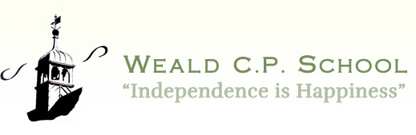
Weald
Primary School
ART Policy
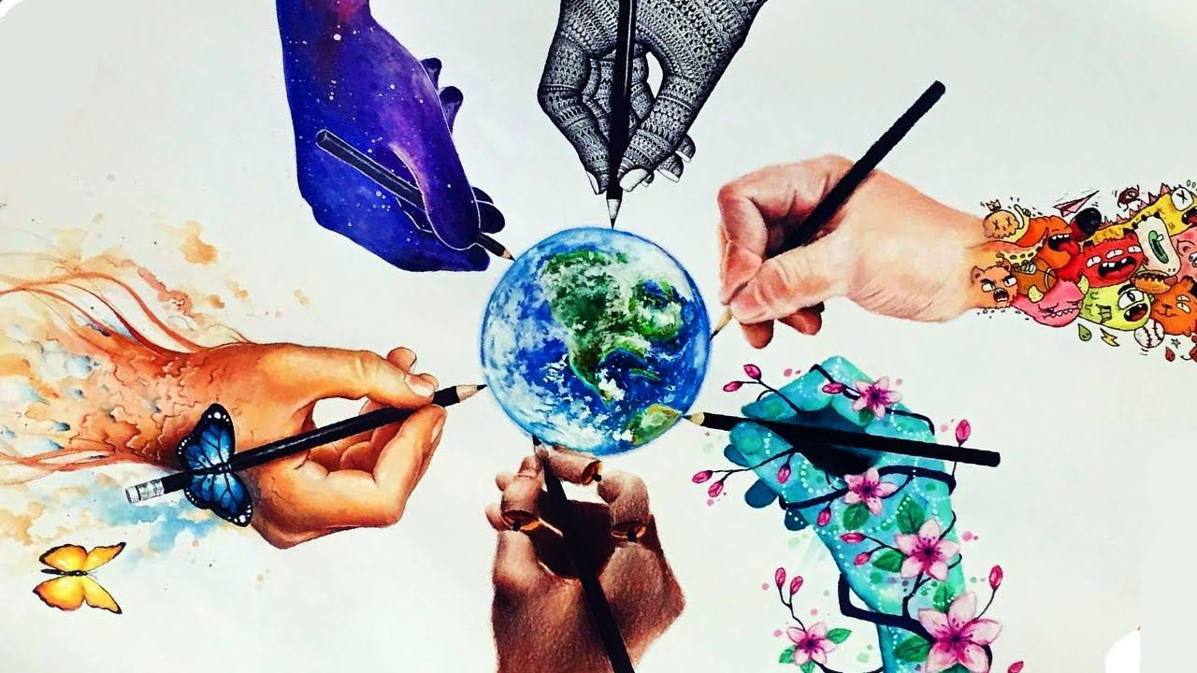

Character Qualities:
Independence to select materials and make decisions using own ideas
Curiosity to use different materials and techniques
Self control to use concentration and work collaboratively

September 2023

ART POLICY
“Creativity is contagious, pass it on”
Albert Einstein
“The arts are like your backbone. You may be able to survive without your backbone but what quality of life would you have?”
Sir Simon Rattle

Purpose of Study
Art, craft and design embody some of the highest forms of human creativity. A high-quality art and design education should engage, inspire and challenge pupils, equipping them with the knowledge and skills to experiment and create their own work. As pupils progress, they should be able to think critically and develop a more rigorous understanding of art and design. They should also know how art and design both reflect and shape our history, and contribute to the culture, creativity and wealth of our nation. Art education should foster an enjoyment and appreciation of the visual arts, and a knowledge of artists

Aims and Intent
At Weald school we show a strong commitment to the arts to ensure a full and rounded education for the pupils. There is an entitlement to a wide range of artistic experiences for every pupil as part of the curriculum.
Our school aims to:
▪ provide a broad, balanced and exciting arts curriculum which enables motivation, originality and imagination as well as the development of skills.
▪ develop and raise self-esteem and raise the standard of arts education across the school.
▪ enhance the children’s appreciation of different cultures through the arts especially through our joint curriculum project with Kanthenga School, Malawi.
▪ provide high quality arts experiences and resources for our children
▪ develop effective links with the community which strengthen and offer diverse arts provision within the school
▪ celebrate the artistic achievements of each child
▪ continue to develop the use of ICT and new technologies in creative learning

National Curriculum Aims
The national curriculum for art and design aims to ensure that all pupils:
• Produce creative work, exploring their ideas and recording their experiences
• Become proficient in drawing, painting, sculpture and other art, craft and design techniques
• Evaluate and analyse creative works using the language of art, craft and design
• Know about great artists, craft makers and designers, and understand the historical and cultural development of their art forms.

Implementation: Teaching and Learning
Subject Content
Art, craft and design embody some of the highest forms of human creativity. A high-quality art and design education should engage, inspire and challenge pupils, equipping them with the knowledge and skills to experiment invent and create their own works of art, craft and design. As pupils progress, they should be able to think critically and develop a more rigorous understanding of art and design. They should also know how art and design both reflect and shape our history, and contribute to the culture, creativity and wealth of our nation.

Foundation stage
In the Foundation Stage, the arts are linked throughout all of the planning, so that opportunities arise each day, to be creative. They form part of the Expressive Arts and Design area of learning (see Early Years policy).

Key stage 1 pupils should be taught:
- To use a range of materials creatively to design and make products
- To use drawing, painting and sculpture to develop and share their ideas, experiences and imagination
- To develop a wide range of art and design techniques in using colour, pattern, texture, line, shape, form, and space
- About the work of a range of artists, craft makers and designers, describing the differences and similarities between different practices and disciplines, and making links to their own work.
- To create sketch books to record their observations and use them to review and revisit ideas.

Key stage 2 pupils should be taught:
- Taught to develop their techniques, including their control and their use of materials, with creativity, experimentation and an increasing awareness of different kinds of art, craft and design.
- To create sketch books to record their observations and use them to review and revisit ideas
- To improve their mastery of art and design techniques, including drawing, painting and sculpture with a range of materials, for example, pencil, charcoal, paint, clay
- About great artists, architects and designers in history.

The aims (detailed above) will be met through the provision of opportunities for all children:
- to continue to develop links with artists and other organisations and broaden interests by being introduced to different artistic experiences
- to provide a range of resources, materials and skills with which to engage children
- to be able to develop cross-curricular learning; for example, using a variety of different stimuli for creative writing
- to celebrate creative thought and outcomes and value every child’s contribution to the arts as important
- to share creative learning, experiences with our sister school in Malawi
- to use ICT technology to explore and extend creative thought

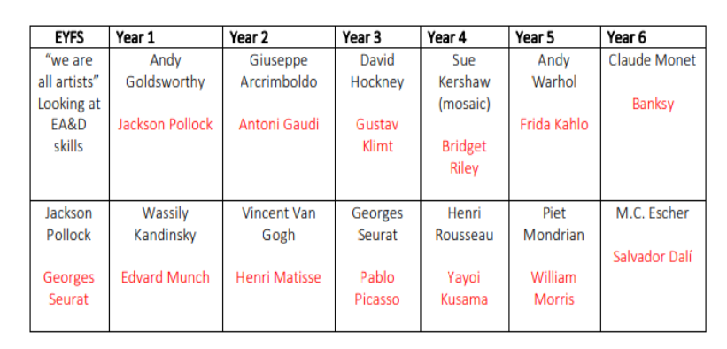
This is an example of some of the focused artists children will be learning about in school. Topics in History and Geography may bring forth other artists which may be studied instead.

Accessible for all
All children regardless of gender, race, culture, background and ability have an entitlement to arts education at an appropriate and challenging level. To ensure that children experience high standards of success, creative development needs to be taught with regard to children’s abilities to ensure progress.
Through the arts the children are encouraged to:
- be self-motivated and self-critical
- value their peers
- develop their thinking and reasoning skills
- observe, present, evaluate and record experiences
- be organised
- use a range of resources to meet their needs
- experience diverse and creative teaching and learning styles and make cross curricular links
- develop an appreciation and enjoyment of the arts

Impact: Assessment and Monitoring

Assessment:
Teachers assess art through observation and responding to their work during practical lessons.
Progress is assessed against the learning objectives for their lessons. Pupils are encouraged to assess their own and each other’s work using the vocabulary and skills they have learnt to demonstrate an understanding of their creative development.

The Role of the subject lead
- Write and review the art policy
- Monitor teaching and learning
- Support teachers with resources
- Attend relevant courses and feedback to staff
- Seek opportunities to link the school with experienced and emerging artists in the community

Monitoring and Review:
The subject leader is responsible for coordinating the art curriculum, supporting colleagues with resources and direction and ensuring a broad and balanced range of skills are taught.

Health and Safety:
General requirements for Health and Safety apply in this subject and care needs to be taken when using tools, and materials. Tools should be checked before use, be age appropriate and children should be trained to use them safely. Children are taught to follow proper procedures. Teaching staff are responsible for the supervision of activities

Character vision
“We are preparing children for the challenges of the 21st century – learning and working in a knowledge making world, rather than a knowledge applying world. Through our creative spirit as teachers, children will heighten their sensitivity, emotional intelligence and resilience and embrace enterprise and risk taking”
David Pyle
Headteacher

Reviewed: September 2022
To be reviewed: July 2023

