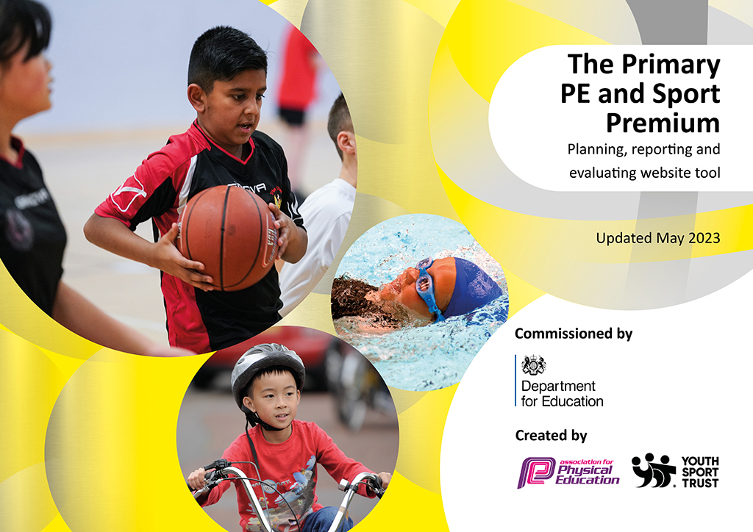
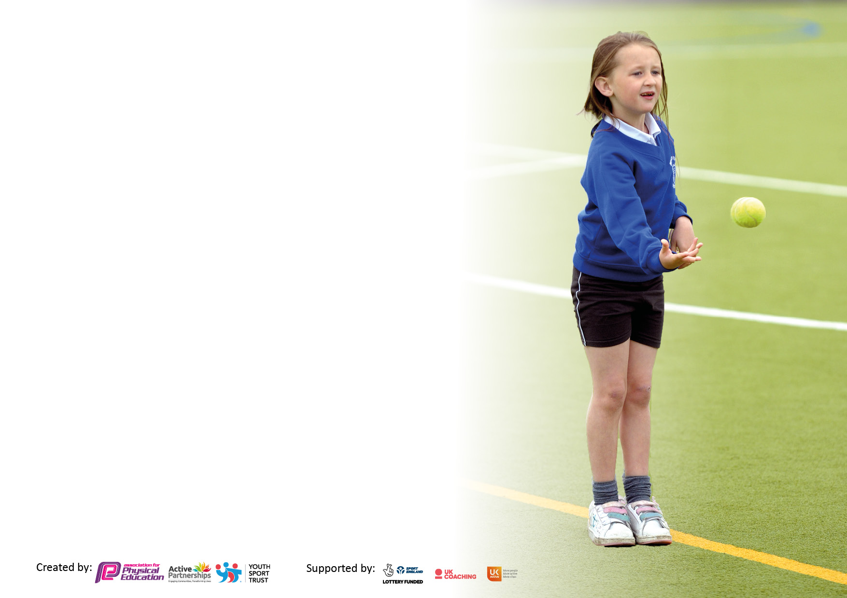

It is important that your grant is used effectively and based on school need. The Education Inspection Framework makes clear there will be a focus on ‘whether leaders and those responsible for governors all understand their respective roles and perform these in a way that enhances the effectiveness of the school’.

Under the Quality of Education Ofsted inspectors consider:
Intent - Curriculum design, coverage and appropriateness
Implementation - Curriculum delivery, Teaching (pedagogy) and Assessment
Impact - Attainment and progress

To assist schools with common transferable language this template has been developed to utilise the same three headings which should make your plans easily transferable between working documents.

Schools must use the funding to make additional and sustainable improvements to the quality of Physical Education, School Sport and Physical Activity (PESSPA) they offer. This means that you should use the Primary PE and sport premium to:

- Develop or add to the PESSPA activities that your school already offer
- Build capacity and capability within the school to ensure that improvements made now will benefit pupils joining the school in future years
- The Primary PE and sport premium should not be used to fund capital spend projects; the school’s budget should fund these.

Please visit gov.uk for the revised DfE guidance including the 5 key indicators across which schools should demonstrate an improvement. This document will help you to review your provision and to report your spend. DfE encourages schools to use this template as an effective way of meeting the reporting requirements of the Primary PE and Sport Premium.

We recommend you start by reflecting on the impact of current provision and reviewing the previous spend.

Schools are required to publish details of how they spend this funding, including any under-spend from 2021/2022, as well as on the impact it has on pupils’ PE and sport participation and attainment. All funding must be spent by 31st July 2023.

Details with regard to funding
Please complete the table below.

Total amount carried over from 2021/22 | £ 0
Total amount allocated for 2021/22 | £17,260
How much (if any) do you intend to carry over from this total fund into 2022/23? | £ 0
Total amount allocated for 2022/23 | £17,100
Total amount of funding for 2023/23. To be spent and reported on by 31st July 2023. | £17,100
Swimming Data
Please report on your Swimming Data below.

Meeting national curriculum requirements for swimming and water safety.

N.B. Complete this section to your best ability. For example you might have practiced safe self-rescue techniques on dry land which you can then transfer to the pool when school swimming restarts.
Due to exceptional circumstances priority should be given to ensuring that pupils can perform safe self-rescue even if they do not fully meet the first two requirements of the NC programme of study
What percentage of your current Year 6 cohort swim competently, confidently and proficiently over a distance of at least 25 meters?  N.B. Even though your pupils may swim in another year please report on their attainment on leaving primary school at the end of the summer term 2023.  Please see note above | 96%
What percentage of your current Year 6 cohort use a range of strokes effectively [for example, front crawl, backstroke and breaststroke]?  Please see note above | 96%
What percentage of your current Year 6 cohort perform safe self-rescue in different water-based situations? | 96%
Schools can choose to use the Primary PE and sport premium to provide additional provision for swimming but this must be for activity over and above the national curriculum requirements. Have you used it in this way? | Yes/No

Action Plan and Budget Tracking
Capture your intended annual spend against the 5 key indicators. Clarify the success criteria and evidence of impact that you intend to measure to evaluate for pupils today and for the future.

Academic Year: 2022/23 | Total fund allocated: | Date Updated:
Key indicator 1: The engagement of all pupils in regular physical activity – Chief Medical Officers guidelines recommend that primary school pupils undertake at least 30 minutes of physical activity a day in school |  |  |  | Percentage of total allocation:
 |  |  |  | 82%
Intent | Implementation |  | Impact
Your school focus should be clear what you want the pupils to know and be able to do and about  what they need to learn and to  consolidate through practice: | Make sure your actions to achieve are linked to your intentions: | Funding allocated: | Evidence of impact: what do pupils now know and what can they now do? What has changed? | Sustainability and suggested next steps:
Vision: ‘Participate, Enjoy, Succeed’.  All pupils to be enthused by sport and to have the opportunity of learning core skills and participating regularly in sporting activity. | Use staff working at Weald with a subject specialism in PE/Sport to deliver weekly PE lessons across the school. | £8210.16 | Greater enjoyment, interest, confidence and competence in all areas of sport & PE. | Further diversification of the sporting programme both within the curriculum and extra-curricular activities. Development of tennis, volleyball and other non-team-based sports.
Vision: ‘Participate, Enjoy, Succeed’.  All pupils to be enthused by sport and to have the opportunity of learning core skills and participating regularly in sporting activity. | sports coaching (DDivine Training) and upskilling of teachers and TAs.  Sport as a high-profile priority in school life: promotion during assemblies, website. Underpinned by Character Education. | £5520.00 | Increased participation rates, notably in KS1. Increased skill levels and performance in inter-school competitions.  Greater enjoyment, interest, confidence and competence in all areas of sport & PE. | Increased sporting appreciation across the school to continue as well as integrated weekly CPD for staff (link with key indicator 3). ensure that this continues to be delivered and enhance PE across the school.
To encourage children to engage in meaningful lunchtime play and activity | provide sustainable, durable equipment for use at lunchtime and in sports lessons to facilitate play for children on the field and playground across all phases. | £130 | Children are actively engaged in meaningful activities during their free play at lunch time, facilitated by the use of appropriate equipment. | PE equipment is constantly being updated and this will be continued
Extend sports clubs to least active pupils. | Ensure that extra-curricular programme attracts children of all abilities and levels of fitness e.g. Introduction of KS1 football club | £200.00 | Comprehensive programme of sporting activities with an increased allocation for KS1.  Early development of skills e.g., emphasis on cricket and early ks1 football. | Deployment of specialist coaches/ staff to train pupils in reception and Years 1 and 2. Planning for the future.
Key indicator 2: The profile of PESSPA being raised across the school as a tool for whole school improvement |  |  |  | Percentage of total allocation:
 |  |  |  | 8%
Intent | Implementation |  | Impact
Your school focus should be clear what you want the pupils to know and be able to do and about what they need to learn and to consolidate through practice: | Make sure your actions to achieve are linked to your intentions: | Funding allocated: | Evidence of impact: what do pupils now know and what can they now do? What has changed? | Sustainability and suggested next steps:
Greater accessibility to high quality equipment to enhance sporting engagement and performance. | Purchase of equipment for PE. | £549.82 | Increase in pupil participation and sporting performance. Facilitation of extra-curricular clubs. Improved pupil fitness and character development. | Upkeep of high-quality sports equipment with sports leaders insuring we have the required equipment.
Provision of a first class Multi Use Games Area (MUGA) at the school to encourage PE/Sport within the curriculum and after-school and holiday sports clubs. | Additional facilities and maintenance: high-pressure cleaning and new nets for goals | £675.00 | Community cohesion: use of MUGA by local community.  Expanded opportunities for inter-school competition (beyond football and netball) as well as inter-house competitions. | Ensure the continued upkeep and maintenance of MUGA to provide a high-quality facility for the school and the local community.
To provide extra lessons to extend knowledge and skill in Swimming for those with a lower ability. | Further lessons in Swimming for non and low attaining swimmers using local pool and coaches. | £150.00 | Additional lessons for children to extend skill in Swimming | Increased ability to Swim and leave school with the ability to Swim at least 25 meters unaided

Key indicator 3: Increased confidence, knowledge and skills of all staff in teaching PE and sport |  |  |  | Percentage of total allocation:
 |  |  |  | 1%
Intent | Implementation |  | Impact
Your school focus should be clear | Make sure your actions to | Funding | Evidence of impact: what do | Sustainability and suggested
what you want the pupils to know | achieve are linked to your | allocated: | pupils now know and what | next steps:
and be able to do and about | intentions: |  | can they now do? What has
what they need to learn and to |  |  | changed?
consolidate through practice:
Upskilling of specialist PE teachers through attending course so they can then share in whole staff CPD to upskill other teachers  Links with the ongoing CPD provided by DDivine and Specialist PE member of staff (See section 1) | CPD opportunities for staff in delivery of PE lessons | £150.00 | Staff audit to evaluate confidence and competence in teaching PE.  Clear evidence of up-skilling. | Development of teaching programme so that all teachers and TAs can teach PE confidently, safely, and progressively.
Key indicator 4: Broader experience of a range of sports and activities offered to all pupils |  |  |  | Percentage of total allocation:
 |  |  |  | 3%
Intent | Implementation |  | Impact
Your school focus should be clear | Make sure your actions to | Funding | Evidence of impact: what do | Sustainability and suggested
what you want the pupils to know | achieve are linked to your | allocated: | pupils now know and what | next steps:
and be able to do and about | intentions: |  | can they now do? What has
what they need to learn and to |  |  | changed?:
consolidate through practice:
Teach the sport’s leadership award In Year 6, led by DDevine Training. | Giving children in Year 6 the opportunity to take part in a sports leadership programme, giving them the additional skills needed to plan events such as intra competitions and sports day | £100.00 | Year 6 children have a confidence and enthusiasm for all sports (not just football and netball) and can successfully plan and lead on events such as sports day. | Enthuse other years to do the same and be interested in the organization and opportunities of sports leadership
Purchasing of specialist sports equipment for Volleyball and dodgeball to broaden the experience of sport in school | Giving children the opportunity to learn and participate in new sports to broaden their experiences | £120.00 | Knowledge of a new sport and the enthusiasm to want to play it using the proper equipment. | Use the same equipment in the following years to broaden other classes knowledge of Volleyball and dodgeball.
Purchase of tickets to take children to the Wimbledon tennis competition | Giving children the opportunity to visit the famous Wimbledon tennis competition to enthuse in sport further | £225 | Life-long enthusiasm in Tennis and increased ability through watching professionals | Further interest from those who attended who also share with others who might want to attend in further years

Key indicator 5: Increased participation in competitive sport |  |  |  | Percentage of total allocation:
 |  |  |  | 6%
Intent | Implementation |  | Impact
Your school focus should be clear | Make sure your actions to | Funding | Evidence of impact: what do | Sustainability and suggested
what you want the pupils to know | achieve are linked to your | allocated: | pupils now know and what | next steps:
and be able to do and about | intentions: |  | can they now do? What has
what they need to learn and to |  |  | changed?:
consolidate through practice:
Pupils to represent the school in a positive and professional manner through the use of specialist equipment, including school, team kits and tracksuits (Horncastles). | School to update and provide children representing the school during competitive sports with the equipment and uniform needed. | £460.92 | Children perform in school competitions with confidence and pride and have great success. | Staff to be supplied with specialist uniform. Ongoing purchase of kit to ensure children look and feel-good participating in competitive sport.
Memberships to sports associations to obtain opportunities for competitive sport (Knole and Sevenoaks) | Enter competitions put on by Knole, Sevenoaks sports associations and the Edenbridge Sports Partnership | £450.00 | Children have been given additional opportunities to enter specialist competitions such as Netball, athletics and cricket | Children are confident to compete in competitions the following year and offered more opportunities
To provide extra curricular lessons to extend knowledge and skill in Dance in preparation for a Dance competition. | Further skill and participation in Dance by using external Dance company to teach and provide opportunity in competition. | £150.00 | Additional lessons for children to extend skill in performance with entry in a dance competition | Sustained interest in Dance and opportunity for others to be enthused and to take part in the following years.

Signed off by
Head Teacher: | Mr David Pyle
Date: | 29/06/23
Subject Leader: | Mr Chris Taylor
Date: | 29/06/23
Governor: | Mrs Wendy Wallace-Holman
Date: | 04/07/23

