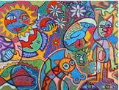
Neptune-Term 1 Creative Curriculum: What is Mayan Gold? 2020/2021
Art/DT:

- to use sketch books to record observations and use them to review and revisit ideas
- to improve their mastery of art and design techniques, including drawing, painting and sculpture with a range of materials [for example, pencil, charcoal, paint, clay

  - Story telling through art
  - Mayan ruins
  - Mayan Writing

SPaG
spag.com
Synonyms and Antonyms Relative clauses – who, which, where, when, whose, that.
Modal verbs – possibility
Adverbs – possibility
Brackets or dashes
Use of Commas
Computing
Children will be taught to:

- select, and use software devices to collect, analyse, evaluate and present data and information
- use technology safely, respectfully and responsibly; recognise acceptable/ unacceptable behaviour; identify a range of ways to report concerns about content and contact
Topic: A non-European society that provides contrasts with British history
What is Mayan gold?
Who are the Maya & where do they live?
Why was Mayan farming so sophisticated?
Why was farming so important to the Mayas?
Application of skills & processes:
Recognise Identify Describe Empathise
Observe Select Categorise Reach informed conclusions
Classify Sequence Compare & contrast Make reasoned judgements
Recall Summarise Reason/speculate Critique
Synthesise Explain Hypothesise Demonstrate understanding
Justify Apply Evaluate

Literacy:
2 weeks-
Kensuke’s Kingdom - Michael Morpurgo
Classic Fiction (Fiction 5 Sum): Features of graphic novels, opening chapter, portrayal of characters through language, character profiles, descriptive writing
5 weeks-
Main Text: Journey to the River Sea Eva Ibbotson. Supporting Texts: The Chocolate Tree: A Mayan Folktale Linda Lowery, Middleworld (Jaguar Stones) J&P Voelkel
Classic Fiction (Fiction 5 Sum): Features of playscripts, narrative style of authors, differing viewpoints, descriptive language, similes & metaphors, story writing-scaffold planning & editing, dialogue-direct speech features
R.E: - Is it better to
express your religion
in arts and architecture
or in charity and generosity?

This investigation enables pupils to learn in depth from two different religions about why their holy buildings and works of art matter to them as expressions of devotion to God and worship, and about how they practice generosity and charity.
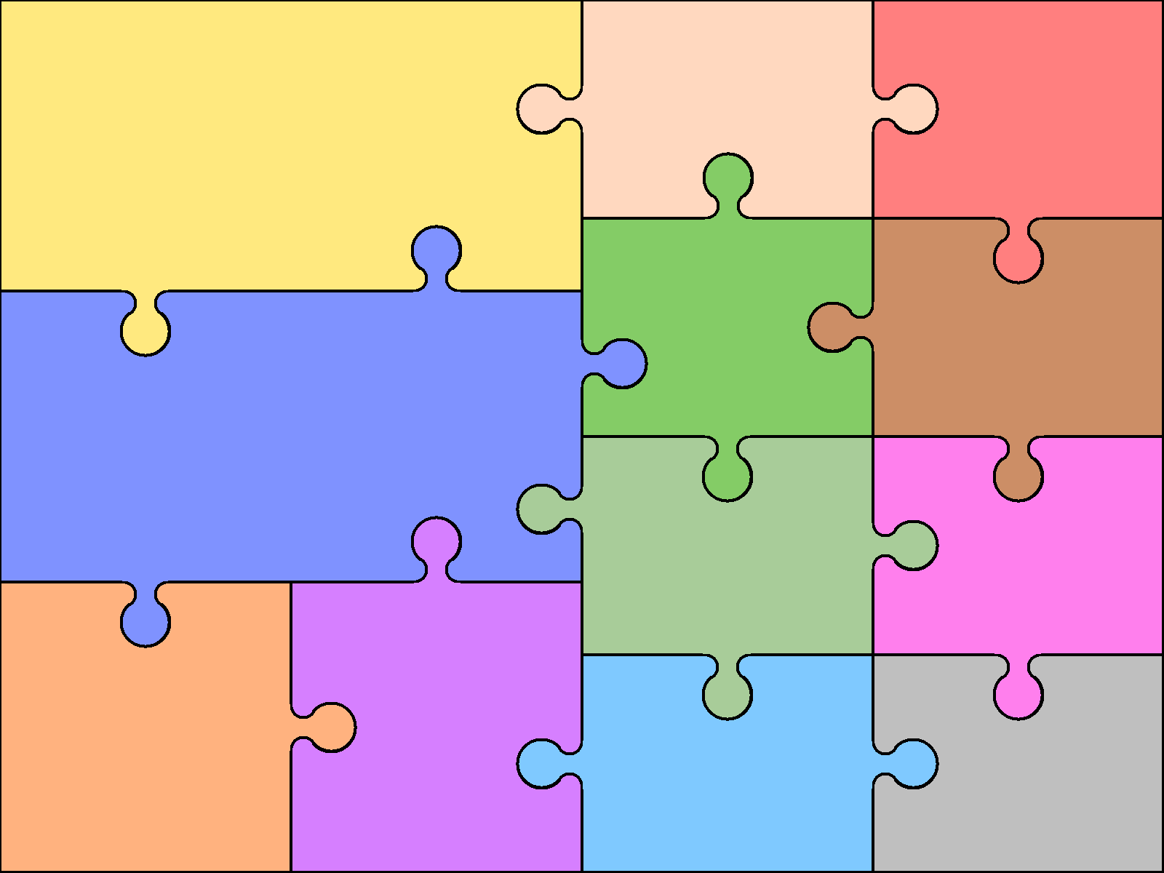  Numeracy  - Number – Place Value  - Number – Addition and Subtraction  - Number –Multiplication and Division  - Conclusion | Numeracy - Reasoning  Reasoning is the catalyst for the teaching of maths. A key skill in becoming fully numerate (and to becoming an independent thinker) is the ability to make your own decisions and learn from them.  This key skill is central to the children’s math’s learning and a chance to allow learners to choose their own methods and ways of recording, then present their findings in whichever way they decide. Learners are encouraged to explain their reasoning, thus extending the understanding and their ability to communicate, numerically. |  |  | Science- Light  - Describe how light travels  - Explain how we see object  - Explain why shadows have the same shapes as the objects that cast them  Languages: Spanish  Languagenut  - read carefully and show understanding of words, phrases and simple writing  - broaden their vocabulary and develop their ability to understand new words that are introduced into familiar written material, including through using a dictionary  - describe people, places, things and actions orally* and in writing | Physical Education  Football-  Children will be taught the primary skills of invasion games using Ultimate Frisbee as a catalyst e.g. finding space, passing, throwing, teamwork, control,  Leadership Award-  Children will be taught how to organise and take a lead in PE. They will develop their knowledge of competition eventually leading to organising and supporting events  Music  As part of the wider opportunities in music the children will continue to learn the Djembe Drums.  Children will be:  - play and perform musical instruments with increasing accuracy, fluency, control and expression  - improvise and compose music for a range of purposes  - listen with attention to detail and recall sounds with increasing aural memory  - develop an understanding of the history of music.

