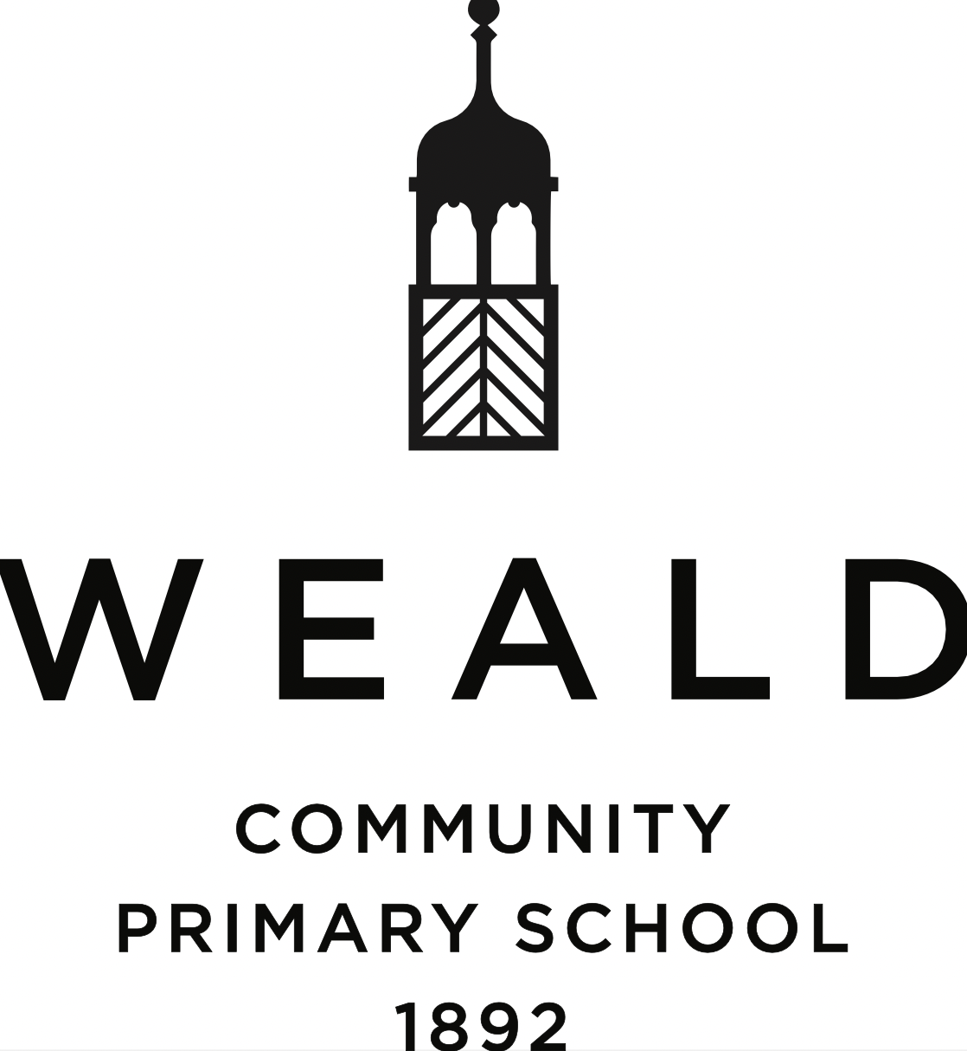

Phonics (Read Write Inc) Policy

Date written: September 2022

Date agreed and ratified by Governing Body: October 2022

Date of next review: September 2025

Contents

1. Aims & Intentions 2
2. Legislation 2
3. Definitions: Read Write Inc scheme outlined 3
4. Delivery of RWI scheme 3
5. Assessment, reviewing and monitoring 4
6. The RWI leader 4
6. Home support and reading books 5
7. Monitoring arrangements 5
8. Links with other policies and documents 5

Aims

We aim to enable our children to:
- Apply the skill of blending phonemes in order to read words.
- Segment words into their constituent phonemes in order to spell words.
- Learn that blending and segmenting words are reversible processes.
- Read high frequency words that do not conform to regular phonic patterns.
- Read texts and words that are within their phonic capabilities as early as possible.
- Decode texts effortlessly so all their resources can be used to comprehend what they read.
- Spell effortlessly so that all their resources can be directed towards composing their writing.

Legislation

This policy is based on the statutory OFSTED Framework https://www.gov.uk/government/publications/school-inspection-handbook-eif/school-inspection-handbook#evaluating-the-quality-of-education-1:

245. In reaching an evaluation against the ‘quality of education’ judgement, inspectors will consider whether:
- the school is determined that every pupil will learn to read, regardless of their background, needs or abilities. All pupils, including the weakest readers, make sufficient progress to meet or exceed age-related expectations
- stories, poems, rhymes and non-fiction are chosen for reading to develop pupils’ vocabulary, language comprehension and love of reading. Pupils are familiar with and enjoy listening to a wide range of stories, poems, rhymes and non-fiction
- the school’s phonics programme matches or exceeds the expectations of the national curriculum and the EYFS early learning goals. The school has clear expectations of pupils’ phonics progress term by term, particularly from Reception to Year 2
- the sequence of reading books shows a cumulative progression in phonics knowledge that is matched closely to the school’s phonics programme. Teachers give pupils sufficient practice in reading and re-reading books that match the grapheme–phoneme correspondences they know, both at school and at home
- reading, including the teaching of systematic synthetic phonics, is taught from the beginning of Reception
- the ongoing assessment of pupils’ phonics progress is sufficiently frequent and detailed to identify any pupil who is falling behind the programme’s pace. If they do fall behind, targeted support is given immediately
- the school has developed sufficient expertise in the teaching of phonics and reading

Definitions: Read Write Inc scheme outlined

Read Write Inc (RWI) is an inclusive literacy programme for all children in Reception to Year 2 learning to read. Children learn the 44 common sounds in the English language and how to blend them to read and spell. The scheme includes both a reading and a writing focus.
Reading is the key that unlocks the whole curriculum so the ability to efficiently decode is essential. The RWI sessions run 4 days a week as the continuity and pace of the programme is key to accelerating the progress of children’s reading development.

Delivery of RWI scheme

- Initial sounds are to be taught in a specific order.
- Sounds taught should be ‘pure’ ie ‘b’, not ‘buh’ as this is central to phonics teaching and ability to recognise sounds in words.
- Blends are to be declustered. E.g. bl is two specific sounds.
- Children are to be taught that the number of graphemes in a word always corresponds to the number of phonemes. This greatly aids spelling.
- Set 2 sounds are to be taught after Set 1 (initial sounds).
- Letter names are to be introduced with Set 3.

Foundation Stage: RWI is fully implemented in Reception by fully trained teachers and TAs, where the class will be split into groups after a baseline assessment is completed. Within lesson time, a 10 minute speed sounds session will occur with follow up handwriting and sentence writing.
Key Stage One: RWI groups will be set following assessments carried out by the RWI leaders. The sessions will occur 4 times per week and will be carried out by fully trained teachers and TAs. These sessions will form the children’s literacy teaching, with a 10 minute Speed Sounds session followed by Reading and Get Writing. Any children who struggle with their reading, writing and sound knowledge will continue to receive differentiated RWI sessions in Year 2.
Key Stage Two: RWI catch up will take the form of an intervention during sessions for those children with the greatest need and gaps in their learning. This will be done using the RWI and Fresh Start programmes.
Pupils with SEND are fully involved in RWI lessons as all pupils work in ability groups and teaching is geared to the speed of progress of each group.

- Assessment, reviewing and monitoring
Children are assessed throughout every lesson. Every time partner work is used the teacher assesses the progress of their children. The teacher assesses how children:
- Read the grapheme chart
- Read the green and red word lists
- Decode the ditty/story
- Comprehend the story
Formal assessment is carried out every half term by the RWI leaders using the RWI assessments. This allows for achieving homogeneity within each group and indicates the correct access point for new entrants.

- The RWI leaders
The RWI leaders will:
- Assesses all Key Stage One pupils and designates children to the correct groups.
- Coaches RWI teachers and check that pupils are in the correct groups.
- Attends up-date meetings when they occur and reports back to the RWI teachers.
- Speaks with the LT regarding groups and any children needing further support.
- Is responsible for reporting to the governors about the quality of the implementation of RWI and the impact on standards.
- The RWI leaders are: Annie Littlejohn and Holly Taylor

- Home support and reading books
There is an expectation for parents/ carers to read daily with their child at home.
For KS1, a RWI ‘book bag book’ will be sent home to aid the phonics teaching in school. This will be matched with the child’s group and will be changed once a week when the RWI book has been finished in school.
Additionally, a further supplementary book will be sent home to give extra practice as well as a non-fiction alternative. This may be changed daily.

Monitoring arrangements
This policy and information report will be reviewed by every three years. It will also be updated if any changes to the information are made during the year.
It will be approved by the governing body.

Links with other policies and documents
This policy links to the following documents:

- Literacy Policy

