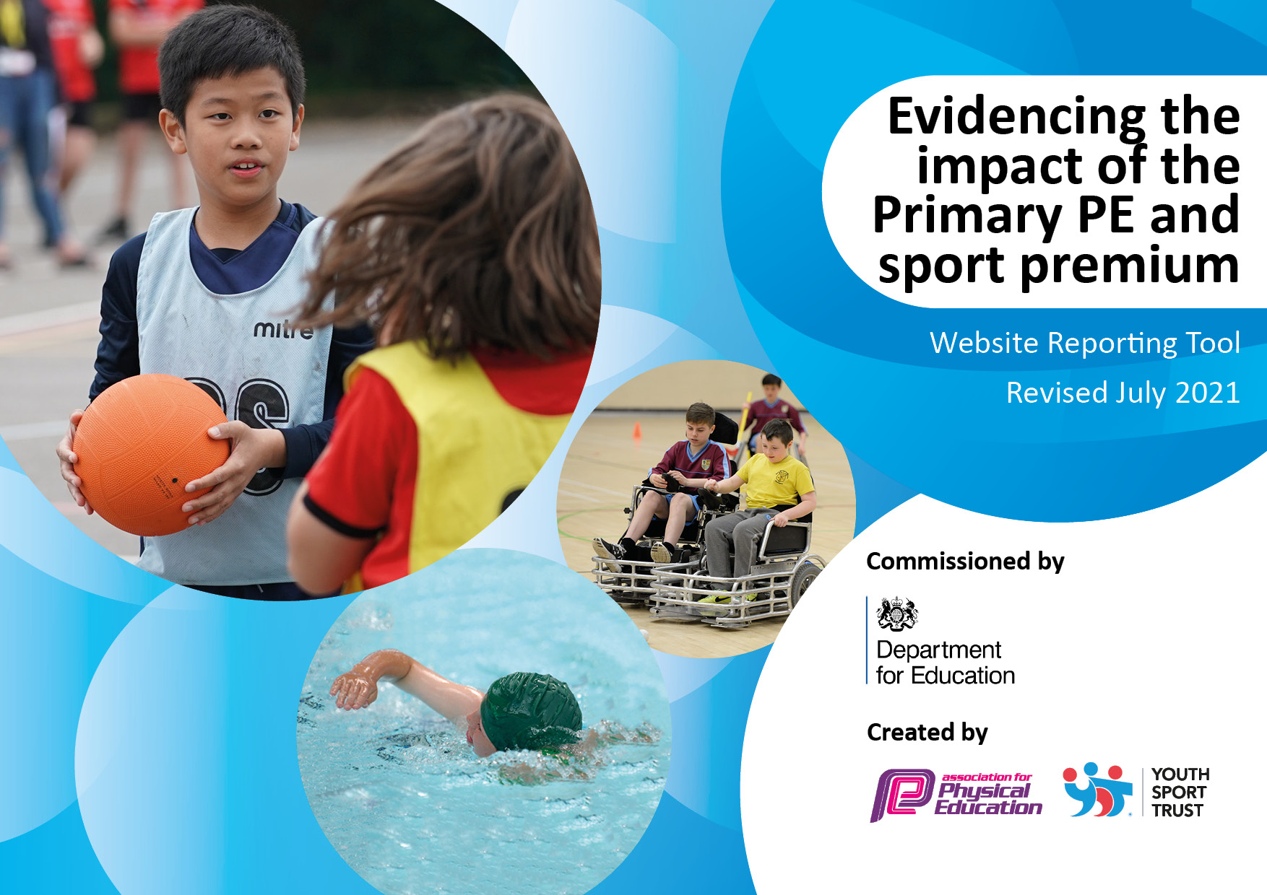

Details with regard to funding
Please complete the table below.

Total amount carried over from 2019/20 | £0
Total amount allocated for 2020/21 | £17,260
How much (if any) do you intend to carry over from this total fund into 2021/22? | £0
Total amount allocated for 2021/22 | £17,260
Total amount of funding for 2021/22. To be spent and reported on by 31st July 2022. | £17,260
Swimming Data
Please report on your Swimming Data below.

Meeting national curriculum requirements for swimming and water safety

What percentage of your current Year 6 cohort swim competently, confidently and proficiently over a distance of at least 25 metres? | 94%
What percentage of your current Year 6 cohort use a range of strokes effectively [for example, front crawl, backstroke and breaststroke]? | 94%
What percentage of your current Year 6 cohort perform safe self-rescue in different water-based situations? | 94%
Schools can choose to use the Primary PE and sport premium to provide additional provision for swimming but this must be for activity over and above the national curriculum requirements. Have you used it in this way? | No

Action Plan and Budget Tracking
Capture your intended annual spend against the 5 key indicators. Clarify the success criteria and evidence of impact that you intend to measure to evaluate for pupils today and for the future.

Academic Year: 2021/22 | Total fund allocated: £17,260 | Date Updated: 9th June 2022
Key indicator 1: The engagement of all pupils in regular physical activity – Chief Medical Officers guidelines recommend that primary school pupils undertake at least 30 minutes of physical activity a day in school. |  |  |  | Percentage of total allocation:
 |  |  |  | 73%
Intent | Implementation |  | Impact
Your school focus should be clear what you want the pupils to know and be able to do and about  what they need to learn and to  consolidate through practice: | Make sure your actions to achieve are linked to your intentions: | Funding allocated: | Evidence of impact: what do pupils now know and what can they now do? What has changed?: | Sustainability and suggested next steps:
Vision: ‘Participate, Enjoy, Succeed’.  All pupils to be enthused by sport and to have the opportunity of learning core skills and participating regularly in sporting activity. | Use staff working at Weald with a subject specialism in PE/Sport to deliver weekly PE lessons across the school. | £4900.00 | Greater enjoyment, interest, confidence and competence in all areas of sport & PE. | Further diversification of the sporting programme both within the curriculum and extra-curricular activities. Development of tennis and other non-team based sports.
Vision: ‘Participate, Enjoy, Succeed’.  All pupils to be enthused by sport and to have the opportunity of learning core skills and participating regularly in sporting activity. | Continuation of specialist sports coaching (Sprint PE provider) and upskilling of teachers and TAs.  Sport as a high-profile priority in school life: promotion during assemblies, website. Underpinned by Character Education. | £7480.00 | Increased participation rates, notably in KS1. Increased skill levels and performance in inter-school competitions.  Greater enjoyment, interest, confidence and competence in all areas of sport & PE. | Increased sporting appreciation across the school to continue as well as integrated weekly CPD for staff (link with key indicator 3). If sports grant to continue next academic year, ensure that Sprint continue to deliver and enhance sport across the school.
Extend sports clubs to least active pupils. | Ensure that extra-curricular programme attracts children of all abilities and levels of fitness e.g. Introduction of Handball | £200.00 | Comprehensive programme of sporting activities with an increased allocation for KS1.  Early development of skills e.g. netball squad and swimming team. | Deployment of specialist coaches/ staff to train pupils in Years 3 & 4. Planning for the future.
Key indicator 2: The profile of PESSPA being raised across the school as a tool for whole school improvement |  |  |  | Percentage of total allocation:
 |  |  |  | 19%
Intent | Implementation |  | Impact
Your school focus should be clear what you want the pupils to know and be able to do and about  what they need to learn and to  consolidate through practice: | Make sure your actions to achieve are linked to your intentions: | Funding allocated: | Evidence of impact: what do pupils now know and what can they now do? What has changed?: | Sustainability and suggested next steps:
Greater accessibility to high quality equipment to enhance sporting engagement and performance. | Purchase of equipment for gymnastics and a wide range of invasion sports. | £2469.00 | Increase in pupil participation and sporting performance. Facilitation of extra-curricular clubs. Improved pupil fitness and character development. | Upkeep of high quality sports equipment, liaison between the subject leader and sports leaders (Year 6) on what is needed to expand the PE provision at Weald.
Provision of a first class Multi Use Games Area (MUGA) at the school to encourage PE/Sport within the curriculum and after-school and holiday sports clubs. | Additional facilities and maintenance : high-pressure cleaning and re-painting of lines | £650.00 | Community cohesion: use of MUGA by local community.  Expanded opportunities for inter-school competition (beyond football and netball) as well as inter-house competitions. | Ensure the continued upkeep and maintenance of MUGA to provide a high-quality facility for the school and the local community.
Swimming (catch-up)  Ensure that all children in Year 6 can meet the national curriculum requirements by the end of KS2. | Those children who can not: swim 25 metres confidently, use a range of strokes effectively or can perform save self-rescue will have the opportunity for additional sessions to meet these requirements by the end of KS2. | £100.00 | All children in Year 6 will be able to meet the national curriculum requirements. | Extend this to all children from Year 4 upwards who need additional skills around competency in water before they get to Year 6.

Key indicator 3: Increased confidence, knowledge and skills of all staff in teaching PE and sport |  |  |  | Percentage of total allocation:
 |  |  |  | 3%
Intent | Implementation |  | Impact
Your school focus should be clear | Make sure your actions to | Funding | Evidence of impact: what do | Sustainability and suggested
what you want the pupils to know | achieve are linked to your | allocated: | pupils now know and what | next steps:
and be able to do and about | intentions: |  | can they now do? What has
what they need to learn and to |  |  | changed?:
consolidate through practice:
Upskilling of teachers & TAs.  Impact is sustainability of high quality PE/sports coaching.  Links with the ongoing CPD provided by Sprint PE (See section 1) | CPD opportunities for staff on selected areas of sports provision (Sprint PE). | £500.00 | Staff audit to evaluate confidence and competence in sports coaching.  Increased preparedness and skill in teaching Sport & PE. Clear evidence of up-skilling. | Development of coaching programme so that all teachers and TAs can teach Sport & PE safely and progressively.
Key indicator 4: Broader experience of a range of sports and activities offered to all pupils |  |  |  | Percentage of total allocation:
 |  |  |  | 1%
Intent | Implementation |  | Impact
Your school focus should be clear | Make sure your actions to | Funding | Evidence of impact: what do | Sustainability and suggested
what you want the pupils to know | achieve are linked to your | allocated: | pupils now know and what | next steps:
and be able to do and about | intentions: |  | can they now do? What has
what they need to learn and to |  |  | changed?:
consolidate through practice:
Introduction of a sport’s leadership award In Year 6, led by Sprint PE. | Giving children in Year 6 the opportunity to take part in a sports leadership award, giving them the additional skills needed to plan events such as sports day and to lead by example across all areas of sport at Weald. | £100.00 | Year 6 children have a confidence and enthusiasm for all sports (not just football and netball) and can successfully plan and lead on events such as sports day.  To act as good role models for the rest of the school. | To introduce similar awards in the following academic year.

Key indicator 5: Increased participation in competitive sport |  |  |  | Percentage of total allocation:
 |  |  |  | 4%
Intent | Implementation |  | Impact
Your school focus should be clear | Make sure your actions to | Funding | Evidence of impact: what do | Sustainability and suggested
what you want the pupils to know | achieve are linked to your | allocated: | pupils now know and what | next steps:
and be able to do and about | intentions: |  | can they now do? What has
what they need to learn and to |  |  | changed?:
consolidate through practice:
Pupils to represent the school in a positive and professional manner through the use of specialist equipment , including school, team kits and tracksuits (Horncastles). | School to update and provide children representing the school during competitive sports with the equipment and uniform needed. | £751.00 | Children perform in school competitions with confidence and pride and have great success. | Staff to be supplied with specialist uniform which represents the school and links with the children’s kit.
Swimming (squad)  Ensure that the swimming squad have adequate time to prepare and train ready for the swimming gala at the end of the year. | School to provide transport and cover pool costs for the swimming squad to train and prepare for the end of year gala. | £100.00 | From previous years, the swimming team have had great success in the local gala.  At time of report, 2021/2022 gala has not taken place. | Continue with preparation of swimming gala for subsequent yearly meets.

Signed off by
Head Teacher: | D. Pyle
Date: | 16/06/22
Subject Leader: | C. Taylor
Date: | 16/06/22
Governor: | M. Lowe
Date:

