The Anglo Saxons

Who were the Anglo-Saxons?

**ICT**

The internet

Understand the internet as a network of networks which need to be kept secure.

Evaluate online content to decide how honest, accurate, or reliable it is.

**Science**

Sounds

Look at how vibrations cause sounds and how sounds travel, how sounds can change pitch and loudness. Explore pitch, understand how high and low sounds are made.

**PE**

Dance

Invasion games – skills across games.

**History**

Why did the Romans leave Britain?

Who were the Anglo Saxons?

- converting to Christianity

- Artefacts and Culture

**Music**

Performing with others

Recorders

**Art/DT**

Saxon masks, printing and weaving.

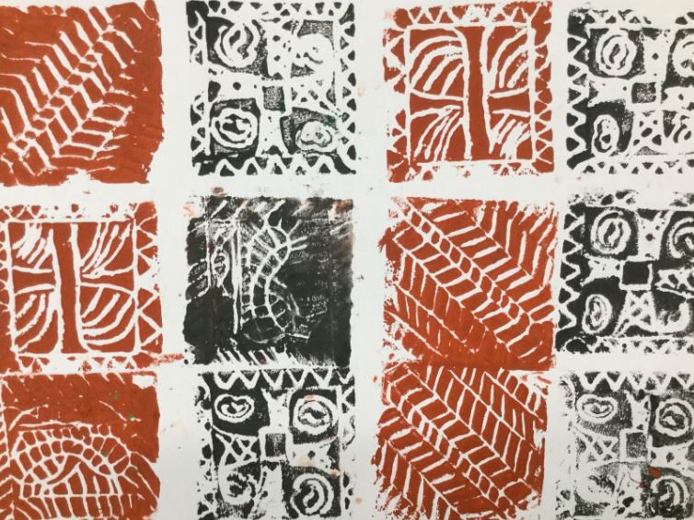 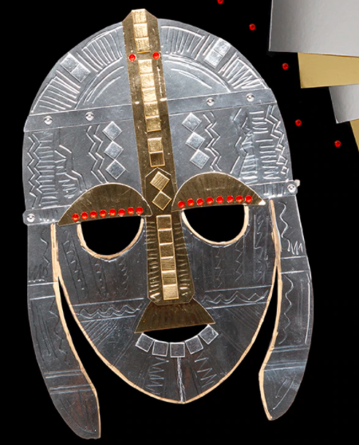

**Numeracy**

Multiplication and division

- 11 and 12 times table

- multiply 3 numbers

- factor pairs

- efficient multiplication

- multiply 2 digits by 1 digit

- multiply 3 digits by 1 digit

- divide 2 digits by 1 digit

Area

- what is area

- making shapes

- counting squares

- comparing area

Fractions

- unit and non unit fractions

- what is a fraction

- tenths

- equivalent fractions

- fractions greater than 1

- count in fractions

- add fractions

**RE/PSHE**

Why is Jesus so inspiring?

The miracles of Jesus.

**Literacy**

Myths and Legends: *playscripts: Beowulf*

Study dialogue, tense, pronouns. Create playscripts

Traditional tales: *The Princess and the pea.*

Study dialogue, tense, pronouns. Look at different versions of the same play. Rewrite the Princess and the pea.

Recounts: *The Princess who hid in a tree.*

Create recounts of a story and events. Look at adverbials and possessive apostrophes.

**SPaG**

Apostrophes and speech.

Jupiter Class – Spring term one