Venus-Term 3 Creative Curriculum: Who were the Anglo-Saxons and how do we know what was important to them? 2021/2022
Topic: Who were the Anglo-Saxons
- Interpret both primary and secondary sources of evidence to describe and explain
- Empathise with the situation and feelings of Emperor Honorius in ad 410
- Describe and explain why Anglo-Saxon settlers created village communities in the countryside rather than living in the towns
- Identify and describe several Anglo-Saxon gods and explain what and why about their beliefs
- Describe and explain why Britain converted to Christianity following the visit of Augustine and make a reasoned judgment
about what the message from Pope Gregory to King Ethelbert might have been.
- Recognise and describe some of the changes that occurred to buildings and ways of life in Anglo-Saxon Britain as a result of the country’s conversion to Christianity
- Identify and describe the artefacts that were discovered in the Anglo-Saxon ship burial at Sutton Hoo, explain why they are so important to historians and, using these artefacts, reach a judgment as to how the burial would have been constructed and carried out.
- Identify, interpret, and make a judgment about the origin of Anglo-Saxon place names in their own area or region of England.
Application of skills & processes:
Recognise Identify Describe Observe Select Categorise Classify Sequence Recall Synthesise
Empathise Demonstrate Reason/Speculate Summarise Explain Understanding Compare and Contrast

Art/DT:

- to use sketch books to record observations and use them to review and revisit ideas
- to improve their mastery of art and design techniques, including drawing, painting and sculpture with a range of materials [for example, pencil, charcoal, paint, clay

Focus: Still Life, different colour themes. Painting, sketch work. Research and compare artists.
Computing
Children will be taught to: Programme through the use of Scratch software and crumble kits. Crumble involves programming digital devices to sense and interact with the world – an engaging alternative to screen-only activity.
It touches upon many areas of the computing
curriculum, bringing subject knowledge and
programming skills to engaging and
enjoyable classroom activities
- Understand internet safety and how to keep themselves safe online
SPaG
Tenses including perfect form
Prefix and suffixes
Dialogue
Emotive language
Paragraphing

spag.com

Literacy:

2 weeks – Poems on a theme: Beowulf by Rob Lloyd Jones
Express emotion with through the Anglo-Saxon story of Beowulf. Explore, write, and perform emotional poetry. Revise verbs (including irregular verbs), simple past tense and present perfect form. End by writing a narrative poem about an Anglo-Saxon character

3 weeks – classic fiction: exciting stories – fantastic Mr Fox by Roald Dahl
Explore and understand the concepts of setting character and style in Fantastic Mr Fox
Understanding how the story can be told and the plot advanced through dialogue: punctuating dialogue correctly and using a range of reporting clauses
answering comprehension questions, use inference and prediction, analyse how tension is created
Understand tense in verbs; develop and use past tense and then identify and use the present perfect form.
Analyse the features of Fantastic Mr Fox and create a story map of the plot.

2 weeks – Reports: Harry Potter and Hogwarts
Read reports about Harry Potter studio tours. Understand features of reports, study conjunctions,
prepositions and adverbs. Look at Hogwarts students’ school reports

R.E: -

Why do people pray?
Pupils learn in depth from different religious and spiritual ways of life about prayer: the practice, symbols, words and significance of prayer as well as some key beliefs about prayer, so that pupils can develop thoughtful ideas and viewpoints of their own.

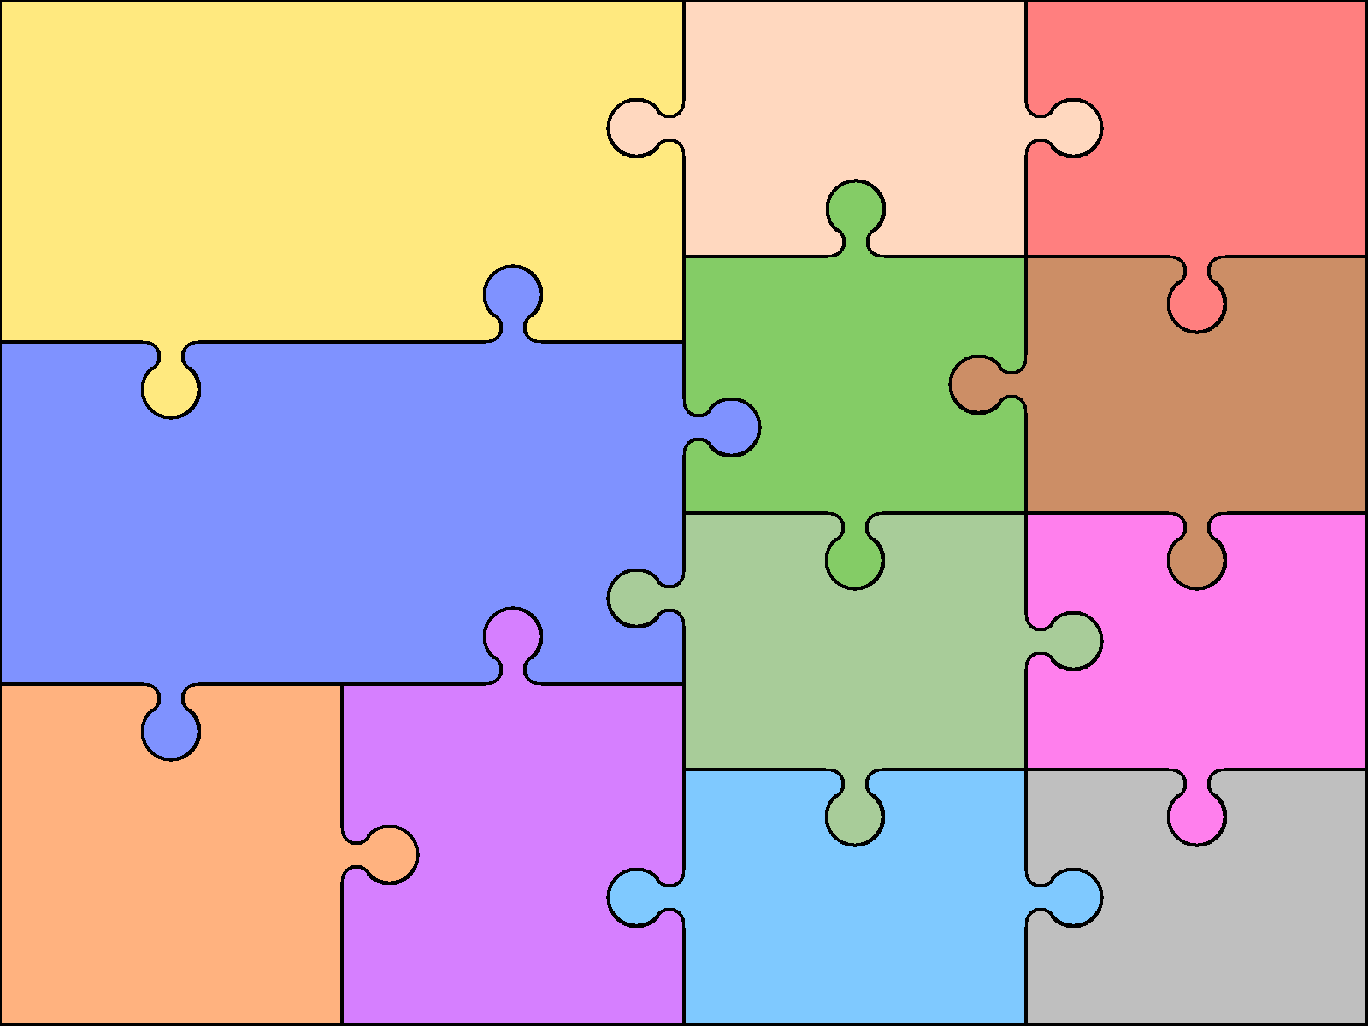  Numeracy  - Number – Multiplication and Division  - Measure – Money  - Statistics – graphs and charts  - Conclusion and revision | Numeracy - Reasoning  Reasoning is the catalyst for the teaching of math. A key skill in becoming fully numerate (and to becoming an independent thinker) is the ability to make your own decisions and learn from them.  This key skill is central to the children’s math’s learning and a chance to allow learners to choose their own methods and ways of recording, then present their findings in whichever way they decide. Learners are encouraged to explain their reasoning, thus extending the understanding and their ability to communicate, numerically. |  | Science-  Forces and magnets  - compare how things move on different surfaces  - notice that some forces need contact between two objects, but magnetic forces can act at a distance  - observe how magnets attract or repel each other and attract some materials and not others  - compare and group together a variety of everyday materials based on whether they are attracted to a magnet, and identify some magnetic materials  - describe magnets as having two poles vi. predict whether two magnets will attract or repel each other, depending on which poles are facing  Languages: Spanish  Languagenut  - read carefully and show understanding of words, phrases and simple writing  - broaden their vocabulary and develop their ability to understand new words that are introduced into familiar written material, including through using a dictionary  - describe people, places, things and actions orally* and in writing | Physical Education  Dance-  - perform dances using a range of movement patterns  - develop flexibility, strength, technique, control and balance  - compare their performances with previous ones and demonstrate improvement to achieve  Music  As part of the wider opportunities in music the children will learn the Recorder.  Children will be:  - play and perform musical instruments with increasing accuracy, fluency, control and expression  - improvise and compose music for a range of purposes  - listen with attention to detail and recall sounds with increasing aural memory  - develop an understanding of the history of music.

