Geography Curriculum: Policy & Practice

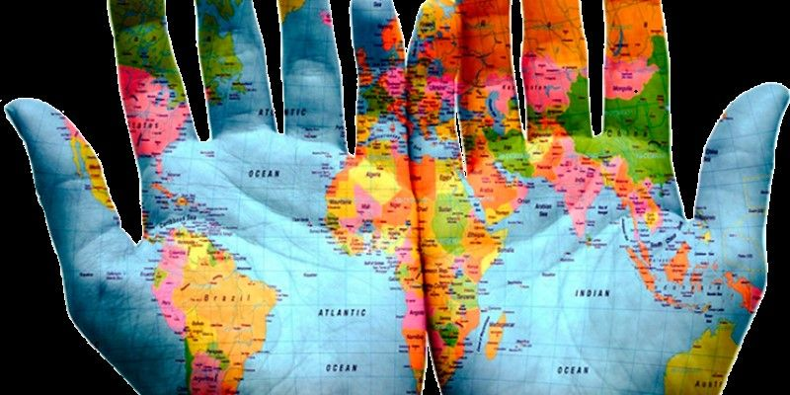

‘Geography is the subject which holds the key to the future’. Michael Palin

Introduction

‘The study of Geography is about more than just memorizing places on a map. It's about understanding the complexity of our world, appreciating the diversity of cultures that exists across continents. And in the end, it's about using all that knowledge to help bridge divides and bring people together’. Barack Obama

Geography is a richly diverse and comprehensive subject that provides us with an understanding of our changing and interconnected world. It involves the study of physical environments and resources; cultures, economies and societies; people and places; and global development and citizenship.

Geographers study the Earth and the distribution of its land, features, and inhabitants. They also examine political or cultural structures and the physical and human geographical characteristics of regions ranging in scale from local to global.

Character Education

The character qualities which will engender high quality geographical enquiry are:
Curiosity; Enthusiasm; Social Intelligence; Teamwork; Resourcefulness; Respect; Empathy and Responsibility.

Accountability

This policy outlines the learning, teaching, organisation and management of Geography at Weald CPS. The implementation of this policy is the responsibility of all teaching staff.

The role of the Geography Leadership Team is to:

- Support colleagues in teaching the subject content and developing their skills in planning, teaching and assessing Geography.
- Update and oversee the audit of resources needed to deliver the curriculum.
- Monitor progression and evaluate the impact of the learning and teaching of Geography
- Review regularly the curriculum content and pedagogy
- Keep up to date with developments in the teaching and assessment of Geography

Aims and Intent
The central intentions of the geography curriculum are to enable children to:
- Develop spatial awareness and an understanding of location, place and space.
- Understand and appreciate the local area, Sevenoaks Weald; how it is changing and how it relates to the rest of the world.
- Acquire rich subject knowledge and specialised geographical vocabulary.
- Understand the processes responsible for key physical and human geographical features.
- Understand the interaction and interdependency between people and their natural and human environments at personal, local, regional, national and global scales. Exemplification through the ‘Connecting Classrooms’ curriculum project in partnership with Kanthenga School, Malawi.
- Understand and analyse critically global issues like climate change, biodiversity loss, poverty, pollution and pandemics.
- Grow into citizens who will respect their local and wider environments and take ethical and political responsibility for the planet and the health and prosperity of future generations.
- Develop competency in the geographical skills required to collect, analyse and present data from fieldwork, diagrams, maps and GIS.

Implementation
The Geography Curriculum content is focused on National Curriculum requirements and contextualized to the local community. Provision is made for all abilities and learning styles.
EYFS
Geography is accessed through the Early Learning Goals linked to the specific area ‘Understanding the World’. This is taught through continuous provision, listening to stories set in different locations, the ‘All About Me’ unit and general topic work about the world we live in.
Years 1 – Year 6
Geography is taught on a 2-year cycle, using the Collins Primary Connected Geography scheme. This is an investigative, enquiry-based approach, highlighting key geographical concepts and providing a comprehensive range of examples at different locational scales around the world. At each key phase (Key Stage One – Years 1 & 2; Lower Key Stage Two – Years 3 & 4 and Upper Key Stage Two - Years 5 & 6), six enquiries are conducted across two years, differentiated to meet age group expectations, whilst maintaining high expectations of subject knowledge and level of vocabulary.

Exemplar of Geography Curriculum subject coverage: Cycle One
Key Phase | Terms 1 | Term 2 | Term 3 | Term 4 | Term 5 | Term 6
KS1 | Why don’t penguins need to fly? |  | What’s the geography of where I live like? |  | How does the geography of Kampong Ayer compare with where I live?
LKS2 |  | How can we live more sustainably? |  | How and why is my local environment changing? |  | Why do so many people live in megacities?
UKS2 | Why is fair trade fair? |  | Why are mountains so important? |  | How is climate change affecting the world?

Exemplar of Geography Curriculum subject coverage: Cycle Two

Key Phase | Terms 1 | Term 2 | Term 3 | Term 4 | Term 5 | Term 6
KS1 |  | How does the weather affect our lives? |  | Why do we love being beside the seaside so much? |  | Why does it matter where our food comes from?
LKS2 | Beyond the Magic Kingdom: what is the Sunshine State really like? |  | Why are jungles so wet and deserts so dry? |  | Why do the biggest earthquakes not always cause the most damage?
UKS2 |  | What is a river? |  | Who are Britain’s National Parks for? |  | How do volcanoes affect the lives of people in Hiemaey?

Fieldwork
Investigations, experiential visits and/or visitors to school are key elements of the learning and teaching strategies.
There will be opportunities for children to undertake purposeful fieldwork both within the outdoor environment of the school, the village and local National Trust sites.

Cross-curricular connections
Through Geography, we can:
- Improve pupils’ critical thinking skills.
- Improve pupils’ competencies in Literacy, Maths, ICT, History, RE, Science and outdoor learning.
- Promote pupils’ awareness and understanding of gender, social, cultural, spiritual and moral issues.
- Develop pupils as active citizens.

Assessment
Teacher assessments (TA) will be made from a variety of sources but most learning will be evidenced in children’s books (knowledge and understanding and key skills). TA data will be inputted into our school data tracking system (Arbor) bi-annually at February half-term and at the end of the academic year in July.

Monitoring and Evaluation

The teaching and learning of Geography will be monitored through pupil interviews, analysis of assessment data, scrutiny of books/work samples and lesson observations.

Impact
The intended impact is for the majority of children in each year group to be working at or above the expected standards for their age. Fundamentally, we want them to be inspired by Geography and develop a passion for extending their geographical knowledge and enquiry; to develop their map reading and GIS skills; to discuss their learning and commit geographical concepts, processes and case studies to long term memory. In addition, we want children to recognise their role as global citizens in safeguarding natural and human systems.

Health and Safety

In line with the Health and Safety, Educational Visits and Supervision during extra-curricular activities policies, comprehensive risk assessments and safeguarding practices will be conducted when planning and carrying out Geography activities.

Resources
Geography resources will be allocated according to the curriculum content for each year group. Children will have the opportunity to use the following resources: globes, atlases, visual media (including aerial photographs), Geography books, maps, graphs, compasses, fieldwork equipment and GIS.

Geographical Association
https://www.geography.org.uk/Teaching-Resources
Royal Geographical Society with IBG
https://www.rgs.org/schools/teaching-resources/

