The Romans

How did the arrival of the Romans change Britain?

**PE**

Swimming

**Music**

Notation.

Crotchets, quavers, minims, semibreves

**Science**

Electricity

Identify electrical and nonelectrical appliances. Explain, with support, how a circuit works. Name at least two electrical conductors and insulators. Create a simple series circuit both with and without a switch. Record findings in a table.

**ICT**

Repetition of shapes

create programs by planning, modifying, and testing commands to create shapes and patterns.

**Art/DT**

Bean mosaics - aqueducts - catapults

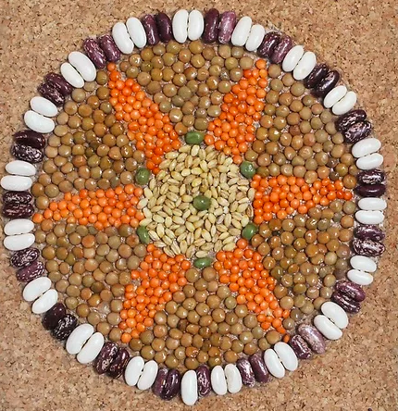

**History**

Language, writing and numbers: What Latin words do we still use today?

Roman towns: How did the Romans change towns? What Roman towns still exist?

Hadrian’s wall: Why was Hadrian’s wall built?

Daily life: How did the Romans change the way we live? (Hygiene/religion)

**Numeracy**

Place value:

- represent numbers to 1000

- round to the nearest 10, 100, 1000

- count in 1000s

- partitioning

- find 1, 10, 100, 1000 more or less

- compare numbers

- order numbers

- count in 25s

- negative numbers

- Roman numerals to 100

Addition and subtraction

- add and subtract 1s, 10s, 100s, and 1000s

- add two 3 digit numbers not crossing 10 or 100

- add two 4 digit numbers – one exchange

- add two 4 digit numbers – more than one exchange

- subtract a 3 digit number – no exchange

- subtract two 4 digit numbers

- estimate subtraction

- estimate answers

**Literacy**

Diary writing

Understand main parts of a diary.

Write a diary entry for a gladiator.

Persuasive writing

Write a persuasive letter.

Reports: *Amazing architecture.*

Read and write stimulating reports. Revise extending sentences with conjunctions and use apostrophes for possession. (*Cool Architecture* by Simon Armstrong)

Stories with familiar themes: *Romans on the Rampage*

Explore setting, character and plot. Study expanded noun phrases and fronted adverbials. Write a new story.

**SPaG**

Pronouns

**RE/PSHE**

Why are festivals so important?

Diwali festival – Rangoli patterns, the story of Prahlad and Holika.

Passover – Seder plate

Look at the Bible and understand its importance to Christians.