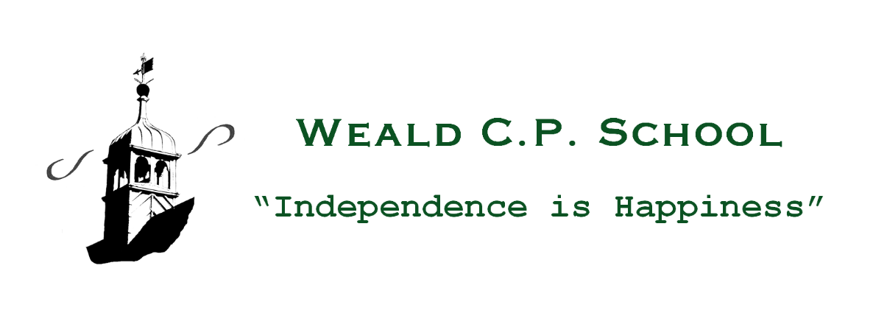

24th February, 2021
Dear Parents/Carers,
Weald CPS COVID-19 Action Plan: Phase 7
Following the pronouncements of Boris Johnson (Prime Minister) last Monday, we have now received ‘Schools coronavirus (COVID-19) operational guidance’ for the full opening of schools from 8th March, 2021. All children are expected to return to school full-time on this date. The up-dated guidance is contextualized to Weald CPS and essentially seeks to balance the minimisation of risks from COVID-19 with the delivery of a full educational experience.
Proportionate control measures to limit the transmission of COVID-19
- Requirement that people who are ill stay at home and self-isolate.
- Robust hand and respiratory hygiene.
- Enhanced cleaning arrangements.
- Minimisation of contact and social distancing wherever possible.
- The wearing of face coverings by adults in all communal areas (not classrooms) and the wearing of personal protective equipment (PPE) in specific circumstances; for example, caring for an ill child.
- Ventilation of occupied areas.
- Asymptomatic Lateral Flow Device testing of adults, twice weekly.
Response to any infection
- Active engagement with NHS Test & Trace
- Managing and containing any confirmed cases of COVID-19 amongst the school community through local health protection team advice.
Grouping of children
The risk of virus transmission will continue to be minimised by limiting the number of pupils and staff in contact with each other to only those within their specified year group/class. Therefore, each year group within the school (from Reception to Year 6) will form its own ‘bubble’. The children currently in the ‘Vulnerable/Critical Worker’ group will, subject to a negative Lateral Flow Test on Sunday 7th March, return to their respective year groups on 8th March. These year group sized bubbles will be kept apart from each other where possible and older children will be encouraged to keep their distance within groups. The sharing of rooms and social spaces between groups will be limited as much as possible. That said, the separation of groups/’bubbles’ and social distancing are not ‘all-or-nothing’ options and will still bring benefits if implemented partially. Therefore, some children will keep in their class groups for the majority of their time at school but may be part of wider groups for specialist teaching and wraparound care; for example, After School Care.
Where at all possible, members of staff will only operate within one group or bubble; however, there will be situations where it is necessary for them to operate across different groups in order to deliver the school timetable. In these cases, they will try to keep their distance (ideally 2 metres) from pupils and other staff. Similarly, peripatetic teachers, temporary members of staff and support staff for SEND children will be able to fulfil their areas of educational provision.
Measures within the classroom and elsewhere within the school
- When circumstances allow, maintaining 2 metres distance from pupils and staff.
- Avoiding face to face contact and minimising time spent within 1 metre of other people. The exception to this is the management of SEND children who may require close contact care.
- Adapting the classroom to support distancing where possible, including seating pupils side by side and facing forwards.
- Avoiding large gatherings like assemblies.
- Timetabling so that movement around the school site is minimised; for example, staggered breaktimes and lunch times.
- Minimising use of the Staff Room.
- Educational equipment may be shared within the designated groups/’bubbles’. These will be cleaned regularly.
- The equipment that pupils bring to school will be limited to school bags, lunch boxes, water bottles, stationery, books and school uniform clothing.
- Pupils and teachers will be allowed to take books and other equipment home but unnecessary sharing should be avoided, especially where it does not contribute to pupils’ education and development.
Drop-off and collection of pupils from school
This potential area of virus transmission was not working smoothly prior to the recent lockdown and so we will be returning to the system employed successfully during Phase 4 of our COVID-19 Action Plan; namely:
- Staggered start and finish times aimed at reducing interaction between groups/’bubbles’.
- All arrivals/drop-offs and collections via the Main Green Gate according to the timings listed in the table below. It is of paramount importance that children are punctual.
- A socially distanced queuing system – please adhere closely to this practice.
- A requirement for all parents and other adults to wear face coverings at drop-off and collection.
- No parents are to enter the school premises without prior appointment.
- Communication with the School Office via telephone (01732 463307) or email (office@weald.kent.sch.uk)
Year Group | Drop-off time | Collection time
Reception | 8.20 a.m. | 3.00 p.m.
Year One | 8.25 a.m. | 3.05 p.m.
Year Two | 8.30 a.m. | 3.10 p.m.
Year Three | 8.35 a.m. | 3.15 p.m.
Year Four | 8.40 a.m. | 3.20 p.m.
Year Five | 8.45 a.m. | 3.25 p.m.
Year Six | 8.50 a.m. | 3.30 p.m.

Attendance expectations
As from 8th March, the Government is making school attendance mandatory again, meaning that the usual rules will apply:
- parents’ duty to ensure that their child attends school regularly
- the school’s responsibility to record attendance and follow up absence
- the availability to issue sanctions (including fixed penalty notices) in line with the Local Authority’s codes of conduct.

Pupils and families who are anxious about the return to school
Some pupils and households may be reluctant or anxious about attending school. Parents who are concerned should contact me via the School Office to seek reassurance on the measures that we are putting in place to reduce any risks.
School lunches from 8th March, 2021
In order to effect a smooth transition back into school life and to maintain social distancing at lunch times, there will be no hot meals until after the Easter holidays. Instead, children may bring their own packed lunch or order one through the school lunch ordering system, making sure to select the cold option. Those eligible for benefits-related free school meals or universal infant free school meals should follow the same process but no payment will be required.
Educational visits
Government guidance advises against educational trips at this time. This advice will be kept under review.
School Uniform
All children will be expected to attend school according to our usual uniform policy. Uniforms do not need to be cleaned any more often than usual. PE lessons will re-commence from 8th March. Your child’s class teacher will be sending you details of the weekly PE schedule, specifying the days when children need to come into school wearing their kit.

Extra-curricular provision
Play4Ages after school provision will re-commence from 8th March on the same days as previously (Mondays & Wednesdays). Session times remain the same:
Full session until 6.00 p.m. £12.00
Half session until 4.30 p.m. £7.00
Both include a healthy snack tea and fruit.

All expressions of interest/booking requests should be sent via email directly to childcare@play4ages.co.uk

A Play4Ages flyer is also attached.

School clubs, sport and other extra-curricular provision will be re-introduced after the Easter holidays, subject to continuing Government approval.
Pupil well-being and support
Some pupils may be experiencing a variety of emotions in response to the COVID-19 outbreak, such as anxiety, stress or low mood. This may particularly be the case for vulnerable children. It is important to contextualize these feelings as normal responses to an abnormal situation.
Pastoral strategies and other activities/interventions will be used to:
- Support the rebuilding of friendships and social engagement.
- Address and equip pupils to respond to issues linked to COVID-19.
- Support pupils with approaches to improving their physical and mental well-being.
Remote education support
The ‘Teams’ online learning platform that has proved so successful during lockdown will be retained for the following purposes:
- The capacity to offer immediate remote education where a small number of pupils/class ‘bubble’ need to self-isolate or there is a local lockdown.
- The setting and assessment of homework assignments to develop the knowledge and skills of all pupils and challenge the more able.
- Learning opportunities for children away from school owing to illness.
- Parent-Teacher consultations during the period that parents are not allowed on the school premises.
As with all COVID-19 phases to date, I know that you and your children will help us to implement this next phase of the Action Plan with optimism, positivity and co-operation.
With my very best wishes,
David

