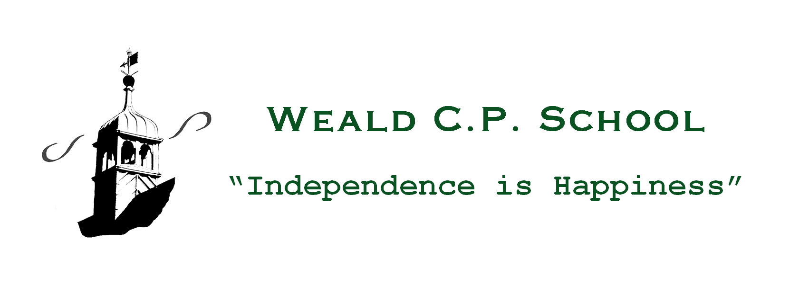
31st December, 2020
Dear Parents and Carers,
I am writing to up-date you following the Government’s announcement yesterday afternoon regarding increased transmission rates and the emergence of variant strains of COVID-19. This has resulted in Sevenoaks being designated as one of the ‘Contingency Framework Areas’ where there are very high rates of virus infection and transmission and where extra protective measures are deemed necessary.
Consequently, the school will not fully open on Monday 4th January, although we will be open to those children who are classed as Vulnerable or those who are the children of Critical Workers. The definitions of these groups may be found at:
https://www.gov.uk/government/publications/coronavirus-covid-19-maintaining-educational-provision/guidance-for-schools-colleges-and-local-authorities-on-maintaining-educational-provision
Those defined as Vulnerable are expected to attend full-time as usual. Those of you who are defined as Critical Workers should notify me via email on dpyle@weald.kent.sch.uk by 7.00 p.m. on Friday 1st January 2021 if you need your children to be educated at school at any time throughout this period. Please note that, where possible, you should keep your children at home if you are a Critical Worker to ensure we can cater effectively for those children for whom there is no adult supervision at home. Please be sure to email me directly and not via the School Office email address.
As you will be aware, at Weald CPS, we are using Microsoft Teams (Years 1-6) and Tapestry (Reception) as our methods of online learning for children. You child should have an account for the appropriate online platform; however, if you are unsure about how to access this please email your child’s class teacher and they will be very happy to assist you with this (email addresses can be found at the bottom of this letter).
This online learning will be functioning by the morning of Monday 4th January and class teachers will be setting work by 9 a.m. each morning. Teachers will be available on Teams to answer any enquiries between 9.00 and 12.00 each morning and will also be logging in again at 1.30 p.m. to check on the children’s progress. It is not our intention for children to be sitting in front of a computer screen all day and the work set will include online work, book-based learning, reading and physical exercise.
If you find yourself in a position where you do not have appropriate equipment at home to allow the children to access Teams, then please contact me and we will endeavour to help.
If you have something confidential you wish to discuss with your child’s class teacher then please email them. In addition, we have two members of staff who have particular responsibilities for the welfare of children: Miss Holly Hutchins and Mrs Alice Coleman. Please contact them should you need guidance or support.
For those children attending school, please note the following:
- School will open at 8.30 a.m. Please come to the School Office door rather than the Green Gate where you will be greeted by the members of staff on duty.
- The school will be staffed each day by two members of teaching staff as well as Mr Taylor and me.
- The children may attend school in their own clothes.
- Please send your child with a packed lunch, water bottle and a snack.
- If you qualify for Free School Meals, then vouchers will be made available to you for you to spend at local supermarkets.
- The children will be working on the same work as those children who are not in school via their Teams or Tapestry accounts.
- No After School Facility (Play4Ages), clubs or school trips will be running until further notice.
- Even if your child is coming into school, you must continue to follow Government advice that if any one person in your household presents with symptoms of COVID-19, everyone living there must stay at home for 10 days.
- Collection will be from the School Office door at 3.00 p.m.
Please note that these arrangements will stay in place until further notice. As soon as there are any changes to the above, then I will of course let you know.
Although this next step presents us with some operational challenges, I am very grateful to you all for your continued support. I understand that this recent announcement will have been met with various responses depending on your personal views on home learning and the benefits and risks associated with children attending school throughout this pandemic. My utmost priority has always been that the children’s education and emotional and mental well-being are safeguarded as much as possible and I truly hope that the school will be fully open again before too long.
Kindest regards,
David

Staff email addresses:
Reception selbra@weald.kent.sch.uk
Year One kmulley@weald.kent.sch.uk
Year Two alittlejohn@weald.kent.sch.uk
Year Three lehlers@weald.kent.sch.uk
Year Four efox@weald.kent.sch.uk
Year Five phousden@weald.kent.sch.uk and jives@weald.kent.sch.uk
Year Six ctaylor@weald.kent.sch.uk
Learning Success Team
hhutchins@weald.kent.sch.uk and acoleman@weald.kent.sch.uk

