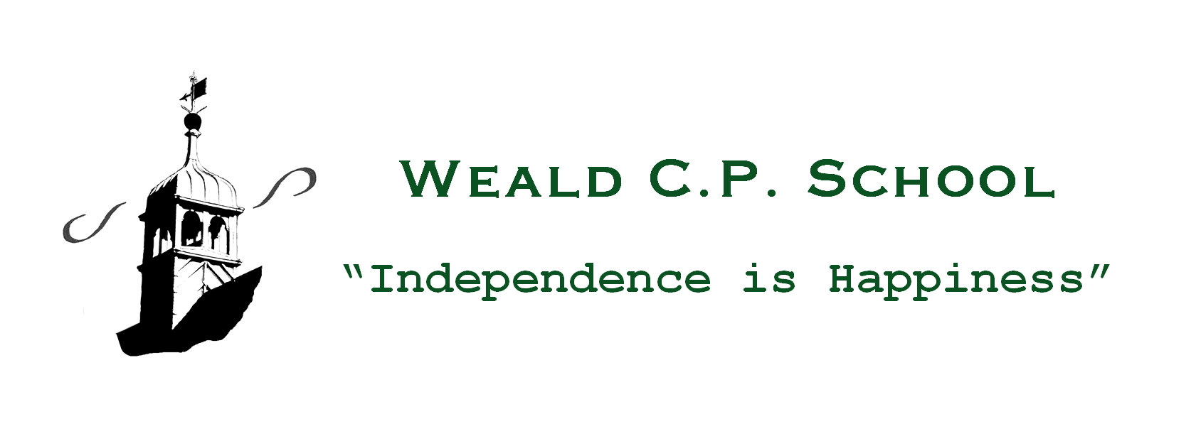
17th December, 2020
Dear Parents/Carers,
Christmas this year will be different, not only because we will continue to be restricted in who we can see, share laughter with and hug but also because our feelings will inevitably be governed by everything we have had to contend with throughout 2020.
It has been an unbelievably challenging year and we should not underestimate the levels of intuition, compassion, creativity, collaboration and determination required to turn a negative situation into positive experiences. In our attempts to reduce virus transmission, we have adopted new ways of living: communicating via virtual platforms; working from and being educated at home; going for country walks rather than to the cinema or a theme park and missing out on holidays, activities and social gatherings. For many, there has been a true sense of putting life on hold as medical experts, politicians and others charged with steering us through the global pandemic have wrestled to make the right decisions on behalf of the nation.
Communities are inevitably defined by the way in which they cope during periods of adversity or crisis. The various constituencies of life in our village (church, school, shop, pub, parish council etc) have learnt to adapt their practices admirably well and have ‘walked the extra mile’ in order to safeguard the welfare of all Weald citizens.
This overriding concern for others is reminiscent of the children’s stop-motion animation, ‘Trumpton’, which was a great TV favourite during the 1960s. In every episode, there was a minor catastrophe, leading to the call-out of the Trumpton Fire Brigade. They never put out any fires but were hugely successful in retrieving the Mayor’s hat from a tree, removing fallen branches; mending the town clock and rescuing Chippy Minton’s savings from a rocking horse on an unlit bonfire!
What was so reassuring about life in Trumpton? I sense that, despite the chaos and mishap integral to the plot, children trusted the kindness and competence of well-rounded characters and recognised that things would always work out satisfactorily in the end. Furthermore, solace, hope and peace of mind could be derived from the constancy and repeated features of day-to-day happenings. Each Trumpton programme, for example, started with a shot of the Town Hall Clock, accompanied by the words: ‘Here is the clock, the Trumpton clock. Telling the time, steadily, sensibly; never too quickly, never too slowly. Telling the time for Trumpton’. Similarly, at the end of each episode, the playing of the band was a welcome release from the tension that had ensued earlier.
Likewise, life in Weald since March has been a wonderful combination of resilience and community cohesion. Within school, serving to re-invigorate the staff and maintain their dedication and energy levels has been the children’s limitless and all enduring enthusiasm for life; their curiosity, sense of humour and positive outlook have been a regular tonic to us all. We should be justly proud of the part our children play in community life; nowhere was this more evident this year than at the short Remembrance Service at the flag-pole on the Village Green.
In the wider community, initiatives such as ‘Weald Cares’ are emblematic of the deep-seated virtues of kinship, that should be uppermost in our minds and hearts, particularly at this time of the year. The love and support voluntarily bestowed, by so many, upon the most vulnerable within our community are precious commodities that should be universally applauded and appreciated. There are times in close-knit settlements when ‘everyone knowing each other’s business’ might be considered an annoyance; however, in difficult circumstances, the interest of neighbours often becomes a genuine strength that offsets loneliness and feelings of despair. Deliveries of food parcels, medical prescriptions and a friendly knock on the door to check that everything is okay are invaluable lifelines, sustaining physical and mental well-being. So, in your capacity as ‘village volunteers’, whether you see yourself as Captain Flack, Pugh, Pugh, Barney McGrew, Cuthbert, Dibble or Grubb, take a moment to pat yourself on the back and feel warm inside. Contributing to the care of one’s community is not only a sign of altruism but it helps each of us to grow in character. As Mahatma Gandhi suggested, ‘The best way to find yourself is to lose yourself in the service of others’.
Therefore, as this term comes to a close and we all look forward to some relaxation, exercise, healthy eating (!) and convivial (albeit limited) company, let us focus as a community on the star adorning our Christmas trees that offers direction, aspiration, joy and hope to the darkness of this world.
May I take this opportunity of wishing you and your families a Christmas full of fresh air, mince pies, board games and good cheer.
Kindest regards,
David

The Christmas Star

On that first Christmas, long ago
They say a brilliant star shone forth.
It guided Magi on their way
to where the infant Jesus lay.
What was that star that shone that night?
was it a comet streaking by?
Perhaps two wanderers in the sky,
or else a star about to die.
Oh kindly light
that offered hope
You burned bright briefly
then were gone.
But a people in darkness
saw a bright new dawn
when a baby cried
that Christmas morn

Long Barn Road, Weald, Sevenoaks TN14 6PY
Tel 01732 463307
Email office@weald.kent.sch.uk
Website www.weald.kent.sch.uk

