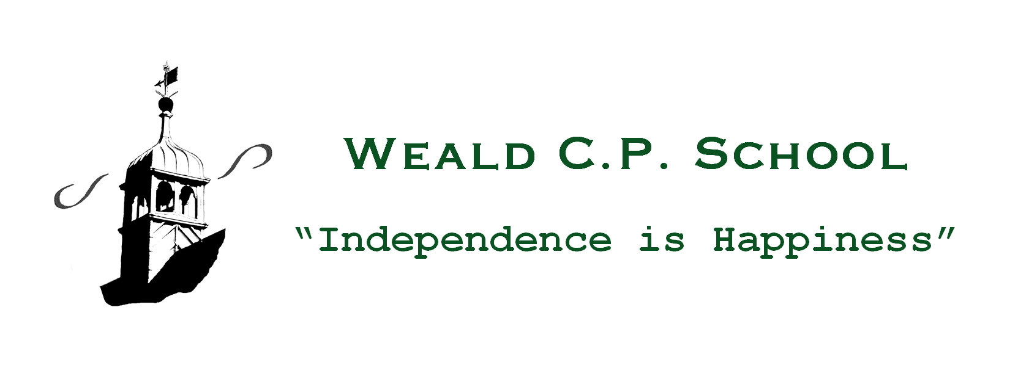
27th May, 2020
Dear Parents and Carers,
Thank you for indicating whether you intend to send your child(ren) back to school or not on Monday, 1st June. This information has helped enormously with our planning.
I am now writing to give you further details of our updated plans for reopening Weald CPS on Monday 1st June (assuming this continues to be confirmed by the Government) for the children in Reception, Year 1 and Year 6. The provision for vulnerable/critical worker children will remain as it is currently.
The paramount consideration in our planning and provision has been and will continue to be the safety and welfare of the children, the staff and our parents. School will not be as it normally is, and we are having to create a ‘new normal’ for the moment. It would be very helpful if you would discuss the arrangements outlined below with the children as appropriate to their age, to help prepare them to understand that the rooms and outdoor spaces they are used to will not be looking exactly the same and the routines will also be different.
Arrangements for drop off and collection
We ask that only one adult per child/family comes to Weald CPS for drop-off or collection in order to prevent too many people congregating outside the school gates. Collection and drop off times will be as follows:
 | Drop-off | Where | Collection | Where
Reception | 8.30 a.m. | Main School Gate | 11.30 a.m. | Main School Gate
Year One | 8.45 a.m. | Main School Gate | 11.45 a.m. | Main School Gate
Year Six | 9.00 a.m. | Main School Gate | 3.00 p.m. | Main School Gate
Critical Worker Group | 8.30 a.m. | School Office Entrance | 3.15 p.m. | School Office Entrance

- At drop-off times there will be no access for parents to the playground.
- Children will be met at the door/gate by a member of their Teaching Group staff.
- Please be patient during these times and adhere to the 2 metres social distancing rules whilst you wait on the pavement on Long Barn Road. There will be tape and signage indicating where you can wait and line up to drop off your child.
- At collection times, the main School Gate will open and children will walk/be escorted up the slope individually and socially distanced to be re-connected with their parents at the School Gate.
- Signage and markings will indicate where you should go from there.
- It will not be possible to stop and engage staff in conversation at these times. Any messages about the session will be sent to you via email.
- If you need to speak to a member of staff about a particular issue, please arrange this with them by telephoning or emailing the School Office. Please note: we will not be permitting any visitors into school unless it is a matter of extreme importance and has been prior arranged.
Bubbles/Family Groups
Every child will be allocated a Teaching Group or ‘bubble’ (composed of 15 or fewer children) to stay with while they are in school. The bubbles will be staffed by their Class Teacher/TA wherever possible (and certainly by staff who are familiar to the children if not).
In Reception, the children will be divided into two bubbles (if necessary) and will be with their Class Teacher/TA, occupying two classrooms (Pluto and Mercury).
In Year One, the children will be in one Teaching Group/ bubble with their Class Teacher/TA in Venus classroom within the modular building.
In Year Six, the children will be divided into two bubbles with their Class Teacher/TA in Mars and Neptune classrooms.
The Vulnerable/Critical Worker children will be in one Teaching Group/bubble with 2 members of staff in Saturn Classroom.
Each bubble will remain as a separate entity, and the children will not work, play or interact with children from a different bubble, even within their year group. However, it is important to recognise and understand that social distancing within each bubble will simply not be possible, as young children will naturally and automatically interact with each other and with the staff in a way that prevents this from being achieved over a sustained period of time.
Therefore, it is important to be clear with you that it is not the school’s intention to attempt rigid social distancing between pupils and staff within these bubbles, but that by creating them, the number of people the children and staff come into contact with on a daily basis will be significantly reduced.
There are measures, however, that will be put in place in classrooms to create as much space/distance as possible for children to work and move around in:
- Bubbles may have the use of more than one room/break-out area
- When based at tables, older children will use one double desk each
- In Reception and Year 1 classrooms, tables and chairs will be spaced out to allow for easy access and movement around the rooms

Movement around the buildings and use of outdoor areas
Children will remain in their bubbles when they are outside, either for learning or playtimes. They will have designated outdoor areas in which they will stay. Children will have access to outdoor play resources, which will be wiped or sprayed after each use. Break-times for Teaching Groups/bubbles will be staggered.

Cleaning and Hygiene
- Our cleaners will be on site every evening to clean all areas of the school. In addition to their established routines, they will pay particular attention to frequently touched features such as door handles, light switches and keypads.
- Staff will also carry out regular wiping down of classroom furniture and resources as necessary during the session.
- Children and adults will follow established routines for handwashing and use of hand sanitiser. Hand sanitiser is available in classrooms and at entrances to the buildings. Hands will be washed frequently throughout the session, including on arrival at school, before and after snack time, after being outside and before going home.
- We will promote good respiratory hygiene practices by encouraging children not to touch their mouth, eyes or nose and to use a tissue or elbow to cough or sneeze and use bins for tissue waste (‘Catch It, Bin It, Kill It’).
- Only one child at a time to use the toilets.
- We will ensure that where possible that classrooms remain well-ventilated by opening doors and windows.
- Removal of soft furnishings and toys that are hard to clean.
- We ask pupils to come into school wearing their own home clothes so that clothes can be washed frequently and clean clothes can be worn each day. If parents feel strongly about children wearing uniform, this should only be items that can be washed easily and replaced each day.

Medical
We would advise you to take your child’s temperature before sending them to school. If your child is at all unwell or has a slightly raised temperature, please keep them at home.
At school, we will take the temperatures of pupils and staff only if anyone shows (or indicates) they are feeling unwell. If we think your child needs to go home due to feeling unwell, we will inform you immediately. Members of staff administering medication or taking temperatures will be expected to wear PPE to protect themselves. The guidelines indicate that PPE is not required for all staff in school.
Furthermore, it is essential that all members of the school community continue to follow the Government advice regarding children or adults who present with symptoms of COVID 19 by self-isolating for 7 days and all household members self-isolating for 14 days. If a child presents with symptoms of COVID 19 whilst at school, we will isolate the child with a member of staff, ask the member of staff to use the available PPE and contact you immediately.
If anyone tests positive for Covid-19 we will inform all parents of the school. The other children within the bubble would be required to self-isolate for 14 days. Advice concerning the wider school setting would be given by Public Health England.

Food and Drink
Please provide children with snacks in disposable bags each day to avoid cross contamination. Lunch will not take place in school.
Please send a named water bottle to school on the first day back. This will remain in school and be cleaned and filled every day for each child.

No bags or other items should be brought to school from home.

Remote Teaching
There will inevitably be some changes to our remote teaching from 1st June. It is important to remember that the class teachers in these returning year groups will be in school for half of the day teaching and supervising our bubbles of children. If your child is in a year group that has been allowed to return to school and you have opted not to send your child in during this period, you will still receive the online provision for home learning as normal, but the Teams class check-in sessions will not take place as frequently as they have been. If your child is in a year group that has not been told they can return to school, the remote learning will continue as it has been, although your child’s class teacher may now have other commitments, so their availability may not be as accessible as it has been. Please keep in contact with your child’s class teacher via the usual channels so that we can ensure your child’s needs are being met whether your child is at home learning or in school.
Thank you as always for your continuing support and the wonderful work that has been taking place during this first half term. Please enjoy the rest of the half-term break. The staff and I look forward to seeing many of you on 1st June, all being well.

Kindest regards,

David

Long Barn Road, Weald, Sevenoaks TN14 6PY
Tel 01732 463307
Email office@weald.kent.sch.uk
Website www.weald.kent.sch.uk

