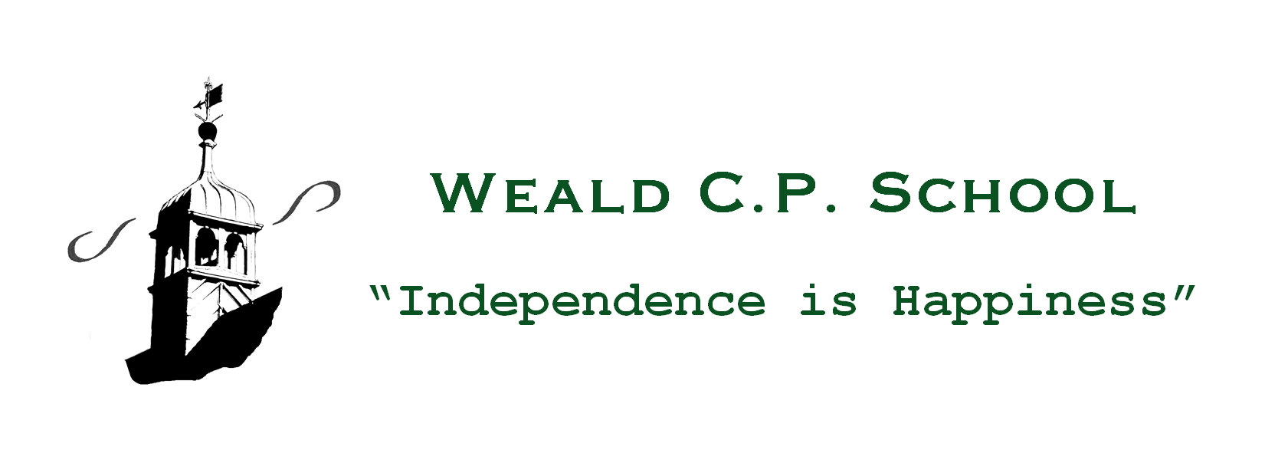

6th July, 2020

Dear Parents/Carers,

Weald CPS COVID-19 Action Plan: Phase 4
Following the pronouncements of Gavin Williamson (The Secretary of State for Education) last Thursday, we have now received ‘Guidance for the full opening of schools’ from September. This letter sets out the arrangements for all children returning to school full-time from 2nd September 2020 and should be read in conjunction with my letters dated 19th and 27th May and 11th June. The up-dated guidance is contextualized to Weald CPS and essentially seeks to balance the minimisation of risks from COVID-19 with the delivery of a full educational experience.
Proportionate control measures to limit the transmission of COVID-19
- Requirement that people who are ill stay at home
- Robust hand and respiratory hygiene
- Enhanced cleaning arrangements
- Active engagement with NHS Test & Trace
- Minimising contact and social distancing wherever possible
- The wearing of personal protective equipment (PPE) only in specific circumstances; for example, caring for an ill child.
- Managing any confirmed cases of COVID-19 amongst the school community through local health protection team advice.
Grouping of children
To date, the risk of virus transmission has been minimised by limiting the number of pupils and staff in contact with each other to only those within the specified group or ‘bubble’. Going forwards from 2nd September, this approach will be maintained; however, in order to enable all children to re-adopt a full timetable of schooling, the maximum size of the ‘bubble’ will increase from 15 to 30 pupils.
Therefore, each year group within the school (from Reception to Year 6) will form its own ‘bubble’. The children currently in the ‘Vulnerable/Critical Worker’ group will return to their respective year groups. These year group sized bubbles will be kept apart from each other where possible and older children will be encouraged to keep their distance within groups. The sharing of rooms and social spaces between groups will be limited as much as possible. That said, the separation of groups/’bubbles’ and social distancing are not ‘all-or-nothing’ options and will still bring benefits if implemented partially. Therefore, some children will keep in their class groups for the majority of their time at school but may be part of wider groups for specialist teaching and wraparound care; for example, After School Care: see later under ‘Extra-curricular provision’.
Where at all possible, members of staff will only operate within one group or bubble; however, there will be situations where it is necessary for them to operate across different groups in order to deliver the school timetable. In these cases, they will try to keep their distance (ideally 2 metres) from pupils and other staff. Similarly, peripatetic teachers, temporary members of staff and support staff for SEND children will be able to fulfil their areas of educational provision.

Measures within the classroom and elsewhere within the school
- When circumstances allow, maintaining 2 metres distance from pupils and staff.
- Avoiding face to face contact and minimising time spent within 1 metre of other people. The exception to this is the management of SEND children who may require close contact care.
- Adapting the classroom to support distancing where possible, including seating pupils side by side and facing forwards.
- Avoiding large gatherings like assemblies.
- Timetabling so that movement around the school site is minimised; for example, staggered breaktimes and lunch times.
- Minimising use of the Staff Room.
- Educational equipment may be shared within the designated groups/’bubbles’. These will be cleaned regularly.
- The equipment that pupils bring to school will be limited to school bags, stationery, books and school uniform clothing.
- Pupils and teachers will now be allowed to take books and other equipment home but unnecessary sharing should be avoided, especially where it does not contribute to pupils’ education and development.

Drop-off and collection of pupils from school
- Staggered start and finish times will help to reduce interaction between groups/’bubbles’.
- Reception drop-off will be via the Side Gate by the School Office.
- All other arrivals/drop-offs and collections will be via the Main Green Gate according to the timings listed in the table below. It is of paramount importance that children are punctual.
- The current socially distanced queuing system will continue – please adhere closely to the established practice.
- No parents are to enter the school premises without prior appointment.
- Communication with the School Office will continue to be via telephone (01732 463307) or email (office@weald.kent.sch.uk)

Year Group | Drop-off time | Collection time
Reception | 8.20 a.m. | 3.00 p.m.
Year One | 8.25 a.m. | 3.05 p.m.
Year Two | 8.30 a.m. | 3.10 p.m.
Year Three | 8.35 a.m. | 3.15 p.m.
Year Four | 8.40 a.m. | 3.20 p.m.
Year Five | 8.45 a.m. | 3.25 p.m.
Year Six | 8.50 a.m. | 3.30 p.m.

Attendance expectations
Under Phases 1, 2 & 3 of the Weald CPS COVID-19 action Plan, pupil attendance has been optional. As from September, the Government is making school attendance mandatory again, meaning that the usual rules will apply:
- parents’ duty to ensure that their child attends school regularly
- the school’s responsibility to record attendance and follow up absence
- the availability to issue sanctions (including fixed penalty notices) in line with the Local Authority’s codes of conduct.

Pupils and families who are anxious about return to school
Parents of pupils with significant risk factors who are concerned should contact me via the School Office to discuss their concerns and receive reassurance of the measures that have been put in place to reduce risk at school.

School lunches from 2nd September, 2020
In order to maintain social distancing at lunch times, there will be no hot meals until further notice; instead, children may bring their own packed lunch or order one through the new school lunch ordering system, making sure to select the cold option: see separate communication. Those eligible for benefits-related free school meals or universal infant free school meals should follow the same process but no payment will be required.

Educational visits
Government guidance advises against domestic (UK) overnight and overseas educational trips. Non-overnight domestic educational visits will, however, resume subject to protective/control measures and detailed risk assessments.
School Uniform
During Phases 1, 2 & 3 of the COVID-19 Action Plan, we relaxed our uniform policy. As from 2nd September, we will return to our usual uniform policy as it plays a valuable role in contributing to the school’s ethos and setting an appropriate tone. Uniforms do not need to be cleaned any more often than usual.
Extra-curricular provision
Play4Ages after school provision will re-commence from 2nd September; however, in order to safeguard the coherence of the pupil groups/’bubbles’, there will be no clubs or other activities, neither during the school day nor after. The situation regarding clubs, sport and other extra-curricular provision will be reviewed in line with Government guidance as the Autumn Term progresses.

Pupil well-being and support
Pupils will be experiencing a variety of emotions in response to the COVID-19 outbreak, such as anxiety, stress or low mood. This may particularly be the case for vulnerable children. It is important to contextualise these feelings as normal responses to an abnormal situation.
Over the last month, many children have needed support in re-adjusting to school; some have enjoyed being at home and have required re-settling into the practices of in school learning; others have not experienced any challenges and have relished the opportunity of coming back to school. The return to school has allowed social interaction with peers and teachers which has had a marked positive impact on well-being. The featured article on page 18 of the Sevenoaks Chronicle dated 9th July, 2020 is a testament to this. Re-acclimatisation to school life will continue in September as children make the transition from half to full days. Where children experience issues, there will be focused pastoral support and interventions from outside agencies where appropriate.

Remote education support
The ‘Teams’ online learning platform that has proved so successful during lockdown will be retained for the following purposes:
- The capacity to offer immediate remote education where a small number of pupils/class ‘bubble’ need to self-isolate or there is a local lockdown.
- The setting and assessment of homework assignments to develop the knowledge and skills of all pupils and challenge the more able.
- Learning opportunities for children away from school owing to illness.
- Parent-Teacher consultations during the period that parents are not allowed on the school premises.

I know that you and your children will help me to implement this next phase of the Action Plan with the same positivity and co-operation that you have demonstrated since the COVID-19 pandemic first disrupted our lives. And as we all continue to face multifarious challenges and experience the inevitable confusion that lockdown and the emergence from lockdown has brought, I truly hope that you and your families will be able to re-adjust to the ‘new normal’ and embrace any changes in your lives.
‘And once the storm is over, you won’t remember how you made it through, how you managed to survive. You won’t even be sure, whether the storm is really over. But one thing is certain. When you come out of the storm, you won’t be the same person who walked in. That’s what this storm’s all about’.
Haruki Murakami

With my very best wishes,

David

