Neptune-Term 2 Creative Curriculum: Why were the Nile floods essential to the Ancient Egyptians? 2019/2020
Art/DT:

Create sketch books to record their observations and use them to review and revisit ideas
To improve their mastery of art and design techniques, including drawing, painting and sculpture with a range of materials [for example, pencil, charcoal, paint, clay]
Learn about great artists, architects and designers in history
SPaG
Word - Converting nouns or adjectives into verbs using suffixes and Verb prefixes [for example, dis–, de–, mis–, over– and re–]
Sentence - Relative clauses and modal verbs
Text - Linking ideas across paragraphs using adverbials
Punctuation - Brackets, dashes or commas

ICT - Finding things out – Research

- Select an appropriate search engine and develop strategies for finding information
- Continue to develop a deeper understanding of the internet.
- Consider the effectiveness of their search results.
- Discuss issues of copyright and downloading material
  - Recognise different types of webpages,
question their reliability.
  - Begin to reference sources used in their work
  - Copy, paste, save and use pictures, text + sound.

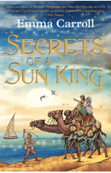
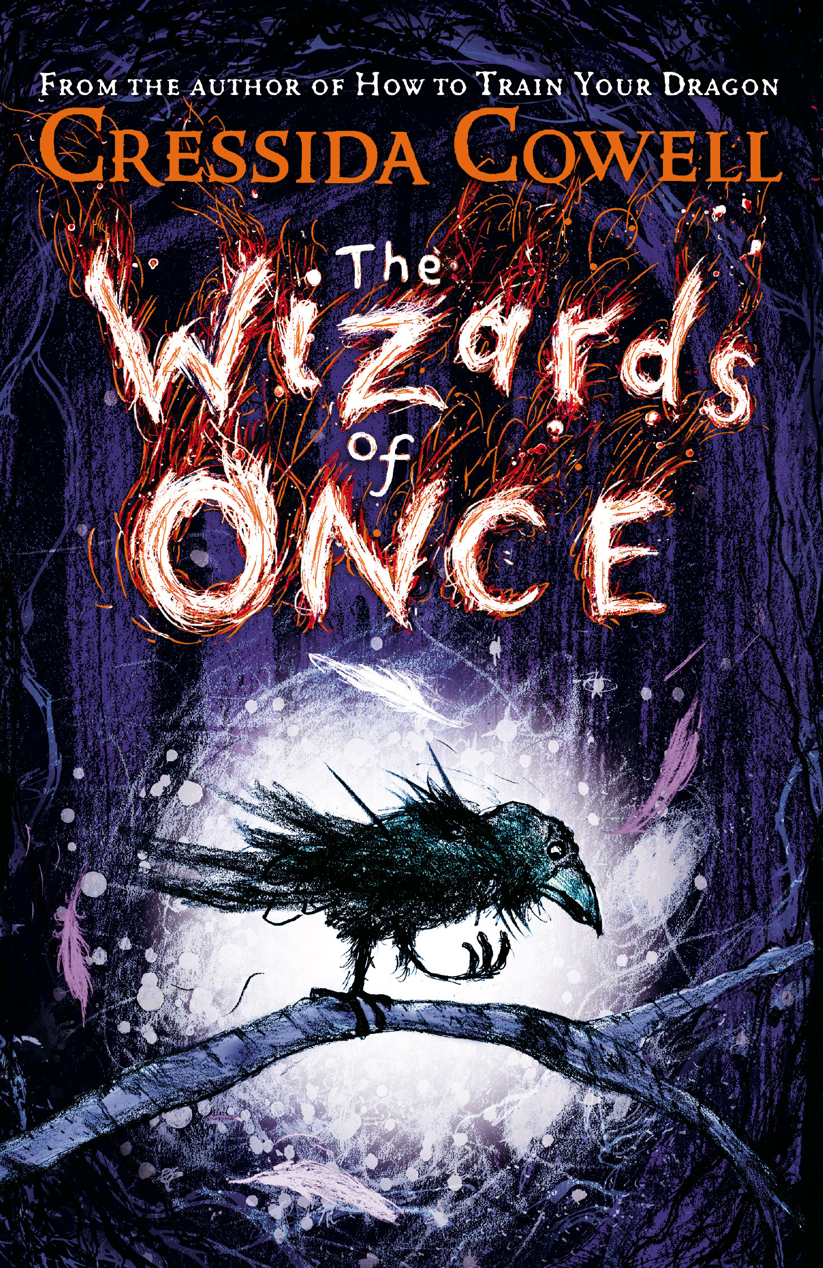
Topic:
Why were the Nile Floods essential to the Ancient Egyptians?
Where is the river Nile located - Compare maps from now and then?
What was The Nile Used for?
Explain roles within Egyptian life
Why did the Nile flood?
Application of skills & processes:
Recognise Identify Describe Empathise
Observe Select Categorise Reach informed conclusions
Classify Sequence Compare & contrast Make reasoned judgements
Recall Summarise Reason/speculate Critique
Synthesise Explain Hypothesise Demonstrate understanding
Justify Apply Evaluate

Literacy/ SPAG:

Text: Secrets of a Sun King, Emma Carroll.
Text: The Wizards of Once, Cressida Cowell
Author study – way in which she writes, novel comparison
Shared learning with school
Book introduction, character and setting descriptions.
Story prediction.

Classic Fiction (Fiction 5 Sum): Features of playscripts, narrative style of authors,
differing viewpoints, descriptive language, similes & metaphors, story
writing-scaffold planning & editing,dialogue-direct speech features

R.E:
How many people believe in God?
Is God Real? What do Christians think?
How do we know what is true? Why do people believe or not believe in God?
What do Christians believe about how the world began? Do they all share the same idea?
Is God Real? Why do some people believe God exists? Why do some people believe God doesn’t exist?

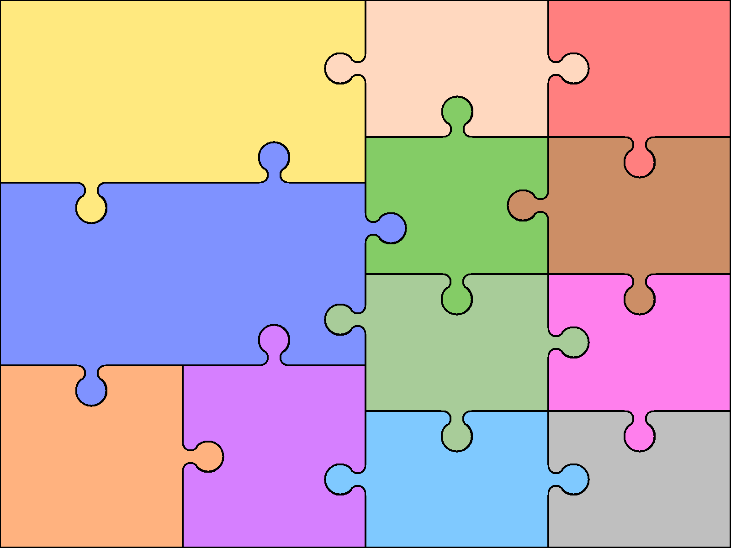  Numeracy  - Number –Division  - Number – Fractions  - Geometry – position and direction  - Conclusion | Numeracy - Reasoning  Reasoning is the catalyst for math’s this year. A key skill in becoming fully numerate (and to becoming an independent thinker) is the ability to make your own decisions and learn from them.  This key skill is central to the children’s math’s learning and a chance to allow learners to choose their own methods and ways of recording, then present their findings in whichever way they decide. Learners are encouraged to explain their reasoning, thus extending the understanding and their ability to communicate, numerically. |  |  | Science- electricity  Building on their work in year 4, pupils should construct simple series circuits, to help them to answer questions about what happens when they try different components, for example, switches, bulbs, buzzers and motors. They should learn how to represent a simple circuit in a diagram using recognised symbols  Languages: Spanish  - To be able to know greetings  - To be able to say their name and how old they are  - To be able recall family information  - To name animals in Spanish  - Weather and seasons | Physical Education  Gymnastics  - Body Management - Review & Progress  - Quality sequences using strength & control  - Hand Apparatus  - Continued Hand Apparatus  - Advanced Floor actions  - Vault  - Circuit of events  Music  As part of the wider opportunities in music the children will spend the year learning the Djembe Drums.  Children will be:  - Learning the notes  - Playing simple call and response rhythm  - Learn cannon  - conduct

