Weald CPS Attendance Statement

To promote independent, confident, well organised and happy children with enquiring minds and the skills to maximise their full learning potential.

- Good attendance by pupils and staff is part of this school’s daily life
- We ensure that the teaching and ancillary staff are of a high calibre and have time and resources to deliver excellent education.
- We ensure a high-quality curriculum and teaching.
- We ensure support is in place to meet the individual needs of every pupil.
- We have systems/procedures in place that are monitored and reviewed with the input of staff, pupils and parents.
- We make decisions and plan based on evidence, including data analysis.
- We fast track attendance issues with an emphasis on early intervention and referral to external agencies when required.
- We work in partnership with the local community, businesses and parents.
Attendance matters
We are committed to working with parents and the Missing Education & Child Employment Service to maintain our excellent attendance rate …….

Why is good attendance so important
Pupils who do not regularly attend school are more likely to fall short of achieving their full academic potential. Statistics show that 90% of persistent absentees, poor attenders or non-attenders fail to achieve five or more good grades at GCSE and approximately one third end up with no GCSEs at all. Parents/carers have a legal duty to ensure that their child attends school on a regular, full time basis. Schools have a duty to monitor and act early to address patterns of absence. Where parents/carers fail to meet their legal responsibilities, the local authority has powers to take legal action in the form of penalty notices or prosecution. Poor attendance at school can lead to their child's life chances being detrimentally affected. Poor attendance can lead to disaffection amongst peers (lost friendship groups, missed opportunities to take part in school events). Irregular attendance can cause difficulties for pupils to catch up with work and pastoral events and can lead to long term absence.

Absence due to illness
On the first day of absence, parents/carers, should notify the school of their child's absence. The school will only authorise absences that are reported as being due to illness and where we are satisfied that the absences are genuine. We may request medical evidence to cover the absence; for example, an appointment card/slip, a text message confirming that an appointment has been made with the GP, a photocopy of the tear off slip retained by the parent when a prescription is issued.

To report an absence, please telephone the school on 01732 463307 and leave a message on our absence line. Alternatively, if you would like to speak to a member of staff about the absence, please telephone the School Office from 8.45 a.m.

Missing registration for a medical or dental appointment will be recorded as an authorised absence; however, parents/carers are encouraged to make appointments outside school hours and to keep children out for the minimum time necessary for the appointment. A copy of the appointment letter/card should be provided to the school in order for the absence to be authorised.

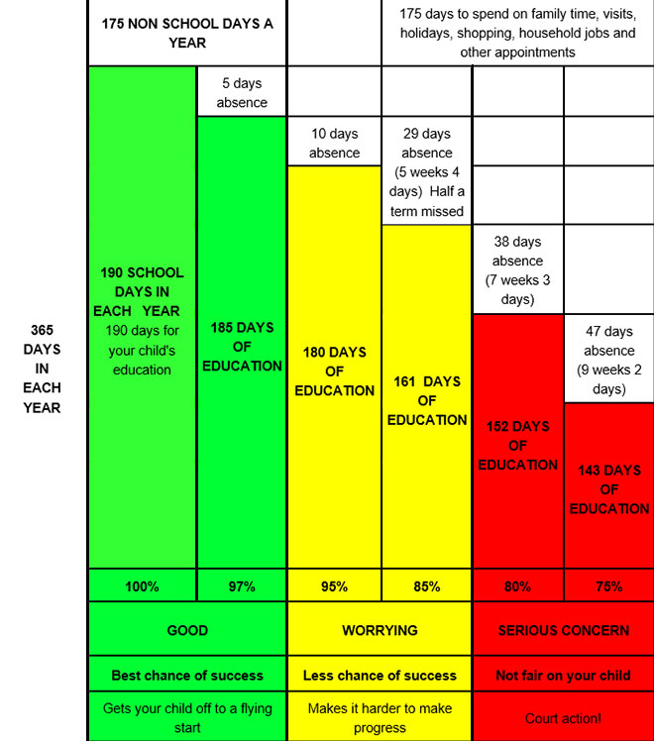
Traffic Light Diagram: the importance of good school attendance

