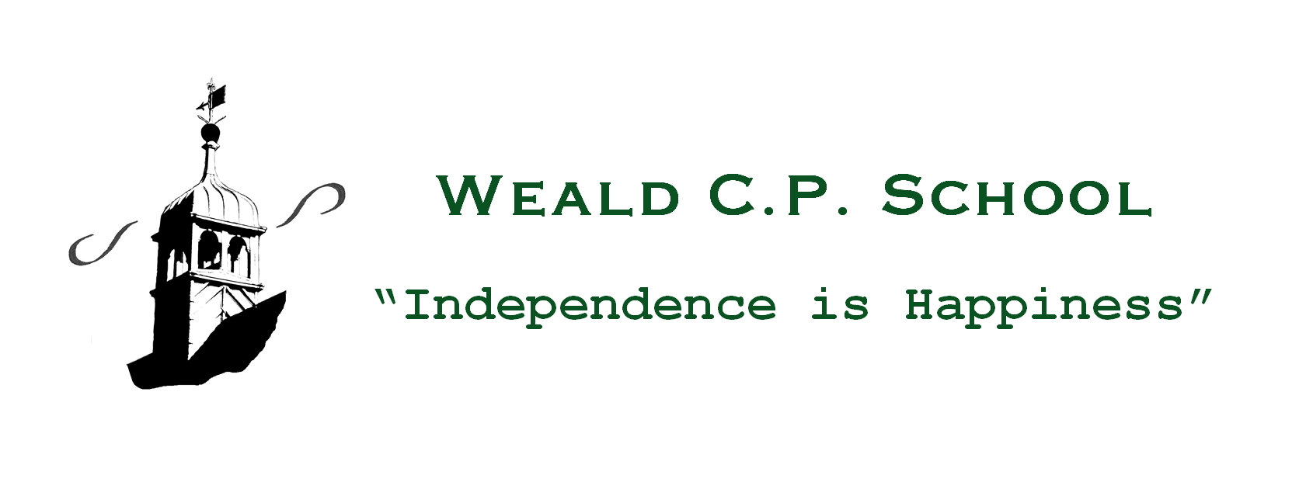
Weald CPS: Social Media Policy
Context
Social media (e.g. Facebook, Twitter, LinkedIn) is a broad term for any kind of online platform which enables people to directly interact with each other. Some games, for example Minecraft or World of Warcraft and video sharing platforms such as You Tube have social media elements to them.
Weald CPS recognises the numerous benefits and opportunities which a social media presence offers. Staff, parents/carers and pupils/students are actively encouraged to find creative ways to use social media. Nonetheless, there are risks associated with social media use, especially around the issues of safeguarding, bullying and personal reputation. This policy aims to encourage the safe use of social media by Weald CPS, its staff, parents, carers and children.

Scope
This policy is subject to the school’s E-Safety Policy and Acceptable Use Agreements.
This policy:
- Applies to all staff and to all online communications which directly or indirectly, represent the school.
- Applies to online communications posted at any time and from anywhere.
- Encourages the safe and responsible use of social media through training and education
The school respects privacy and understands that staff and pupils may use social media forums in their private lives; however, personal communications likely to have a negative impact on professional standards and/or the school’s reputation are within the scope of this policy.
Professional communications are those made through official channels, posted on a school account or using the school name. All professional communications are within the scope of this policy.
Personal communications are those made via a personal social media accounts. In all cases, where a personal account is used which associates itself with the school or impacts on the school, it must be made clear that the member of staff is not communicating on behalf of the school with an appropriate disclaimer. Such personal communications are within the scope of this policy.
Personal communications which do not refer to or impact upon the school are outside the scope of this policy.
Digital communications with pupils are also considered. Staff should not use social media to communicate with children.

Organisational control

Roles & Responsibilities
- Headteacher
  - Facilitate training and guidance on Social Media use.
  - Develop and implement the Social Media policy
  - Take a lead role in investigating any reported incidents.
  - Make an initial assessment when an incident is reported and involve appropriate staff and external agencies as required.
  - Approve account creation
- IT Technician
  - Create the account following LT approval
  - Store account details, including passwords securely
  - Monitor the account
  - Control the process for managing an account after the lead staff member has left the organisation (closing or transferring)
- Staff
  - Know the contents of and ensure that any use of social media is carried out in line with this and other relevant policies
  - Attend appropriate training
  - Regularly monitor, update and manage content he/she has posted via school accounts
  - Add an appropriate disclaimer to personal accounts when naming the school

Process for creating new accounts
The school community is encouraged to consider if a social media account will help them in their work, e.g. Twitter account, or a “Friends of the school” Facebook page. A business case for such an account might include:
- The aim of the account
- The intended audience
- How the account will be promoted
- Who will run the account (at least two staff members should be named)
- Will the account be open or private/closed
Anyone running a social media account on behalf of the school must have read and understood this policy and received appropriate training. This also applies to anyone who is not directly employed by the school, including volunteers or parents.

Monitoring
School accounts must be monitored regularly and frequently (preferably 7 days a week, including during holidays). Any comments, queries or complaints made through those accounts must be responded to within 24 hours (or on the next working day if received at a weekend) even if the response is only to acknowledge receipt. Regular monitoring and intervention is essential in case a situation arises where bullying or any other inappropriate behaviour arises on a school social media account.

Behaviour
- The school requires that all users using social media adhere to the standard of behaviour as set out in this policy and other relevant policies.
- Digital communications by staff must be professional and respectful at all times and in accordance with this policy. Staff will not use social media to infringe on the rights and privacy of others or make ill-considered comments or judgments about staff. School social media accounts must not be used for personal gain. Staff must ensure that confidentiality is maintained on social media even after they leave the employment of the school.
- Users must declare who they are in social media posts or accounts. Anonymous posts are discouraged in relation to school activity.
- If a journalist makes contact about posts made using social media, staff must follow the school media policy before responding.
- Unacceptable conduct, (e.g. defamatory, discriminatory, offensive, harassing content or a breach of data protection, confidentiality, copyright) will be considered extremely seriously by the school and will be reported as soon as possible to the Headteacher, and escalated where appropriate.
- The use of social media by staff while at work may be monitored, in line with school policies. As a general rule, staff should only access private social media sites in the staffroom.
- The school will take appropriate action in the event of breaches of the social media policy. Where conduct is found to be unacceptable, the school will deal with the matter internally. Where conduct is considered illegal, the school will report the matter to the police and other relevant external agencies, and may take action according to the disciplinary policy.

Legal considerations
- Users of social media should consider the copyright of the content they are sharing and, where necessary, should seek permission from the copyright holder before sharing.
- Users must ensure that their use of social media does not infringe upon relevant data protection laws, or breach confidentiality.

Handling abuse
- When acting on behalf of the school, handle offensive comments swiftly and with sensitivity.
- If a conversation turns and becomes offensive or unacceptable, school users should block, report or delete other users or their comments/posts and should inform the audience exactly why the action was taken
- If you feel that you or someone else is subject to abuse by colleagues through use of a social networking site, then this action must be reported using the agreed school protocols.

Tone
The tone of content published on social media should be appropriate to the audience, whilst retaining appropriate levels of professional standards. Key words to consider when composing messages are:
- Engaging
- Conversational
- Informative
- Friendly (on certain platforms, e.g. Facebook)

Use of images
School use of images can be assumed to be acceptable, providing the following guidelines are strictly adhered to.
- Permission to use any photos or video recordings should be sought in line with the school’s digital and video images policy. If anyone, for any reason, asks not to be filmed or photographed, then their wishes should be respected.
- Under no circumstances should staff share or upload pictures of children online other than via school owned social media accounts
- Staff should exercise their professional judgement about whether an image is appropriate to share on school social media accounts. Pupils should be appropriately dressed, not be subject to ridicule and must not be on any school list of children whose images must not be published.
- If a member of staff inadvertently takes a compromising picture which could be misconstrued or misused, they must delete it immediately.

Personal use
- Staff
  - Personal communications are those made via a personal social media account. In all cases, where a personal account is used which associates itself with the school or impacts on the school, it must be made clear that the member of staff is not communicating on behalf of the school with an appropriate disclaimer. Such personal communications are within the scope of this policy.
  - Personal communications which do not refer to or impact upon the school are outside the scope of this policy.
  - Where excessive personal use of social media in school is suspected, and considered to be interfering with relevant duties, disciplinary action may be taken
- Pupils
  - Staff are not permitted to follow or engage with current or prior pupils of the school on any personal social media network account.
  - The school’s education programme should enable the pupils to be safe and responsible users of social media.
- Parents/Carers
  - If parents/carers have access to a school learning platform where posting or commenting is enabled, parents/carers will be informed about acceptable use.
  - Parents/carers are encouraged to comment or post appropriately about the school. In the event of any offensive or inappropriate comments being made, the school will ask the parent/carer to remove the post and invite them to discuss the issues in person and, if necessary, refer parents to the school’s complaints procedures.

Monitoring posts about the school
- As part of active social media engagement, it is considered good practice to pro-actively monitor the Internet for public postings about the school.
- The school should effectively respond to social media comments made by others according to a defined policy or process.

Appendix

Managing your personal use of Social Media
- ‘Nothing’ on social media is truly private
- Social media can blur the lines between your professional and private life. Do not use the school logo and/or branding on personal accounts
- Check your settings regularly and test your privacy
- Keep an eye on your digital footprint
- Keep your personal information private
- Regularly review your connections – keep them to those you want to be connected to
- When posting online consider: scale, audience and permanency of what you post
- If you want to criticise, do it politely.
- Take control of your images – do you want to be tagged in an image? What would children or parents say about you if they could see your images?
- Know how to report a problem

Managing school social media accounts
Do
- Check with the Headteacher before publishing content that may have controversial implications for the school
- Use a disclaimer when expressing personal views
- Make it clear who is posting content
- Use an appropriate and professional tone
- Be respectful to all parties
- Ensure you have permission to ‘share’ other peoples’ materials and acknowledge the author
- Express opinions but do so in a balanced and measured manner
- Think before responding to comments and, when in doubt, get a second opinion
- Seek advice and report any mistakes using the school’s reporting process
- Consider turning off tagging people in images where possible
Do not
- Make comments, post content or link to materials that will bring the school into disrepute
- Publish confidential or commercially sensitive material
- Breach copyright, data protection or other relevant legislation
- Link to, embed or add potentially inappropriate content
- Post derogatory, defamatory, offensive, harassing or discriminatory content
- Use social media to air internal grievances

Signed Headteacher: Date:
Signed Chair of Governors: Date:

