Behaviour Principles: written statement
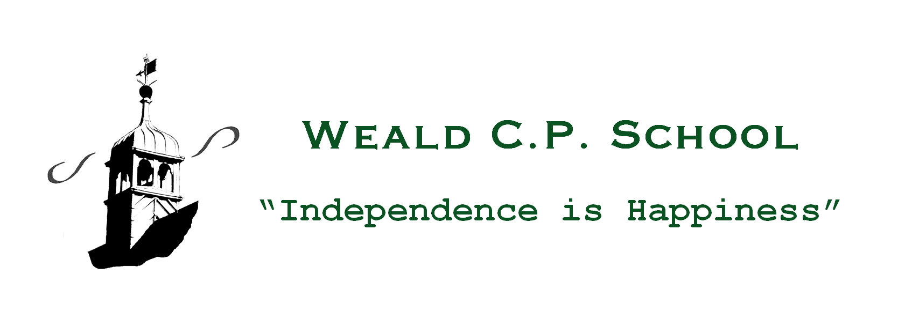

Introduction

Section 88 of the Education and Inspections Act 2006 requires governing bodies of maintained schools to have regard to the statutory guidance from the Secretary of State for Education in making and reviewing a written statement of behaviour. The Governing Body has a duty to produce, and review, a written statement of general principles to guide the Headteacher in determining measures to promote good behaviour and discipline amongst pupils. The document ‘Behaviour and discipline in schools’ – Guidance for governing bodies’ has been used as a reference in producing this Statement of Behaviour Principles.

Schools are required to have a Behaviour Policy which includes the school rules. It is the responsibility of the Headteacher along with the staff at Weald CPS to produce the school’s Positive Behaviour Policy and the duty of the Governing Body to provide the Headteacher with a clear written statement of the principles around which the Positive Behaviour Policy will be formed and follow. The Statement of Behaviour Principles will be reviewed regularly to take account of any legislative or other changes which may affect the content or relevance of this document.

In deciding on these Behaviour Principles, the Governors consulted with parents, pupils, school staff and the Headteacher in order to ensure that the Principles are both relevant and appropriate for the standard of behaviour expected (school rules); the use of rewards and sanctions; the circumstances in which reasonable force will be used and when multi-agency assessment will be considered for pupils who display continuous disruptive behaviour; in our school.

Principles

Right to feel safe at all times:
All young people and staff have the right to feel safe at all times whilst in school. There should be mutual respect between staff and pupils; pupils and their peers; staff and their colleagues; staff and parents or other visitors to the school. All members of the school community must be aware that bullying or harassment of any description is unacceptable and, even if it occurs outside normal school hours, will be dealt with in accordance with the sanctions laid out in the Positive Behaviour Policy.

High standards of behaviour:
The Governors strongly believe that high standards of behaviour lie at the heart of a successful school. Such expected behaviour will enable all children to make the best possible progress in all aspects of their school life and work, and all staff to be able to teach and promote good learning without interruption.
The Governors also believe that the expectation of high standards of behaviour which are required during the school day can have a positive effect on the life of children outside school in encouraging them to become acceptable members of the wider community.

Inclusivity and Equality:
Weald Community Primary School is an inclusive school. All members of the school community should be free from discrimination of any description and this should be further recognised in our Accessibility Plan and promoted in the day-to-day running of the school. The Positive Behaviour and Anti-Bullying Policies should emphasise that bullying and discrimination as a result of gender, race, ability, sexual orientation or background is absolutely unacceptable and attracts a zero tolerance attitude. Measures to counteract bullying and discrimination will be consistently applied and monitored for their effectiveness.
The school’s legal duties in order to comply with the Equality Act 2010 will be further reinforced through the Positive Behaviour Policy and we will seek to safeguard vulnerable pupils, particularly those with special educational needs where reasonable adjustments in the Positive Behaviour Policy’s application may need to be made.

School Rules:
The Positive Behaviour Policy must include details of the school rules. These should set out the expected standards of behaviour, displayed in all classrooms, shared with and explained to all pupils. The Governors expect that any school rules are applied consistently across the whole school by staff and others to whom this authority has been given. School rules which are clear and explained to all staff will ensure that staff have the confidence to apply the rules appropriately and where necessary, give rewards for good behaviour and the appropriate level of sanction for inappropriate or unacceptable behaviour.

Rewards:
The Governors expect the Positive Behaviour Policy to include a wide range of rewards which are clear and enable staff and others with authority to apply them consistently and fairly across the whole school. The rewards system will encourage good behaviour in the classroom and elsewhere in the school. The Governors expect that any rewards system is explained to others who have responsibility for young people such as extended school provision and, where applicable, home to school transport so that there is a consistent message to pupils that good behaviour reaps positive outcomes. The rewards system must be regularly monitored for consistency, fair application and effectiveness.

Sanctions:
Sanctions for unacceptable/poor behaviour should be known and understood by all staff, other adults with authority for behaviour, pupils and parents/carers. Like rewards, sanctions must be consistently applied across the whole school, including extended school provision where applicable.

The range of sanctions must be described in the Positive Behaviour Policy so that all concerned are aware of and understand how and when the sanctions will be applied. The Positive Behaviour Policy should also explain how and when exclusions (both fixed-term and permanent) will be used as a sanction. The Policy should also include the provision for an appeal process against a sanction where a pupil or parent believes the school has exercised its disciplinary authority unreasonably. The Governors, however, believe that the exclusion sanction should only be used as a last resort. ‘Unofficial’ exclusions are illegal and so must be avoided. The Headteacher may inform the police, where necessary and appropriate, if there is evidence of a criminal act or it is thought that one may take place. It is important that sanctions are monitored for their proper use, consistency and effective impact.

Home/School Agreement:
The Home/School Agreement should mirror the statements made in the Positive Behaviour Policy so that parents/carers are encouraged and helped to support their children’s education, just as the pupils should be helped to understand their responsibilities during their time at school, in the wider community and in preparation for their life after school. The responsibilities of children, parents/carers and all school staff with respect to their and their children’s behaviour must be outlined in the Home School Agreement which children, parents/carers and teachers must be asked to sign when a pupil joins the school.

Power to Screen and Search Pupils:
The Governors expect the Positive Behaviour Policy to clearly explain to staff and others with authority their powers in relation to the screening and searching of pupils for items which are ‘prohibited’ and/or banned in accordance with the school rules.

The use of Reasonable Force:
The Governors expect the Positive Behaviour Policy to clearly outline the circumstances where staff may use reasonable force and other physical contact in order to control inappropriate behaviour including removing disruptive pupils from classrooms or preventing them from leaving. A definition of ‘reasonable force’ should be included which should also explain how and under what circumstances pupils may be restrained. The Governors expect that appropriate and ‘authorised’ staff are appropriately trained in the use of reasonable force and restraint and that all staff are given advice on de-escalation and behaviour management techniques. Mention should also be made of the need for individual pupil ‘Behaviour Management Plans’ which may specify particular physical intervention techniques for the pupil concerned.

The Power to discipline for behaviour outside the school gates:
The Governors expect the Positive Behaviour Policy to set out the school’s response to non-criminal bad behaviour and bullying which occurs anywhere off the school premises and which is witnessed by a member of staff or reported to the school. The Policy should include the school’s response to any bad behaviour when the child is:

• taking part in any school-organised or school-related activity, or
• travelling to and from school, or
• wearing school uniform, or
• in some other way identifiable as a pupil at the school

Even if the conditions above do not apply, the Policy must take account of misbehaviour at any time which:
• could have repercussions for the orderly running of the school, or
• poses a threat to another pupil or member of the public, or

• could adversely affect the reputation of the school.

Pastoral care for school staff:
The Positive Behaviour Policy must include details of how the school will respond to an allegation against a member of staff. The Governors would not expect automatic suspension of a member of staff who has been accused of misconduct, pending an investigation. The Governors would, however, expect the Headteacher to draw on and follow the advice in the ‘Dealing with Allegations of Abuse against Teachers and Other Staff’ guidance when setting out the pastoral support school staff can expect to receive if they are accused of misusing their powers. In addition, the Positive Behaviour Policy should set out the disciplinary action that will be taken against pupils who are found to have made malicious accusations against school staff.

Reviewed: June 2019
To be reviewed: June 2020
Signed (Chair of Govs):
Signed (Headteacher):

